Mineral Titles Act 2010
NOTICE OF LAND CEASING TO BE A MINERAL TITLE AREA
Title Type and Number: | Mineral Lease 32074
Area ceased on: | 13 January 2021
Area: | 329.20 Hectares
Locality: | BYNOE
Name of Applicants(s)Holder(s): | 100% LITHIUM DEVELOPMENTS (GRANTS NT) PTY LTD [ACN. 622 047 232]
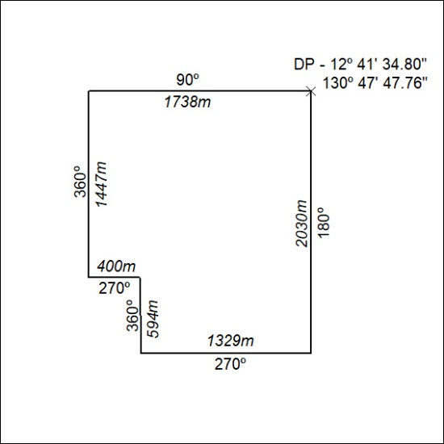

11/21

Mineral Titles Act
NOTICE OF GRANT OF A MINERAL TITLE
Title Type and Number: | Mineral Lease 32346
Granted: | 13 January 2021, for a period of 25 Years
Area: | 494.90 Hectares
Locality: | BYNOE
Name of Holder/s: | 100% LITHIUM DEVELOPMENTS (GRANTS NT) PTY LTD [ACN. 622 047 232]
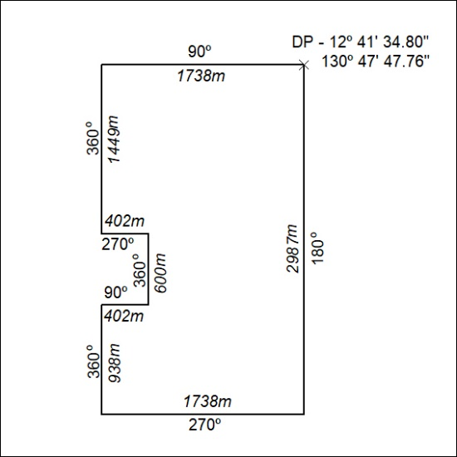

12/21

