Mineral Titles Act 2010
NOTICE OF LAND CEASING TO BE A MINERAL TITLE AREA
Title Type and Number: | Exploration Licence 31824
Area Ceased on: | 11 November 2020
Area: | 112 Blocks, 333.64 km²
Locality: | GREGORYS DEPOT
Name of Applicant(s)/Holder(s): | 100% SCRIVEN EXPLORATION PTY LTD [ACN. 006 264 615]
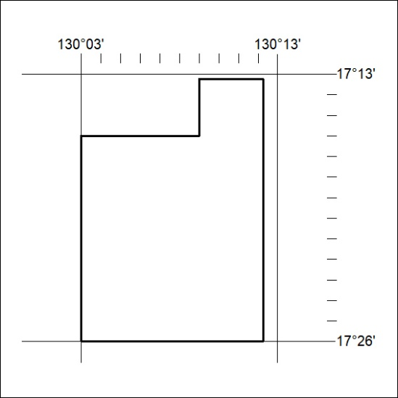

362/20

Mineral Titles Act 2010
NOTICE OF LAND CEASING TO BE A MINERAL TITLE AREA
Title Type and Number: | Exploration Licence 31897
Area Ceased on: | 11 November 2020
Area: | 46 Blocks, 153.35 km²
Locality: | MAINORU
Name of Applicant(s)/Holder(s): | 100% SCRIVEN EXPLORATION PTY LTD [ACN. 006 264 615]
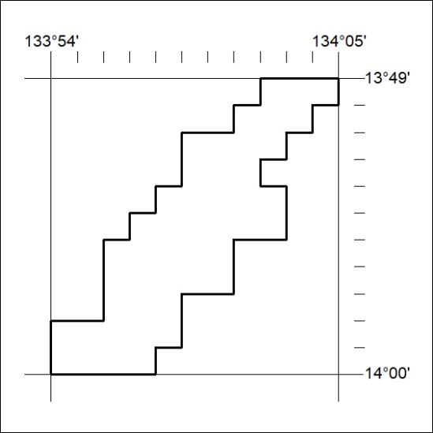

363/20

