Mineral Titles Act 2010
NOTICE OF LAND CEASING TO BE A MINERAL TITLE AREA
Title Type and Number: | Exploration Licence 31098
Area Ceased on: | 28 July 2020
Area: | 52 Blocks, 164.82 km²
Locality: | NAPPERBY
Name of Applicant(s)/Holder(s): | 100% ENERGY METALS LTD [ACN. 111 306 533]
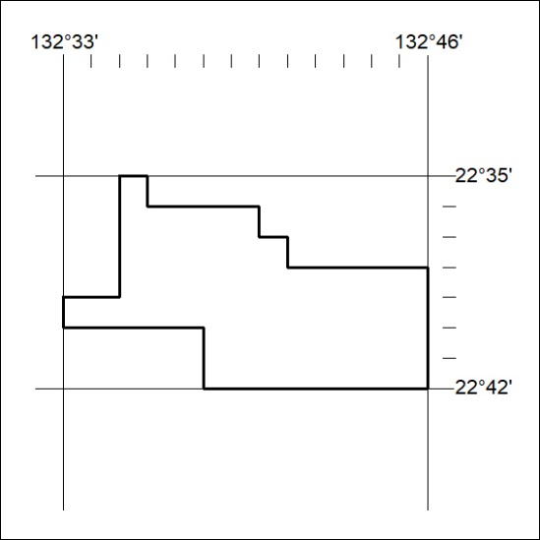

245/20

