Mineral Titles Act
NOTICE OF GRANT OF A MINERAL TITLE
Title Type and Number: | Exploration Licence 32362
Granted: | 14 July 2020, for a period of 1 Year
Area: | 16 Blocks, 51.89 km²
Locality: | ALROY
Name of Holder/s: | 100% MINEX CRC LTD [ACN. 625 533 913]
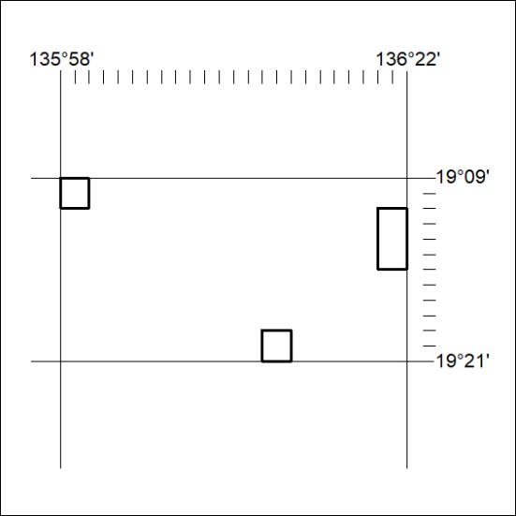
Area granted is indicated above. The titleholder is not permitted to exercise occupational rights on any land that is subject to a development title, or an application for a development title. Any land the subject of a Reserved Land gazettal under the Mineral Titles Act and all land vested in the Commonwealth of Australia is also excluded by description but not excised from the grant area.
223/20

Mineral Titles Act
NOTICE OF GRANT OF A MINERAL TITLE
Title Type and Number: | Exploration Licence 32363
Granted: | 14 July 2020, for a period of 1 Year
Area: | 16 Blocks, 51.79 km²
Locality: | WONARAH
Name of Holder/s: | 100% MINEX CRC LTD [ACN. 625 533 913]
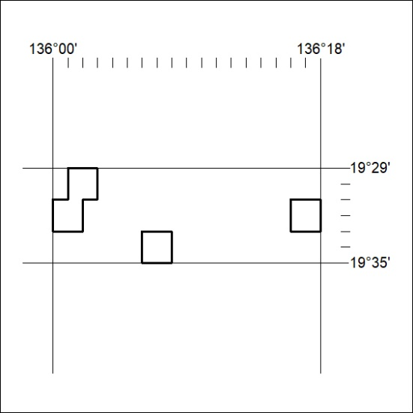
Area granted is indicated above. The titleholder is not permitted to exercise occupational rights on any land that is subject to a development title, or an application for a development title. Any land the subject of a Reserved Land gazettal under the Mineral Titles Act and all land vested in the Commonwealth of Australia is also excluded by description but not excised from the grant area.
224/20

Mineral Titles Act
NOTICE OF GRANT OF A MINERAL TITLE
Title Type and Number: | Exploration Licence 32364
Granted: | 14 July 2020, for a period of 1 Year
Area: | 12 Blocks, 38.82 km²
Locality: | DALMORE
Name of Holder/s: | 100% MINEX CRC LTD [ACN. 625 533 913]
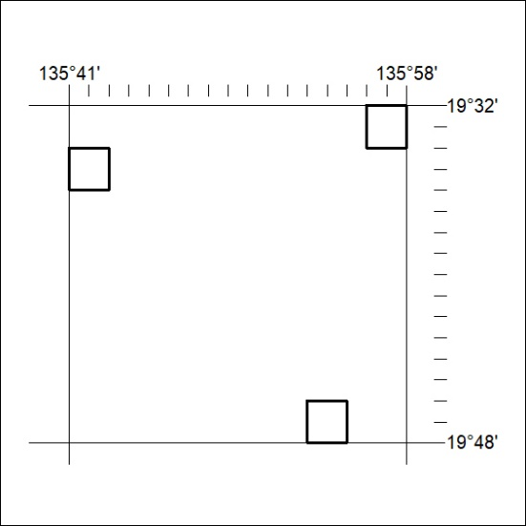
Area granted is indicated above. The titleholder is not permitted to exercise occupational rights on any land that is subject to a development title, or an application for a development title. Any land the subject of a Reserved Land gazettal under the Mineral Titles Act and all land vested in the Commonwealth of Australia is also excluded by description but not excised from the grant area.
225/20

Mineral Titles Act
NOTICE OF GRANT OF A MINERAL TITLE
Title Type and Number: | Exploration Licence 32365
Granted: | 14 July 2020, for a period of 1 Year
Area: | 4 Blocks, 10.73 km²
Locality: | DALMORE
Name of Holder/s: | 100% MINEX CRC LTD [ACN. 625 533 913]
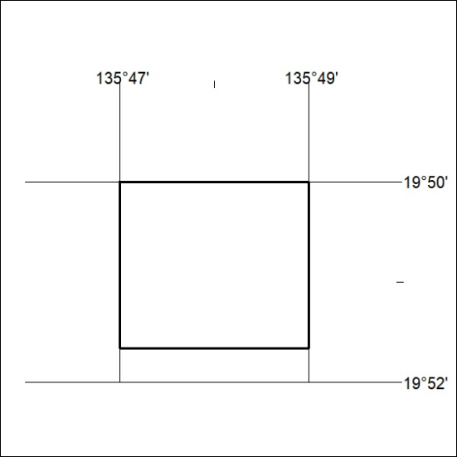
Area granted is indicated above. The titleholder is not permitted to exercise occupational rights on any land that is subject to a development title, or an application for a development title. Any land the subject of a Reserved Land gazettal under the Mineral Titles Act and all land vested in the Commonwealth of Australia is also excluded by description but not excised from the grant area.
226/20

Mineral Titles Act
NOTICE OF GRANT OF A MINERAL TITLE
Title Type and Number: | Exploration Licence 32366
Granted: | 14 July 2020, for a period of 1 Year
Area: | 7 Blocks, 22.72 km²
Locality: | GALLIPOLI
Name of Holder/s: | 100% MINEX CRC LTD [ACN. 625 533 913]
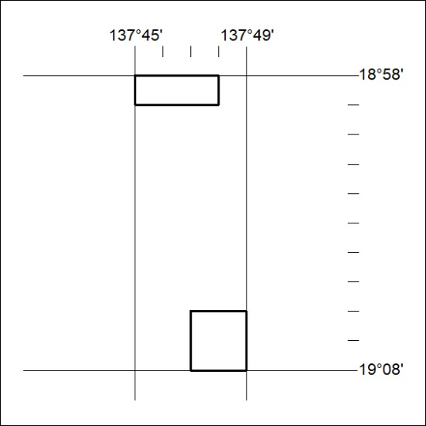
Area granted is indicated above. The titleholder is not permitted to exercise occupational rights on any land that is subject to a development title, or an application for a development title. Any land the subject of a Reserved Land gazettal under the Mineral Titles Act and all land vested in the Commonwealth of Australia is also excluded by description but not excised from the grant area.
227/20

