Mineral Titles Act 2010
NOTICE OF LAND CEASING TO BE A MINERAL TITLE APPLICATION AREA
Title Type and Number: | Exploration Licence 31666
Area Ceased on: | 16 March 2020
Area: | 250 Blocks, 790.18 km²
Locality: | REDVERS
Name of Applicant(s)/Holder(s): | 100% CERBERUS RESOURCES PTY LTD [ACN. 615 192 535]
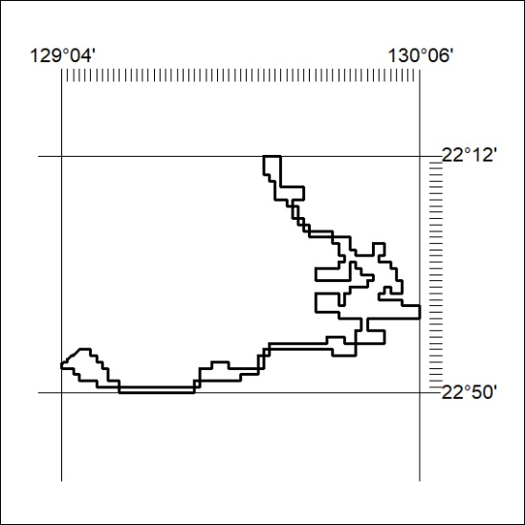

140/20

Mineral Titles Act 2010
NOTICE OF LAND CEASING TO BE A MINERAL TITLE APPLICATION AREA
Title Type and Number: | Exploration Licence 31667
Area Ceased on: | 16 March 2020
Area: | 102 Blocks, 324.46 km²
Locality: | NICKER
Name of Applicant(s)/Holder(s): | 100% CERBERUS RESOURCES PTY LTD [ACN. 615 192 535]
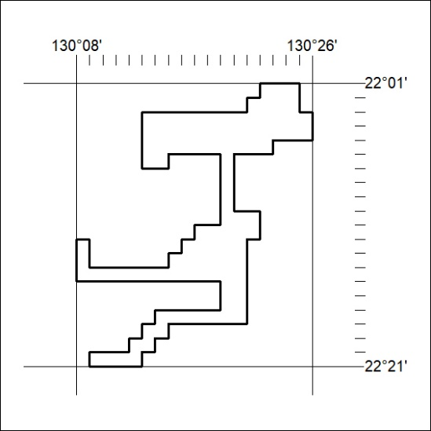

141/20

