Mineral Titles Act 2010
NOTICE OF LAND CEASING TO BE A MINERAL TITLE AREA
Title Type and Number: | Extractive Mineral Exploration Licence 31593
Area Ceased on: | 29 February 2020
Area: | 4 Blocks, 13.35 km²
Locality: | PINE CREEK
Name of Applicant(s)/Holder(s): | 100% JN. MOUSELLIS CIVIL CONTRACTORS PTY LTD [ACN. 122 603 990]
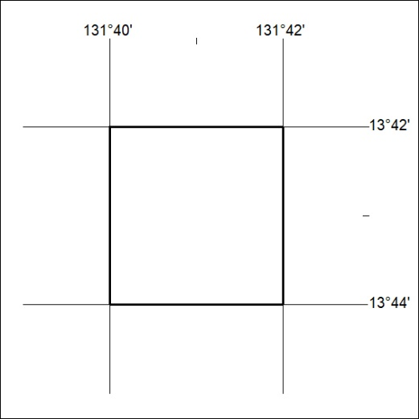

120/20

Mineral Titles Act 2010
NOTICE OF LAND CEASING TO BE A MINERAL TITLE AREA
Title Type and Number: | Extractive Mineral Exploration Licence 31594
Area Ceased on: | 29 February 2020
Area: | 3 Blocks, 10.01 km²
Locality: | PINE CREEK
Name of Applicant(s)/Holder(s): | 100% JN. MOUSELLIS CIVIL CONTRACTORS PTY LTD [ACN. 122 603 990]
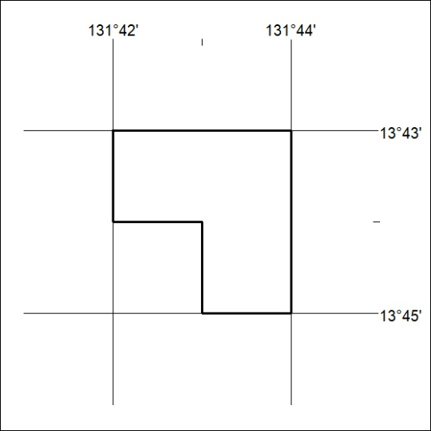

121/20
Mineral Titles Act 2010
NOTICE OF LAND CEASING TO BE A MINERAL TITLE AREA
Title Type and Number: | Exploration Licence 28948
Area Ceased on: | 29 February 2020
Area: | 3 Blocks, 9.50 km²
Locality: | JERVOIS RANGE
Name of Applicant(s)/Holder(s): | 100% MOLYHIL MINING PTY LTD [ACN. 112 922 497]
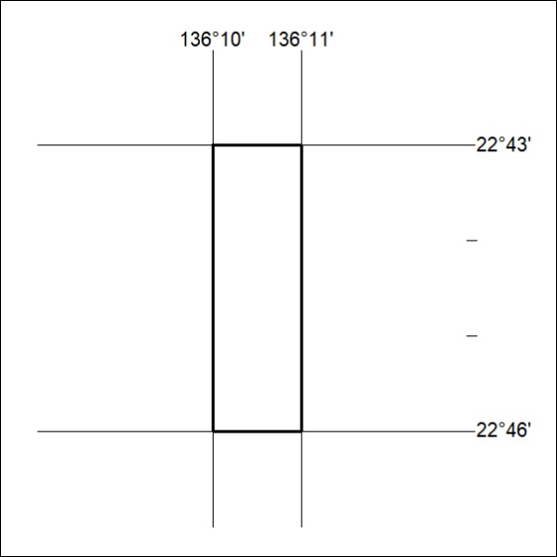

122/20

Mineral Titles Act
NOTICE OF GRANT OF A MINERAL TITLE
Title Type and Number: | Exploration Licence 32176
Granted: | 28 February 2020, for a period of 6 Years
Area: | 242 Blocks, 752.59 km²
Locality: | CARRARA
Name of Holder/s: | 100% STRATEGIC ENERGY RESOURCES LIMITED* [ACN. 051 212 429]
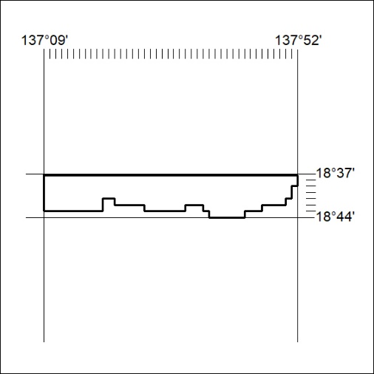
Area granted is indicated above. The titleholder is not permitted to exercise occupational rights on any land that is subject to a development title, or an application for a development title. Any land the subject of a Reserved Land gazettal under the Mineral Titles Act and all land vested in the Commonwealth of Australia is also excluded by description but not excised from the grant area

123/20

