Mineral Titles Act 2010
NOTICE OF LAND CEASING TO BE A MINERAL TITLE AREA
Title Type and Number: | Exploration Licence 31547
Area Ceased on: | 20 December 2019
Area: | 242 Blocks, 751.86 km²
Locality: | CALVERT RIVER
Name of Applicant(s)/Holder(s): | 100% MANGROVE RESOURCES PTY LTD [ACN. 612 043 240]
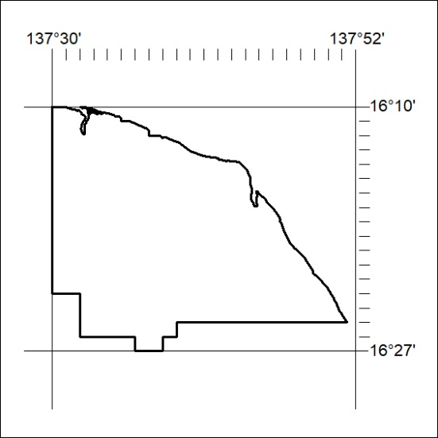

542/19

