Mineral Titles Act 2010
NOTICE OF LAND CEASING TO BE A MINERAL TITLE APPLICATION AREA
Title Type and Number: | Exploration Licence 26279
Area Ceased on: | 05 December 2019
Area: | 240 Blocks, 769.37 km²
Locality: | THEO
Name of Applicant(s)/Holder(s): | 100% TORO ENERGY LIMITED [ACN. 117 127 590]
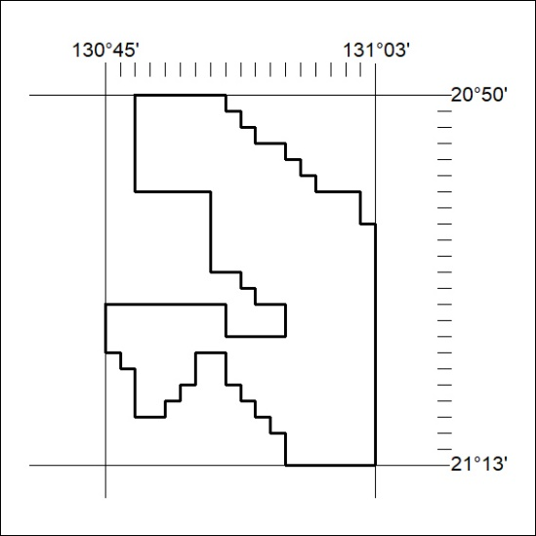

518/19

Mineral Titles Act 2010
NOTICE OF LAND CEASING TO BE A MINERAL TITLE APPLICATION AREA
Title Type and Number: | Exploration Licence 27532
Area Ceased on: | 05 December 2019
Area: | 175 Blocks, 554.35 km²
Locality: | PATRICIA
Name of Applicant(s)/Holder(s): | 100% TORO ENERGY LIMITED [ACN. 117 127 590]
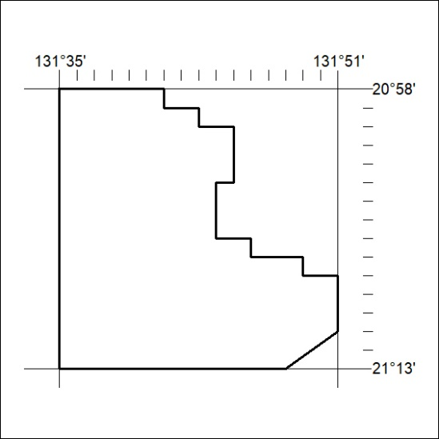

519/19
Mineral Titles Act 2010
NOTICE OF LAND CEASING TO BE A MINERAL TITLE APPLICATION AREA
Title Type and Number: | Exploration Licence 27533
Area Ceased on: | 05 December 2019
Area: | 324 Blocks, 1038.88 km²
Locality: | THEO
Name of Applicant(s)/Holder(s): | 100% TORO ENERGY LIMITED [ACN. 117 127 590]
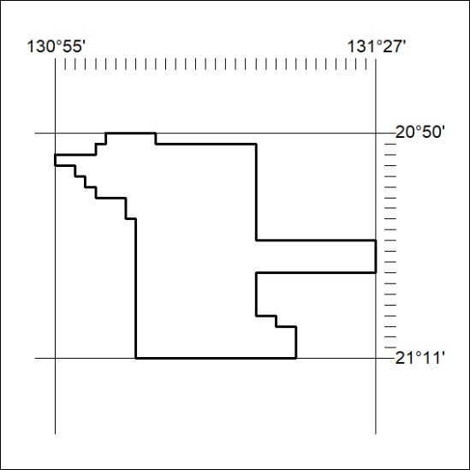

520/19

