Mineral Titles Act 2010
NOTICE OF LAND CEASING TO BE A MINERAL TITLE AREA
Title Type and Number: | Mineral Lease (Northern) 285
Area ceased on: | 27 November 2019
Area: | 10.00 Hectare
Locality: | BYNOE
Name of Applicants(s)Holder(s): | 100% OSTOJIC GROUP PTY LTD* [ACN. 009 629 805]
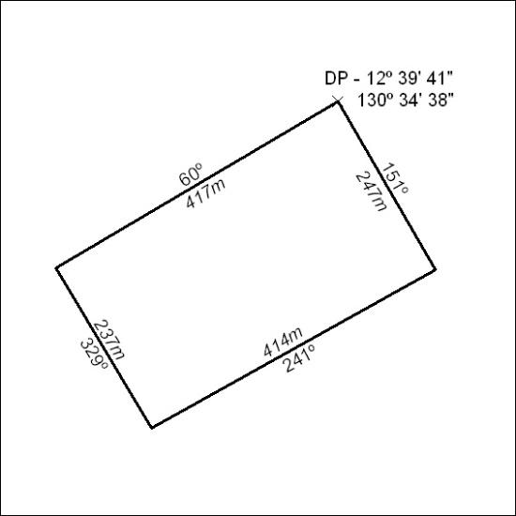

517/19

