Northern Territory
Business Confidence survey
September Quarter 2019

Northern Territory Business Confidence Survey
September Quarter 2019

Summary
- The Territory-wide business confidence level was +50% in the September quarter 2019. This represents a 4 percentage point decrease from the June quarter 2019, but an 8 percentage point increase on the same quarter in 2018.
- Between 1 July and 30 September 2019, 404 businesses were surveyed across Territory regions and industry sectors.
- Business confidence by region ranged from +100% in East Arnhem to +46% in the Greater Darwin region.
- 41% of businesses surveyed expected to perform better this year compared to the previous year, representing a 7 percentage point decrease from the June quarter 2019.

Introduction
Northern Territory Business Confidence is a quarterly publication which highlights confidence levels of Territory-wide businesses.
The survey covers urban and regional areas of the Territory and captures different industry sectors and business sizes (small, medium and large).
Monitoring business confidence levels is important as it is a key barometer and a leading indicator of business conditions and the overall health of the economy. Business confidence drives business growth and investment, supports employment opportunities and attracts people to the region.

Number of businesses surveyed by regions
(ABS statistical area 3 – sa3 levels)
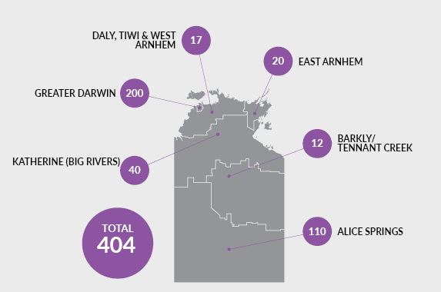

Region | Total no of businesses | Businesses surveyed | Proportional of total
Greater Darwin | 10 652 | 200 | 1.9%
Daly-Tiwi-West Arnhem | 360 | 17 | 4.7%
East Arnhem | 220 | 20 | 9.1%
Katherine (Big Rivers) | 927 | 40 | 4.3%
Barkly-Tennant Creek | 214 | 12 | 5.6%
Alice Springs | 2076 | 110 | 5.3%
Unclassified | n.a | 5 | n.a.
TOTAL | 14 449 | 404 | 2.8%
Source: ABS Cat. No. 81650.0

Business confidence
Q. How confident are you about your business prospects for the next 12 months?

Territory wide
In the September quarter 2019, the Territory-wide business confidence index was +50%. The response rate for this question was 94.6%.

Overall business confidence index
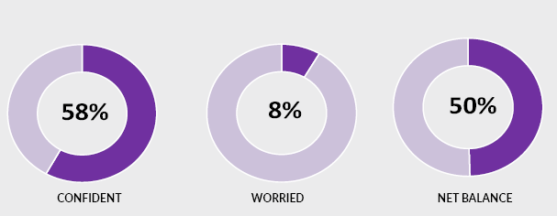
Note: 34% of the responses remained neutral (neither confident nor worried)

Confidence in the regions
Business confidence varied among Territory regions, ranging from +100% in East Arnhem to +46% in the Greater Darwin Region.
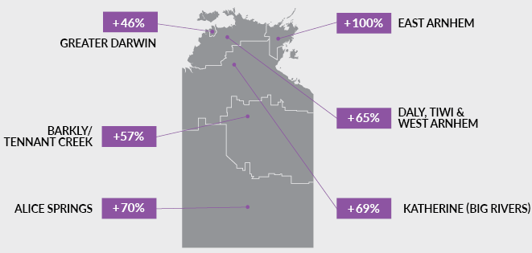

Confidence trends

Territory wide
 | Sep Qtr  2018 | Dec Qtr  2018 | Mar Qtr  2019 | Jun Qtr  2019 | Sep Qtr  2019
Confident | 60% | 60% | 61% | 64% | 58%
Worried | 18% | 10% | 15% | 10% | 8%
Net balance | 42% | 50% | 46% | 54% | 50%

In the September quarter 2019, business confidence decreased 4 percentage points to +50% from the previous quarter. This represents an 8 percentage point increase from the September quarter 2018.
The above table and the chart below show that the level of overall business confidence in the Territory has been stable and relatively buoyant over the past year.

Trends in nt business confidence
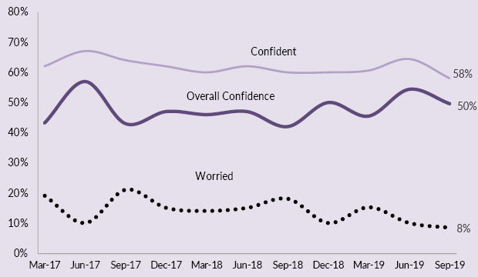

Business confidence by region
In the September quarter 2019, business confidence improved in Daly-Tiwi-West Arnhem, East Arnhem, and Alice Springs, and declined in Greater Darwin, Katherine (Big Rivers) and Barkly-Tennant Creek compared to the previous quarter.
Region | Sep Qtr  2018 | Dec Qtr  2018 | Mar Qtr  2019 | Jun Qtr  2019 | Sep Qtr  2019
Greater Darwin
Confident | 51% | 53% | 57% | 59% | 53%
Worried | 21% | 12% | 16% | 11% | 7%
Net balance | 30% | 41% | 41% | 48% | 46%
Daly-Tiwi-West Arnhem
Confident | 59% | 33% | 42% | 48% | 71%
Worried | 9% | 19% | 37% | 4% | 6%
Net balance | 50% | 14% | 5% | 44% | 65%
East Arnhem
Confident | 75% | 91% | 66% | 82% | 100%
Worried | 17% | 5% | 12% | 0% | 0%
Net balance | 58% | 86% | 54% | 82% | 100%
Katherine (Big Rivers)
Confident | 79% | 88% | 88% | 88% | 77%
Worried | 0% | 0% | 2% | 9% | 8%
Net balance | 79% | 88% | 86% | 79% | 69%
Barkly-Tennant Creek
Confident | 81% | 75% | 78% | 78% | 71%
Worried | 0% | 0% | 22% | 11% | 14%
Net balance | 81% | 75% | 56% | 67% | 57%
Alice Springs
Confident | 84% | 82% | 65% | 81% | 80%
Worried | 9% | 4% | 14% | 8% | 10%
Net balance | 75% | 78% | 51% | 73% | 70%

Business confidence by industry
The Territory-wide business confidence was +50% but remained varied among the industries for the September quarter 2019. The chart below displays the top 10 most surveyed industries.
Sector | Confident | Worried | Net balance
 |  |  | Sep Qtr  2019 | Jun Qtr  2019 | Mar Qtr 2019
Construction | 55% | 11% | 44% | 44% | 8 ppt
Retail Trade | 59% | 13% | 46% | 46% | 4 ppt
Health Care and Social Assistance | 77% | 6% | 71% | 71% | 2 ppt
Other Services | 70% | 7% | 63% | 63% | 19 ppt
Arts and Recreation Services | 71% | 14% | 57% | 57% | -1 ppt
Accommodation and Food Services | 73% | 4% | 69% | 69% | 12 ppt
Administrative and Support Services | 81% | 5% | 76% | 76% | 7 ppt
Professional, Scientific and Technical Services | 68% | 5% | 63% | 63% | -30 ppt
Transport, Postal and Warehousing | 59% | 0% | 59% | 59% | 4 ppt
Manufacturing | 64% | 9% | 55% | 55% | 2 ppt
Note: Caution is advised when using this data as the sample size in some sectors may be relatively small.

Industry expectations
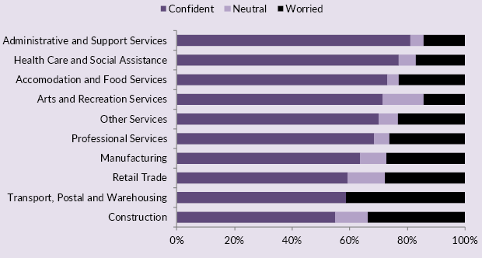

Key business insights

Confident
Of the Territory businesses confident about their business prospects for the next 12 months, key reasons cited are: 'business opportunity'; 'strong customer relations'; 'been in business a long time' and 'strong market position'. The graph below shows the relative importance of the key reasons for confidence.
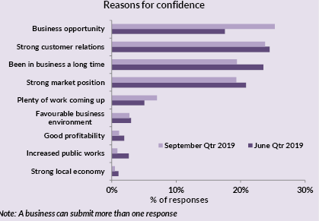

Worried
Of those Territory businesses worried about their business prospects for the next 12 months, the main reasons cited for being worried are: 'decrease in business/sales'; 'increased business costs'; and 'weaker local economy'. The graph below shows the relative importance of the key reasons for being worried for the last two quarters.
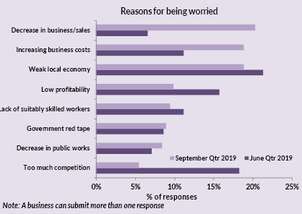

Business performance
Q. How is your business performing this year compared to last year?
41% of Territory businesses noted that their business performance is better this year compared to last year, while 46% of the businesses stated that business performance is the same as last year, and 13% of businesses stated their business performance is worse than last year.
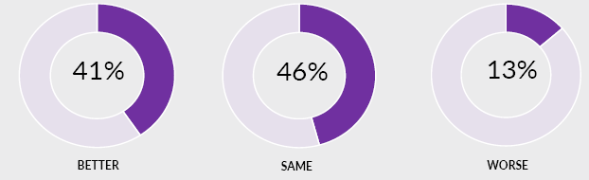

Trend in Business performance
Compared to the same quarter in previous years, fewer businesses felt that their performance was better, and more businesses felt that their business performance was the same as last year.
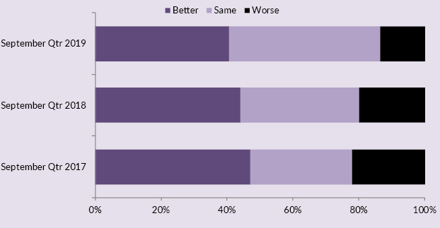

Business performance this year compared to last year by region
The table and graphs below highlight that business performance levels varied among businesses in the regions. Compared to the previous quarter, East Arnhem and Alice Springs show improved business performance, whereas expectations for business performance has declined in all other regions.
Statistical area level 3 (sa3) regions | Business performance
 | Better | Same | Worse
Greater Darwin | 33% | 52% | 16%
Katherine (Big Rivers) | 25% | 60% | 15%
East Arnhem | 55% | 40% | 5%
Daly, Tiwi & West Arnhem | 35% | 47% | 18%
Barkly/Tennant Creek | 29% | 29% | 43%
Alice Springs | 61% | 30% | 9%
Territory-wide | 41% | 46% | 13%

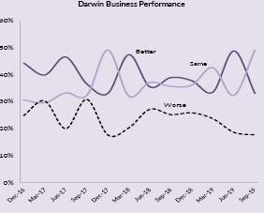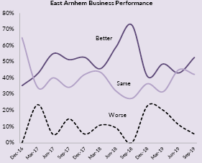
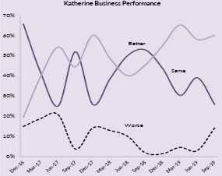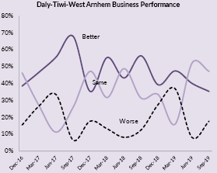

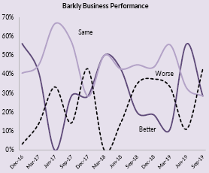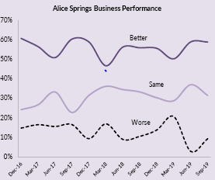

Survey methodology
A face-to-face survey of businesses operating in the Territory is conducted by the Department of Trade, Business and Innovation (DTBI) on a quarterly basis. Business confidence is estimated using the business confidence index.
There are approximately 14,000 operating businesses in the Territory. Therefore, for the sample survey to achieve a 95% confidence level with a margin of error of 5%, 375 survey responses are required.
Business confidence index is calculated as the difference between the proportion of businesses that are ‘confident about their business prospects for the next 12 months' minus the proportion of businesses that are ‘worried about their business prospects for the next 12 months’ (net balance approach).
The higher the net balance the greater the level of business confidence. For example, if 60% of businesses are confident and 40% of businesses are worried, the net balance is +20%. Survey responses are also analysed by region and industry sector of businesses.
The business confidence results are presented for overall Northern Territory, Greater Darwin (Darwin City, Darwin suburbs, Palmerston and Litchfield) and for individual regions.
The overall Territory-wide confidence index is weighted to account for the number of businesses in each of the regions. The weights are based on the proportion of total Territory businesses in each region. The weighted result provides a more balanced reflection of overall business confidence.

business.nt.gov.au

