Mineral Titles Act 2010
NOTICE OF LAND CEASING TO BE A MINERAL TITLE AREA
Title Type and Number: | Exploration Licence 28521
Area Ceased on: | 27 October 2019
Area: | 113 Blocks, 361.76 km²
Locality: | TAYLOR
Name of Applicant(s)/Holder(s): | 100% AUSTRALIAN MINERA RESOURCES PTY LTD [ACN. 152 123 754]
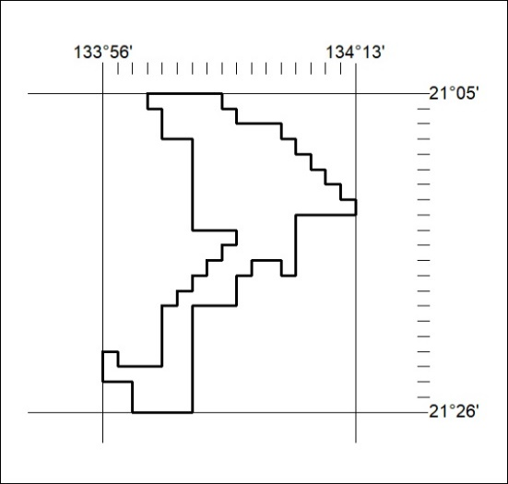

464/19

Mineral Titles Act 2010
NOTICE OF LAND CEASING TO BE A MINERAL TITLE AREA
Title Type and Number: | Exploration Licence 30256
Area Ceased on: | 29 October 2019
Area: | 92 Blocks, 295.67 km²
Locality: | PEDESTAL HILLS
Name of Applicant(s)/Holder(s): | 100% FERDIES FIND PTY LTD [ACN. 168 969 971]
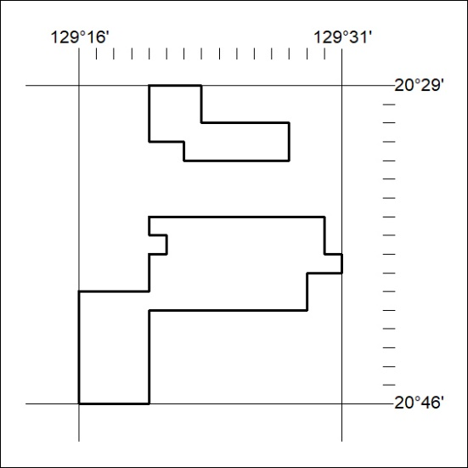

465/19
Mineral Titles Act 2010
NOTICE OF LAND CEASING TO BE A MINERAL TITLE AREA
Title Type and Number: | Exploration Licence 31665
Area Ceased on: | 29 October 2019
Area: | 28 Blocks, 78.96 km²
Locality: | BRUNCHILLY
Name of Applicant(s)/Holder(s): | 100% OM (MANGANESE) LTD [ACN. 097 091 506]
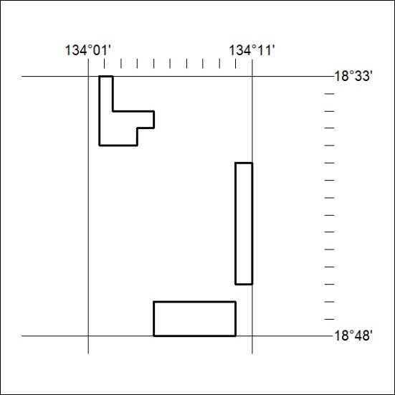

466/19

