Mineral Titles Act 2010
NOTICE OF LAND CEASING TO BE A MINERAL TITLE AREA
Title Type and Number: | Exploration Licence 31475
Area Ceased on: | 09 September 2019
Area: | 5 Blocks, 16.68 km²
Locality: | TIPPERARY
Name of Applicant(s)/Holder(s): | 100% COPPEROZ PTY LTD [ACN. 603 957 124]
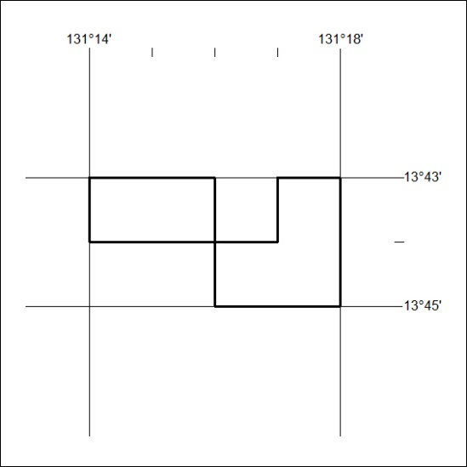

374/19

