Mineral Titles Act 2010
NOTICE OF LAND CEASING TO BE A MINERAL TITLE AREA
Title Type and Number: | Exploration Licence 29481
Area Ceased on: | 08 April 2019
Area: | 14 Blocks, 43.48 km²
Locality: | QUARTZ
Name of Applicant(s)/Holder(s): | 100% XAVIER RESOURCES PTY LTD [ACN. 623 262 304]
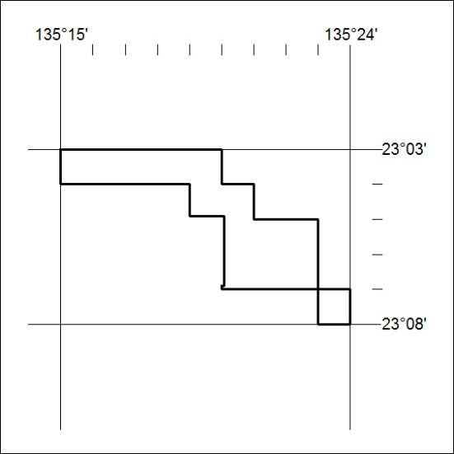

119/19

Mineral Titles Act 2010
NOTICE OF LAND CEASING TO BE A MINERAL TITLE AREA
Title Type and Number: | Exploration Licence 29511
Area Ceased on: | 08 April 2019
Area: | 4 Blocks, 12.64 km²
Locality: | QUARTZ
Name of Applicant(s)/Holder(s): | 100% XAVIER RESOURCES PTY LTD [ACN. 623 262 304]
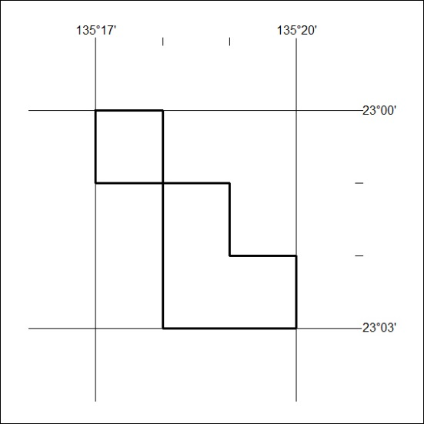

120/19
Mineral Titles Act 2010
NOTICE OF LAND CEASING TO BE A MINERAL TITLE AREA
Title Type and Number: | Exploration Licence 29851
Area Ceased on: | 08 April 2019
Area: | 8 Blocks, 25.26 km²
Locality: | QUARTZ
Name of Applicant(s)/Holder(s): | 100% XAVIER RESOURCES PTY LTD [ACN. 623 262 304]
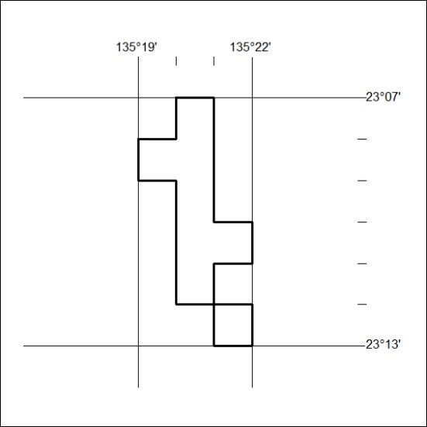

121/19

Mineral Titles Act 2010
NOTICE OF LAND CEASING TO BE A MINERAL TITLE AREA
Title Type and Number: | Exploration Licence 30494
Area Ceased on: | 08 April 2019
Area: | 62 Blocks, 204.84 km²
Locality: | BING BONG
Name of Applicant(s)/Holder(s): | 100% RIPPLE RESOURCES PTY LTD [ACN. 127 220 768]
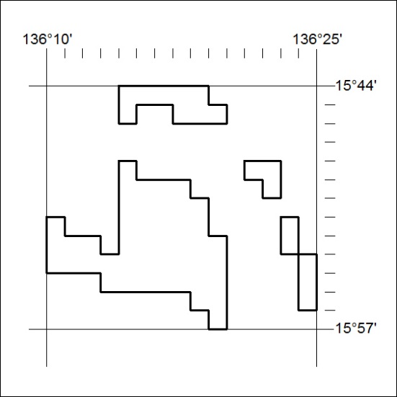

122/19
Mineral Titles Act 2010
NOTICE OF LAND CEASING TO BE A MINERAL TITLE AREA
Title Type and Number: | Exploration Licence 31147
Area Ceased on: | 08 April 2019
Area: | 39 Blocks, 114.52 km²
Locality: | QUARTZ
Name of Applicant(s)/Holder(s): | 100% XAVIER RESOURCES PTY LTD [ACN. 623 262 304]
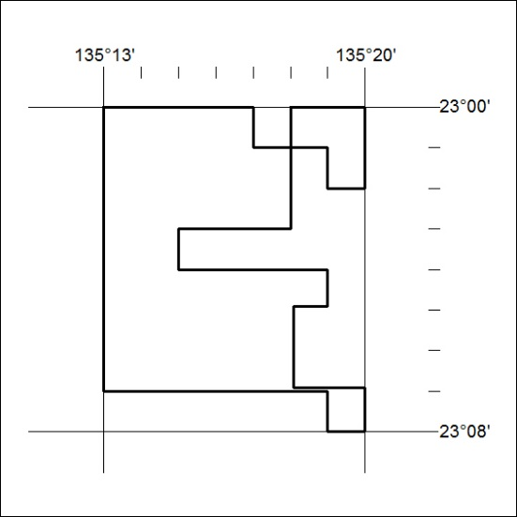

123/19

