Mineral Titles Act
NOTICE OF GRANT OF A MINERAL TITLE
Title Type and Number: | Mineral Authority 30826
Granted: | 22 March 2019, for a period of 5 Years
Area: | 77.17 Hectares
Locality: | NOONAMAH
Name of Holder/s: | 100% BERNO BROS. PTY. LIMITED [ACN. 009 592 741]
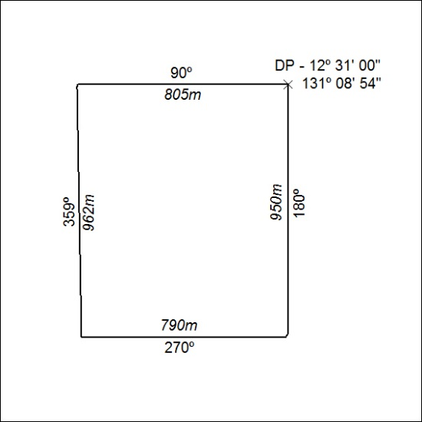

106/19

Mineral Titles Act
NOTICE OF GRANT OF A MINERAL TITLE
Title Type and Number: | Mineral Authority 30827
Granted: | 22 March 2019, for a period of 5 Years
Area: | 71.46 Hectares
Locality: | NOONAMAH
Name of Holder/s: | 100% BERNO BROS. PTY. LIMITED [ACN. 009 592 741]
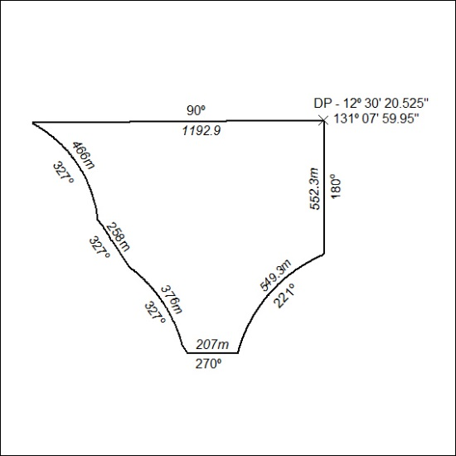

107/19

Mineral Titles Act
NOTICE OF GRANT OF A MINERAL TITLE
Title Type and Number: | Mineral Authority 30828
Granted: | 22 March 2019, for a period of 5 Years
Area: | 85.86 Hectares
Locality: | NOONAMAH
Name of Holder/s: | 100% BERNO BROS. PTY. LIMITED [ACN. 009 592 741]
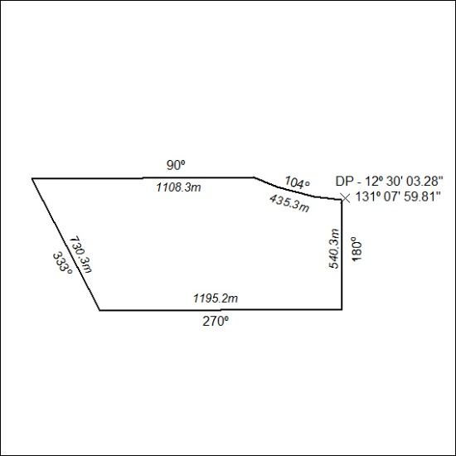

108/19

