Mineral Titles Act
NOTICE OF GRANT OF A MINERAL TITLE
Title Type and Number: | Exploration Licence 31723
Granted: | 31 July 2018, for a period of 6 Years
Area: | 165 Blocks, 471.38 km²
Locality: | HAAST BLUFF
Name of Holder/s: | 100% INDEPENDENCE GROUP NL* [ACN. 092 786 304]
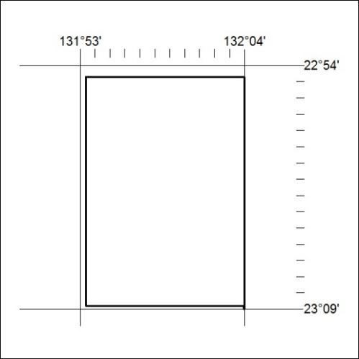
Area granted is indicated above. The titleholder is not permitted to exercise occupational rights on any land that is subject to a development title, or an application for a development title. Any land the subject of a Reserved Land gazettal under the Mineral Titles Act and all land vested in the Commonwealth of Australia is also excluded by description but not excised from the grant area.

330/18

Mineral Titles Act
NOTICE OF GRANT OF A MINERAL TITLE
Title Type and Number: | Exploration Licence 31799
Granted: | 31 July 2018, for a period of 6 Years
Area: | 106 Blocks, 341.54 km²
Locality: | BREADEN
Name of Holder/s: | 100% NORTHERN STAR (TANAMI) PTY LTD [ACN. 603 860 831]
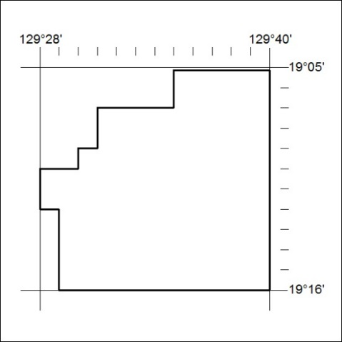
Area granted is indicated above. The titleholder is not permitted to exercise occupational rights on any land that is subject to a development title, or an application for a development title. Any land the subject of a Reserved Land gazettal under the Mineral Titles Act and all land vested in the Commonwealth of Australia is also excluded by description but not excised from the grant area.

331/18

