Mineral Titles Act
NOTICE OF LAND CEASING TO BE A MINERAL TITLE AREA
Title Type and Number: | Exploration Licence 25657
Area Ceased on: | 29 August 2017
Area: | 58 Blocks, 172.79 km²
Locality: | MACDONNELL RANGES
Name of Applicant(s)/Holder(s): | 45.024% CROSSLAND NICKEL PTY LTD* [ACN. 099 477 915], 34.976% ESSENTIAL MINING RESOURCES PTY LTD [ACN. 601 655 725], 20% WDR BASE METALS PTY LTD [ACN. 125 044 984]
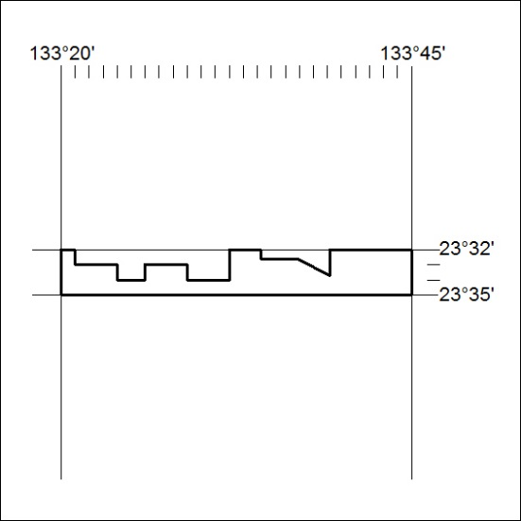

290/18

Mineral Titles Act
NOTICE OF LAND CEASING TO BE A MINERAL TITLE AREA
Title Type and Number: | Exploration Licence 26594
Area Ceased on: | 07 July 2018
Area: | 3 Blocks, 9.30 km²
Locality: | FLYNN
Name of Applicant(s)/Holder(s): | 100% GIANTS REEF EXPLORATION PTY LTD* [ACN. 009 200 346]
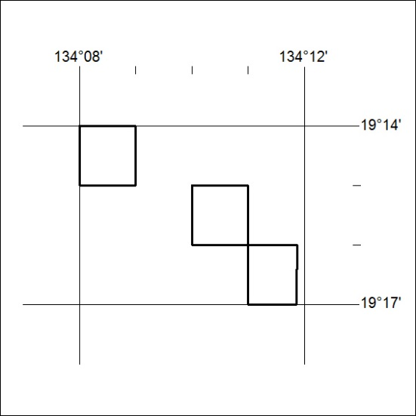

291/18

Mineral Titles Act
NOTICE OF GRANT OF A MINERAL TITLE
Title Type and Number: | Exploration Licence 31773
Granted: | 09 July 2018, for a period of 6 Years
Area: | 4 Blocks, 9.91 km²
Locality: | REYNOLDS RIVER
Name of Holder/s: | 100% NORTHERN TERRITORIES RESOURCES PTY LTD* [ACN. 124 647 829]
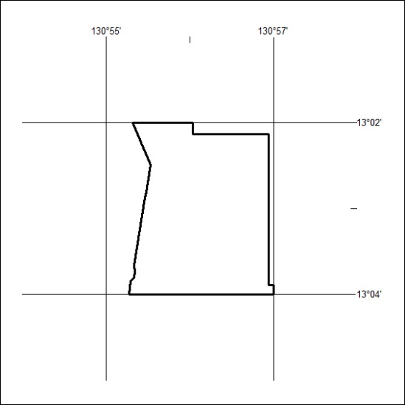
Area granted is indicated above. The titleholder is not permitted to exercise occupational rights on any land that is subject to a development title, or an application for a development title. Any land the subject of a Reserved Land gazettal under the Mineral Titles Act and all land vested in the Commonwealth of Australia is also excluded by description but not excised from the grant area.

292/18

Mineral Titles Act
NOTICE OF LAND CEASING TO BE A MINERAL TITLE AREA
Title Type and Number: | Exploration Licence 31832
Area Ceased on: | 07 July 2018
Area: | 21 Blocks, 68.04 km²
Locality: | FLYNN
Name of Applicant(s)/Holder(s): | 100% GIANTS REEF EXPLORATION PTY LTD* [ACN. 009 200 346]
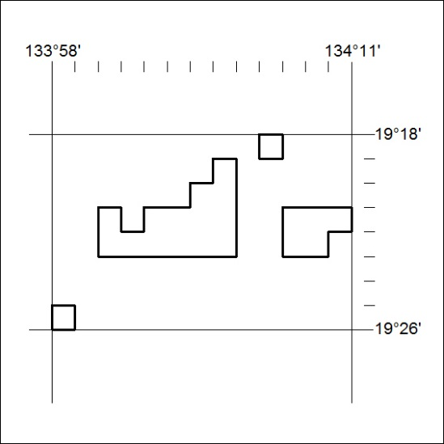

293/18

