Overview
State final demand (SFD) declined by 1.0% in the June quarter, with increased household consumption (0.4%) and public investment (5.8%), offset by weaker public consumption (-1.6%) and private investment (-5.8%). Business investment (-6.6%), notably non-dwelling construction (-12.3%) was the main driver of the decline, as work scheduling and progress for the Santos Barossa project continues to impact the quarterly numbers.
For 2022-23, SFD increased by 2.0%, with consumption contributing 0.8 percentage points (ppt) and investment 1.2ppt. Private investment has plateaued at an elevated level (and so is not contributing to growth), and public activity contributed 1.4ppt to growth, supported by investments in transport infrastructure and public housing, and for defence. The Territory continues to report the strongest SFD growth of the jurisdictions since the onset of COVID-19, with a 16.7% increase since the year to December 2019, ahead of Western Australia (16.6%).
High inflation and the rapid tightening of monetary policy since mid-2022 is having broad impacts across the economy, notably in the housing market – as evidenced by declining housing affordability (Chart 2). That said, housing in the Territory remains the most affordable in Australia. Increased mortgage rates is also impacting housing finance commitments, which are down across the nation (Chart 3). Investor commitments in the Territory are down by 15% in 2022-23 (21% nationally), despite the tight residential rental market and high rental yields on offer (Chart 4).
Indicator | Most recent | Measure | Period change¹ | Annual change² | Year on Year³ | COVID period change⁴
Economic Growth |  | $B
State final demand (NT) (sa) | Jun-23 | 6.978 | -1.0% | 0.7% | 2.0% | 16.7%
Consumption |  | 5.341 | -0.5% | 1.7% | 1.0% | 10.7%
Investment |  | 1.636 | -2.6% | -2.5% | 5.3% | 34.7%
Domestic final demand (Aus) (sa) | Jun-23 | 545.092 | 0.7% | 2.2% | 3.6% | 10.4%
Consumption |  | 415.295 | 0.2% | 1.4% | 4.2% | 10.3%
Investment |  | 129.796 | 2.4% | 4.7% | 1.9% | 10.6%
Gross state product (NT) | 2021-22 | 26.058 | na | na | 4.7% | na
Gross domestic product (Aus) | 2022-23 | 2229.827 | na | na | 3.4% | na
Partial Indicators |  | $B
Nominal retail sales (NT) (sa) | Jul-23 | 0.321 | -0.2% | 3.6% | 4.1% | 21.3%
Nominal retail sales (Aus) (sa) | Jul-23 | 35.383 | 0.5% | 2.1% | 7.8% | 28.0%
Construction work done (NT) (sa) | Jun-23 | 0.755 | 5.0% | 6.6% | 2.1% | 37.4%
Construction work done (Aus) (sa) | Jun-23 | 59.011 | 0.4% | 9.3% | 5.7% | 6.1%
Residential building activity (NT) | Mar-23 | 0.075 | -8.2% | 15.1% | 1.0% | 1.2%
Residential building activity (Aus) | Mar-23 | 17.089 | -7.4% | -4.8% | -4.7% | -6.6%
Nominal goods exports (NT) | Jul-23 | 1.004 | -25.7% | 130.3% | 2.2% | 40.7%
Nominal goods exports (Aus) (sa) | Jul-23 | 44.590 | -2.2% | -9.1% | 9.1% | 50.6%
Prices |  | Annual Δ²
Inflation (Darwin) | Jun-23 | 5.3% | -0.9 ppt | -1.3 ppt | na | 5.9 ppt
Inflation (8 Capitals) | Jun-23 | 6.0% | -1.0 ppt | -0.1 ppt | na | 5.4 ppt
WPI growth (NT) | Jun-23 | 3.3% | 0.3 ppt | 1.2 ppt | na | 0.5 ppt
WPI growth (Aus) | Jun-23 | 3.6% | 0.1 ppt | 1.0 ppt | na | 1.2 ppt
Employment |  | #M
Employment (NT) (sa) | Aug-23 | 0.138 | 0.1% | 0.5% | 3.6% | 5.7%
Employment (Aus) (sa) | Aug-23 | 14.108 | 0.5% | 3.0% | 4.0% | 8.1%
Unemployment |  | Rate
Unemployment rate (NT) (sa) | Aug-23 | 4.3% | 0.5 ppt | 0.1 ppt | na | -1.3 ppt
Unemployment rate (Aus) (sa) | Aug-23 | 3.7% | 0 ppt | 0.2 ppt | na | -1.6 ppt
Population |  | #M
Population (NT) | Mar-22 | 0.252 | 0.4% | 0.9% | na | 1.8%
Population (Aus) | Mar-22 | 26.473 | 0.7% | 2.2% | na | 3.3%
1. Monthly change for retail sales, goods exports, employment and unemployment; quarterly change for all other variables.
2. Compares the latest period with the same period last year.
3. Compares the 12 months up to and including the latest period with the previous 12-month period using original data.
4. Compares the 12 months up to and including latest period with the year to December 2019 period using original data.
Chart 1: All major components of SFD increased in 2022-23, with 5.3% growth in total investment, contributing 1.2ppt to SFD, with non-dwelling construction (1ppt) and general government investment (0.5ppt) the major contributors. Despite solid employment outcomes, household consumption growth has moderated from 2.3% in 2021-22 to 0.5%, and private investment in housing also decreased in the year, impacted by tighter monetary policy. | Chart 2: Housing is more affordable in the Territory than nationally, though since March 2022 (the quarter before monetary tightening started), the Real Estate Institute of Australia’s ‘Home Loan Affordability Indicator’ has dropped by 29% in the Territory and by 22% nationally. The Territory reports slightly weaker income growth than nationally, and while the increase in repayments in dollar terms is lower in the Territory, it comes off a much lower base, which contributes to the larger percentage decline.
State Final Demand – NT  Components, moving annual total ($B)  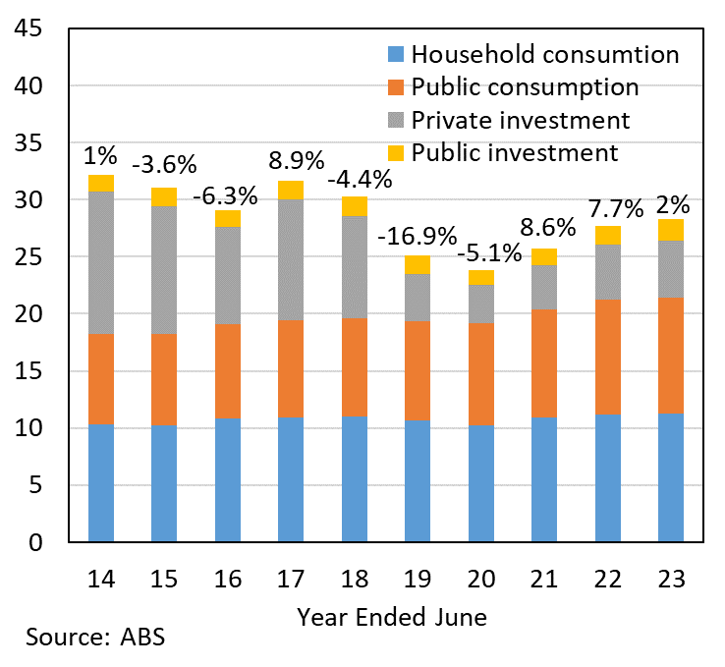 | Home Loan Affordability Indicator  Quarterly (indicator number)  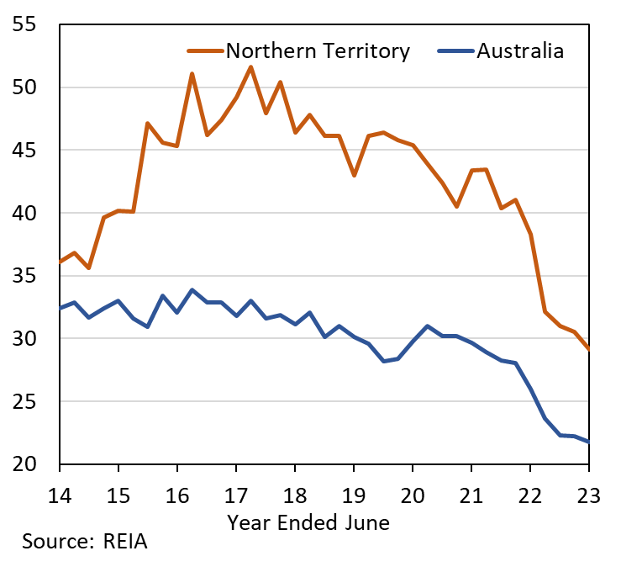
Chart 3: The drop in affordability is impacting housing finance for owner-occupiers and investors, and residential building approvals in the Territory are down by almost 5% in the year to July 2023. This is despite population growth returning to longer term trend, supported by net overseas migration. Weaker building approvals, declining affordability and increasing population will have longer term implications for residential property and rental markets, already reflected in prices, vacancy rates and rents. | Chart 4: The housing supply challenge is consistent across Australia, and is reflected in buoyant property prices, solid growth in rents and low rental vacancy rates. Vacancy rates have tightened since the onset of the COVID-19 pandemic, and as at July 2023 sit at 1% in Darwin and 1.3% nationally. Low vacancy rates are contributing to higher rents and rental yields for investors. Despite Darwin consistently having the highest rentail yields in the nation, investor interest (see Chart 3) is muted, affected by uncertainty regarding the interest rate environment.
Housing finance commitments (excl. refinancing)  Year-on-Year (% change) | Rental Yields  Houses, Monthly (%)
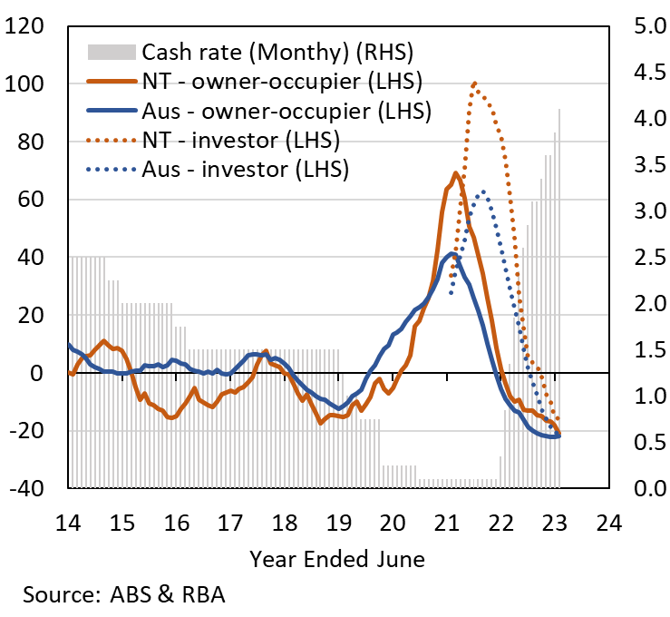 | 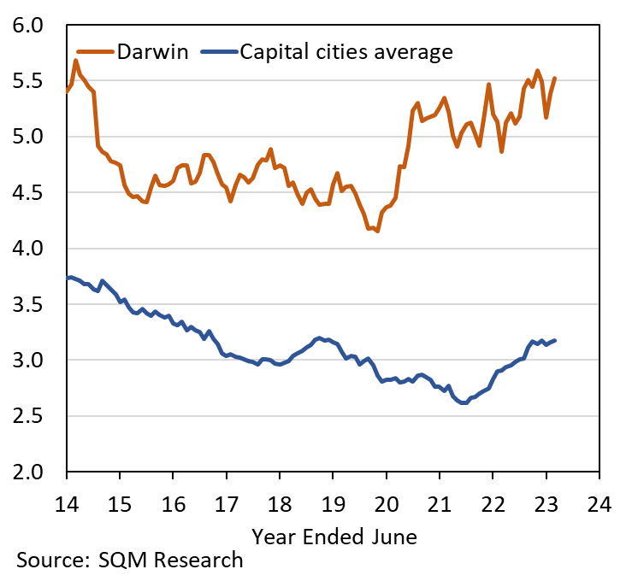

The Northern Territory of Australia exercised due care and skill to ensure that at the time of publication the information contained in this publication is true and correct. However, it is not intended to be relied on as professional advice or used for commercial purposes. The Territory gives no warranty or assurances as to the accuracy of the information contained in the publication and to the maximum extent permitted by law accepts no direct or indirect liability for reliance on its content.

