# Economic growth

See description below

* Economic growth GSP $26.1 billion
* NT forecasted growth rate:
  + 2022-23 is 3.7%
  + 2023-24 is -0.7%
  + 2024-25 is 4.3%
* National growth rate in 2021-22 is 3.6%

# Industry share of output top 5

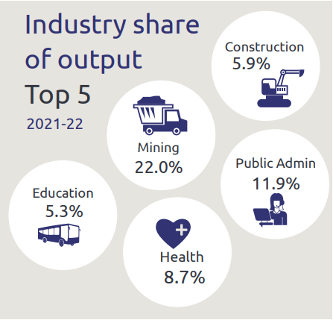

* Construction is 5.9%
* Mining is 22.0%
* Public admin is 11.9%
* Health is 8.7%
* Education is 5.3%

# State Final Demand

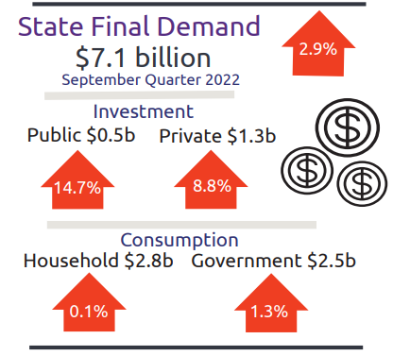

* State Final Demand, up 2.9% to $7.1 billion through the year to September 2022
  + Public investment, up 14.7% to $0.5 billion through the year to September 2022
  + Private business investment, up 8.8% to $1.3 billion through the year to September 2022
  + Household consumption, up 0.1% to $2.8 billion through the year to September 2022
  + Government consumption, up 1.3% to $2.5 billion through the year to September 2022

# Business confidence for the Northern Territory

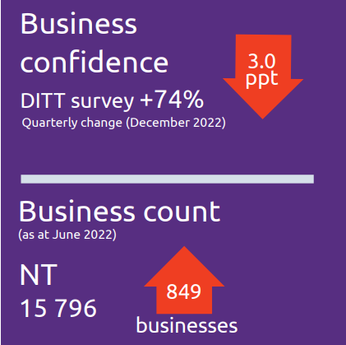

* Business confidence for the Northern Territory is +74% in the December 2022 quarter, down 3 percentage points from the previous quarter
* Business count as at June 2022 for the Northern Territory was 15 796 up 849 businesses over the year to June 2022

# Darwin inflation

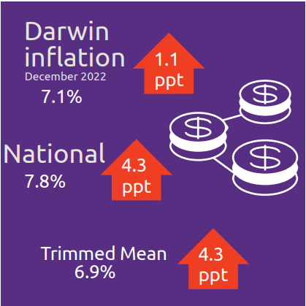

* Darwin inflation increased to 7.1% through the year to December 2022
* National inflation increased to 7.8%
* Trimmed mean increased to 6.9%

# Labour market

See description below

* Unemployment rate is 4.0% as of January 2023, up by 0.2 percentage points
* Employment is 142 503 up 6.1% through the year to January 2023
* Participation rate was 74.7% as of January 2023, up 2.3 percentage points through the year to January 2023

# NT population

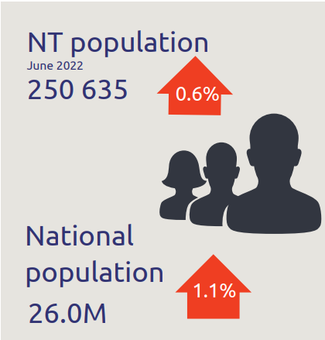

* NT population is 250 635, up 0.6% through the year to June 2022
* National population is 26.0 million, up 1.1% through the year to June 2022

# Population distribution

See description below

* Population distribution:
* Greater Darwin was 148801
* East Arnhem was 14520
* Katherine was 21145
* Alice Springs was 40693
* Barkly was 6020
* Daly-Tiwi-West Arnhem was 18021

# Average weekly earnings

See description below

* Average weekly earnings in the NT is $1844, up 3.1% through the year to November 2022
* Average weekly earnings nationally is $1877, up 3.6% through the year to November 2022
* WPI in the NT increased by 2.6% through the year to December 2022 and 3.4% nationally

# Median house prices

See description below

* Median house prices in the December quarter 2022:
* Katherine $425 000 up 23.2%
* Alice Springs $513 000 up 0.6%
* Tennant Creek $320 000 up 10.3%
* Greater Darwin $540 000 down 8.9%

# Business size

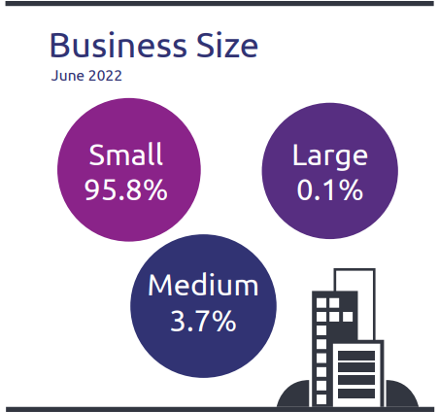

* NT business size:
  + Small is 95.8%
  + Medium is 3.7%
  + Large is 0.1%

# Business location

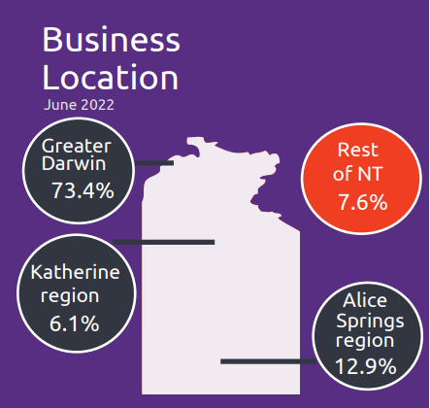

* Businesses by location:
* Greater Darwin has 73.4%
* Katherine has 6.1%
* Alice Springs has 12.9%
* Rest of NT has 7.6%

NT Department of Industry, Tourism and Trade  
t: 08 8999 5139  
industry.nt.gov.au