Mineral Titles Act 2010
NOTICE OF LAND CEASING TO BE A MINERAL TITLE AREA
Title Type and Number: | Exploration Licence 32698
Area Ceased on: | 20 October 2022
Area: | 15 Blocks, 47.58 km²
Locality: | NAPPERBY
Name of Applicant(s)/Holder(s): | 100% MIOXIDE NT PTY LTD [ACN. 636 686 747]
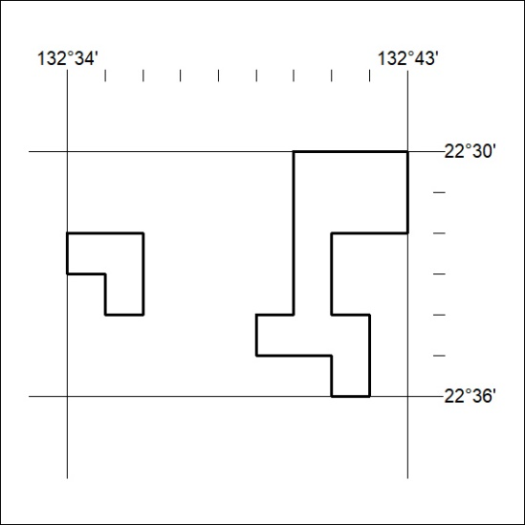

357/22

Mineral Titles Act 2010
NOTICE OF LAND CEASING TO BE A MINERAL TITLE AREA
Title Type and Number: | Extractive Mineral Exploration Licence 32259
Area Ceased on: | 21 October 2022
Area: | 6 Blocks, 6.76 km²
Locality: | KOOLPINYAH
Name of Applicant(s)/Holder(s): | 100% SAGE CONSTRUCTIONS PTY. LTD. [ACN. 009 654 648]
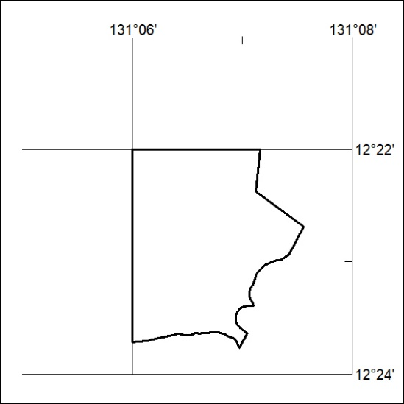

358/22
Mineral Titles Act 2010
NOTICE OF LAND CEASING TO BE A MINERAL TITLE AREA
Title Type and Number: | Extractive Mineral Exploration Licence 32260
Area Ceased on: | 21 October 2022
Area: | 2 Blocks, 2.51 km²
Locality: | KOOLPINYAH
Name of Applicant(s)/Holder(s): | 100% SAGE CONSTRUCTIONS PTY. LTD. [ACN. 009 654 648]
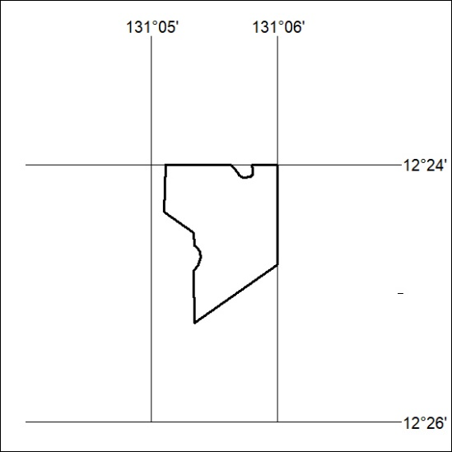

359/22

