Mineral Titles Act 2010
NOTICE OF LAND CEASING TO BE A MINERAL TITLE APPLICATION AREA
Title Type and Number: | Exploration Licence 33009
Area Ceased on: | 01 September 2022
Area: | 250 Blocks, 787.18 km²
Locality: | GOSSES BLUFF
Name of Applicant(s)/Holder(s): | 100% URO CORPORATION PTY LTD [ACN. 653 927 998]
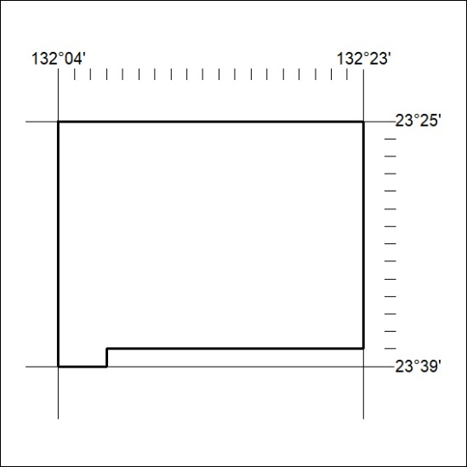

314/22

Mineral Titles Act
NOTICE OF GRANT OF A MINERAL TITLE
Title Type and Number: | Exploration Licence 32923
Granted: | 01 September 2022, for a period of 6 Years
Area: | 204 Blocks, 637.53 km²
Locality: | RODINGA
Name of Holder/s: | 100% ECOSTORAGE SOLUTIONS PTY LTD [ACN. 653 988 419]
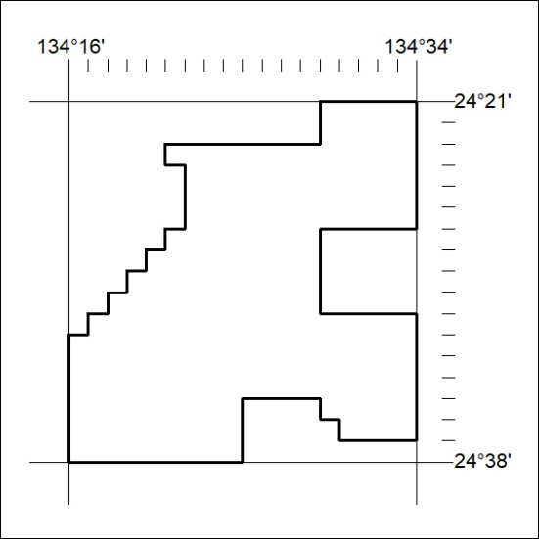
Area granted is indicated above. The titleholder is not permitted to exercise occupational rights on any land that is subject to a development title, or an application for a development title. Any land the subject of a Reserved Land gazettal under the Mineral Titles Act and all land vested in the Commonwealth of Australia is also excluded by description but not excised from the grant area.

315/22

Mineral Titles Act
NOTICE OF GRANT OF A MINERAL TITLE
Title Type and Number: | Exploration Licence 32932
Granted: | 01 September 2022, for a period of 6 Years
Area: | 56 Blocks, 148.51 km²
Locality: | PILLAR RANGE
Name of Holder/s: | 100% ECOSTORAGE SOLUTIONS PTY LTD [ACN. 653 988 419]
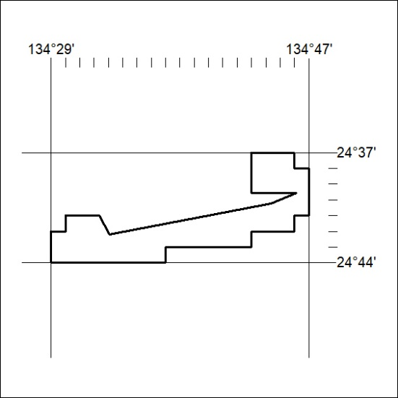
Area granted is indicated above. The titleholder is not permitted to exercise occupational rights on any land that is subject to a development title, or an application for a development title. Any land the subject of a Reserved Land gazettal under the Mineral Titles Act and all land vested in the Commonwealth of Australia is also excluded by description but not excised from the grant area.
316/22

Mineral Titles Act
NOTICE OF GRANT OF A MINERAL TITLE
Title Type and Number: | Exploration Licence 32935
Granted: | 01 September 2022, for a period of 6 Years
Area: | 193 Blocks, 588.69 km²
Locality: | TODD
Name of Holder/s: | 100% ECOSTORAGE SOLUTIONS PTY LTD [ACN. 653 988 419]
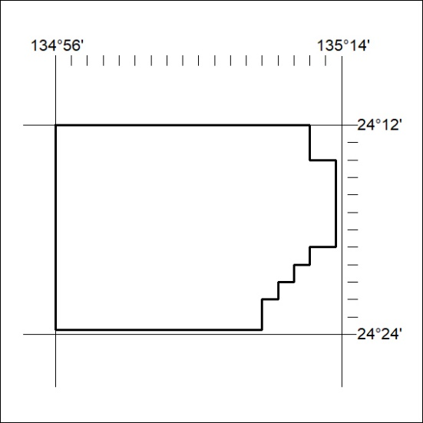
Area granted is indicated above. The titleholder is not permitted to exercise occupational rights on any land that is subject to a development title, or an application for a development title. Any land the subject of a Reserved Land gazettal under the Mineral Titles Act and all land vested in the Commonwealth of Australia is also excluded by description but not excised from the grant area.
316/22

