Mineral Titles Act 2010
NOTICE OF LAND CEASING TO BE A MINERAL TITLE AREA
Title Type and Number: | Exploration Licence 32349
Area Ceased on: | 17 August 2022
Area: | 60 Blocks, 182.53 km²
Locality: | ILLOGWA
Name of Applicant(s)/Holder(s): | 100% GEMPART (NT) PTY LTD* [ACN. 081 859 896]
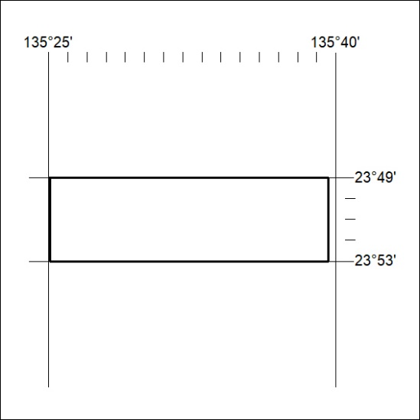

286/22

