Mineral Titles Act
NOTICE OF GRANT OF A MINERAL TITLE
Title Type and Number: | Exploration Licence 32808
Granted: | 28 June 2022, for a period of 6 Years
Area: | 8 Blocks, 25.89 km²
Locality: | WONARAH
Name of Holder/s: | 90% INCA MINERALS LIMITED [ACN. 128 512 907], 5% MRG RESOURCES PTY LTD [ACN. 614 946 164], 5% WEST Jonathan
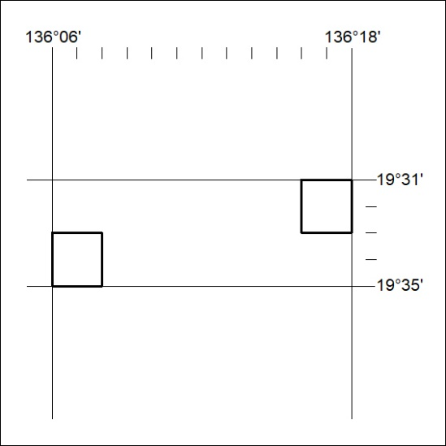
Area granted is indicated above. The titleholder is not permitted to exercise occupational rights on any land that is subject to a development title, or an application for a development title. Any land the subject of a Reserved Land gazettal under the Mineral Titles Act and all land vested in the Commonwealth of Australia is also excluded by description but not excised from the grant area.
214/22

Mineral Titles Act 2010
NOTICE OF LAND CEASING TO BE A MINERAL TITLE APPLICATION AREA
Title Type and Number: | Extractive Mineral Permit 31436
Area ceased on: | 28 June 2022
Area: | 38.00 Hectare
Locality: | NEWRY
Name of Applicants(s)Holder(s): | 100% DUNCAN Ruth Ann
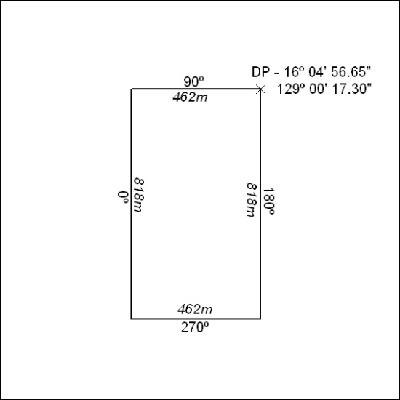

215/22

Mineral Titles Act 2010
NOTICE OF LAND CEASING TO BE A MINERAL TITLE APPLICATION AREA
Title Type and Number: | Extractive Mineral Permit 31470
Area ceased on: | 28 June 2022
Area: | 87.00 Hectare
Locality: | KEEP
Name of Applicants(s)Holder(s): | 100% DUNCAN Ruth Ann
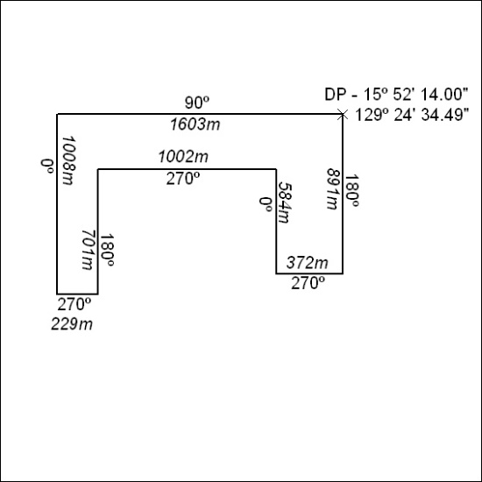

216/22

Mineral Titles Act 2010
NOTICE OF LAND CEASING TO BE A MINERAL TITLE APPLICATION AREA
Title Type and Number: | Extractive Mineral Permit 31979
Area ceased on: | 28 June 2022
Area: | 31.00 Hectare
Locality: | KILDURK
Name of Applicants(s)Holder(s): | 100% DUNCAN Ruth Ann
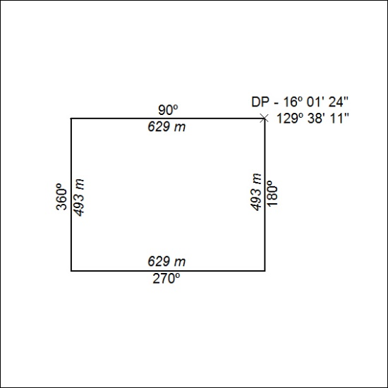

217/22

