Mineral Titles Act 2010
NOTICE OF LAND CEASING TO BE A MINERAL TITLE AREA
Title Type and Number: | Exploration Licence 31698
Area Ceased on: | 09 May 2022
Area: | 20 Blocks, 65.96 km²
Locality: | VICTORIA RIVER DOWNS
Name of Applicant(s)/Holder(s): | 100% ALBIAN RESOURCES PTY LTD [ACN. 629 786 161]
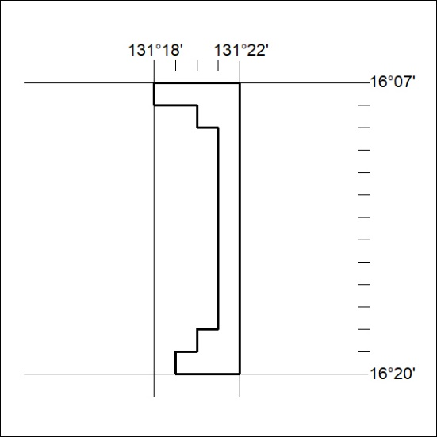

158/22

Mineral Titles Act 2010
NOTICE OF LAND CEASING TO BE A MINERAL TITLE AREA
Title Type and Number: | Exploration Licence 31704
Area Ceased on: | 07 May 2022
Area: | 17 Blocks, 55.77 km²
Locality: | KILGOUR
Name of Applicant(s)/Holder(s): | 100% TODD RIVER METALS PTY LTD [ACN. 600 314 038]
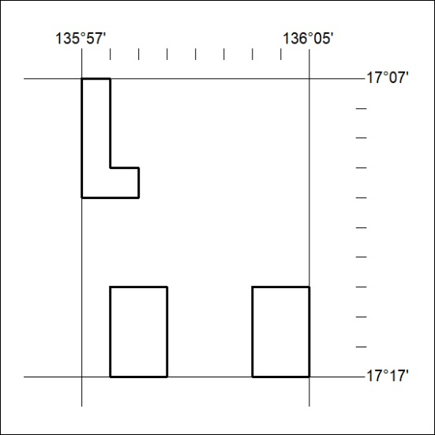

159/22

Mineral Titles Act
NOTICE OF GRANT OF A MINERAL TITLE
Title Type and Number: | Exploration Licence 32883
Granted: | 09 May 2022, for a period of 6 Years
Area: | 250 Blocks, 815.75 km²
Locality: | BOXER
Name of Holder/s: | 100% CEDAR RESOURCES PTY LTD [ACN. 612 086 932]
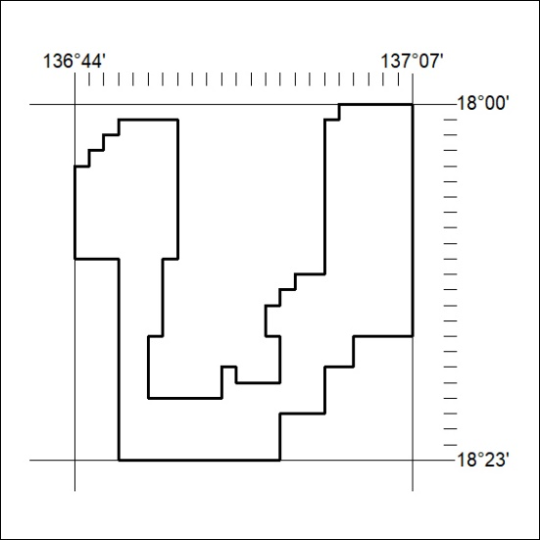
Area granted is indicated above. The titleholder is not permitted to exercise occupational rights on any land that is subject to a development title, or an application for a development title. Any land the subject of a Reserved Land gazettal under the Mineral Titles Act and all land vested in the Commonwealth of Australia is also excluded by description but not excised from the grant area.
160/22

Mineral Titles Act
NOTICE OF GRANT OF A MINERAL TITLE
Title Type and Number: | Exploration Licence 32924
Granted: | 09 May 2022, for a period of 6 Years
Area: | 2 Blocks, 6.68 km²
Locality: | PINE CREEK
Name of Holder/s: | 100% TM GOLD PTY LTD [ACN. 143 126 710]
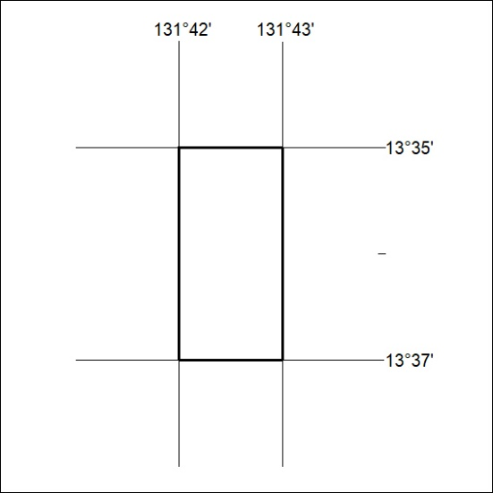
Area granted is indicated above. The titleholder is not permitted to exercise occupational rights on any land that is subject to a development title, or an application for a development title. Any land the subject of a Reserved Land gazettal under the Mineral Titles Act and all land vested in the Commonwealth of Australia is also excluded by description but not excised from the grant area.
161/22

