Mineral Titles Act 2010
NOTICE OF LAND CEASING TO BE A MINERAL TITLE AREA
Title Type and Number: | Exploration Licence 23523
Area Ceased on: | 15 November 2021
Area: | 120 Blocks, 389.87 km²
Locality: | WARE
Name of Applicant(s)/Holder(s): | 100% PRODIGY GOLD NL* [ACN. 009 127 020]
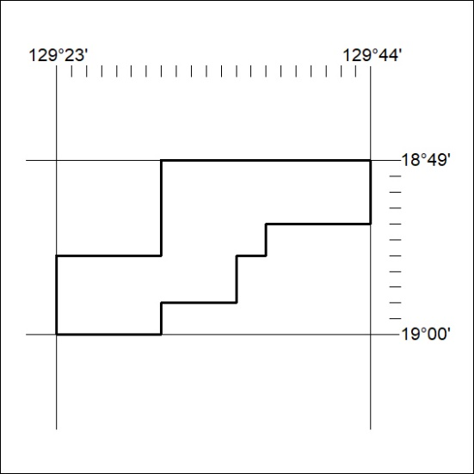

425/21

Mineral Titles Act 2010
NOTICE OF LAND CEASING TO BE A MINERAL TITLE AREA
Title Type and Number: | Exploration Licence 32115
Area Ceased on: | 14 November 2021
Area: | 25 Blocks, 82.22 km²
Locality: | MALLAPUNYAH
Name of Applicant(s)/Holder(s): | 100% SCRIVEN EXPLORATION PTY LTD [ACN. 006 264 615]
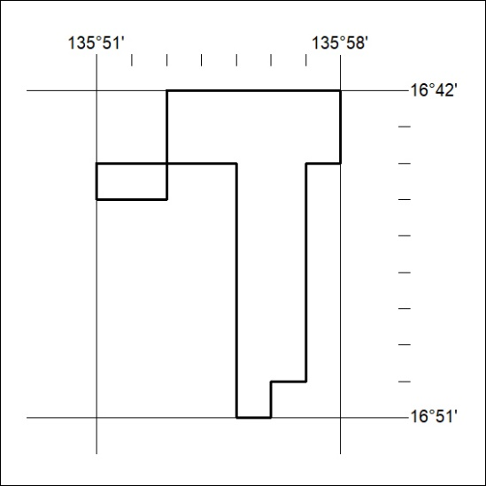

426/21

