Mineral Titles Act
NOTICE OF GRANT OF A MINERAL TITLE
Title Type and Number: | Exploration Licence 32716
Granted: | 11 November 2021, for a period of 6 Years
Area: | 242 Blocks, 741.97 km²
Locality: | UMBEARA
Name of Holder/s: | 100% TRI-STAR ENERGY COMPANY [ACN. 089 539 695]
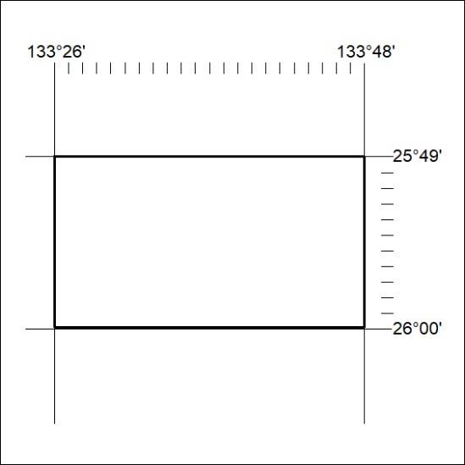
Area granted is indicated above. The titleholder is not permitted to exercise occupational rights on any land that is subject to a development title, or an application for a development title. Any land the subject of a Reserved Land gazettal under the Mineral Titles Act and all land vested in the Commonwealth of Australia is also excluded by description but not excised from the grant area.
421/21

Mineral Titles Act
NOTICE OF GRANT OF A MINERAL TITLE
Title Type and Number: | Exploration Licence 32717
Granted: | 11 November 2021, for a period of 6 Years
Area: | 174 Blocks, 537.82 km²
Locality: | KULGERA
Name of Holder/s: | 100% TRI-STAR ENERGY COMPANY [ACN. 089 539 695]
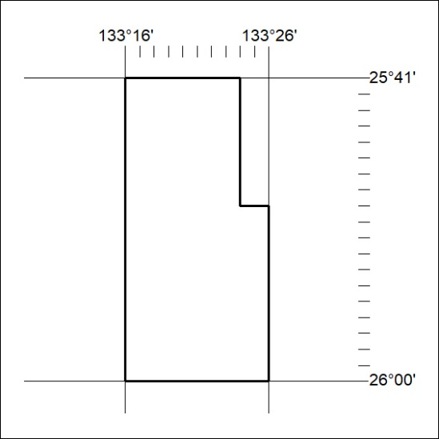
Area granted is indicated above. The titleholder is not permitted to exercise occupational rights on any land that is subject to a development title, or an application for a development title. Any land the subject of a Reserved Land gazettal under the Mineral Titles Act and all land vested in the Commonwealth of Australia is also excluded by description but not excised from the grant area.
422/21

Mineral Titles Act
NOTICE OF GRANT OF A MINERAL TITLE
Title Type and Number: | Exploration Licence 32718
Granted: | 11 November 2021, for a period of 6 Years
Area: | 172 Blocks, 531.51 km²
Locality: | KULGERA
Name of Holder/s: | 100% TRI-STAR ENERGY COMPANY [ACN. 089 539 695]
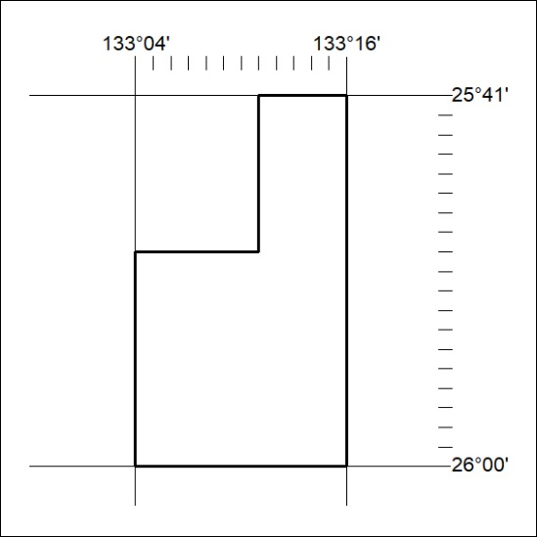
Area granted is indicated above. The titleholder is not permitted to exercise occupational rights on any land that is subject to a development title, or an application for a development title. Any land the subject of a Reserved Land gazettal under the Mineral Titles Act and all land vested in the Commonwealth of Australia is also excluded by description but not excised from the grant area.
423/21

Mineral Titles Act
NOTICE OF GRANT OF A MINERAL TITLE
Title Type and Number: | Exploration Licence 32719
Granted: | 11 November 2021, for a period of 6 Years
Area: | 242 Blocks, 747.62 km²
Locality: | VICTORY
Name of Holder/s: | 100% TRI-STAR ENERGY COMPANY [ACN. 089 539 695]
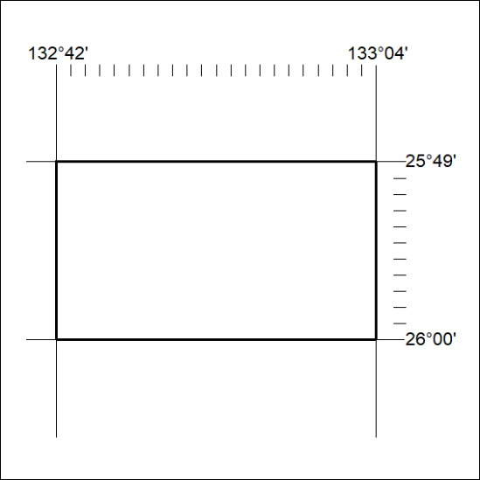
Area granted is indicated above. The titleholder is not permitted to exercise occupational rights on any land that is subject to a development title, or an application for a development title. Any land the subject of a Reserved Land gazettal under the Mineral Titles Act and all land vested in the Commonwealth of Australia is also excluded by description but not excised from the grant area.
424/21

