Mineral Titles Act 2010
NOTICE OF LAND CEASING TO BE A MINERAL TITLE AREA
Title Type and Number: | Extractive Mineral Permit 24775
Area ceased on: | 16 September 2021
Area: | 17.00 Hectare
Locality: | NOONAMAH
Name of Applicants(s)Holder(s): | 100% OSTOJIC GROUP PTY LTD* [ACN. 009 629 805]
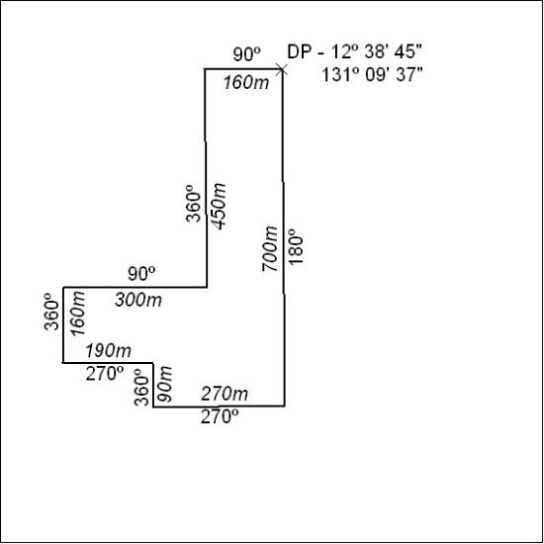

351/21

Mineral Titles Act
NOTICE OF GRANT OF A MINERAL TITLE
Title Type and Number: | Exploration Licence 32229
Granted: | 15 September 2021, for a period of 6 Years
Area: | 70 Blocks, 228.45 km²
Locality: | BOXER
Name of Holder/s: | 100% CEDAR RESOURCES PTY LTD [ACN. 612 086 932]
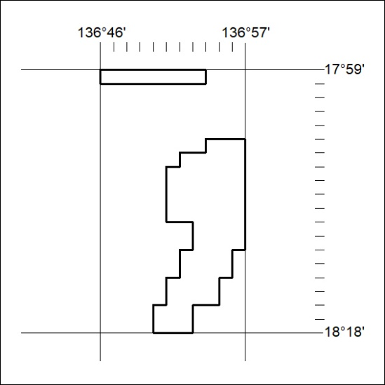
Area granted is indicated above. The titleholder is not permitted to exercise occupational rights on any land that is subject to a development title, or an application for a development title. Any land the subject of a Reserved Land gazettal under the Mineral Titles Act and all land vested in the Commonwealth of Australia is also excluded by description but not excised from the grant area.

352/21

Mineral Titles Act
NOTICE OF GRANT OF A MINERAL TITLE
Title Type and Number: | Exploration Licence 32665
Granted: | 14 September 2021, for a period of 6 Years
Area: | 65 Blocks, 207.21 km²
Locality: | HANLON
Name of Holder/s: | 100% KAILI GOLD PTY LTD [ACN. 608 163 202]
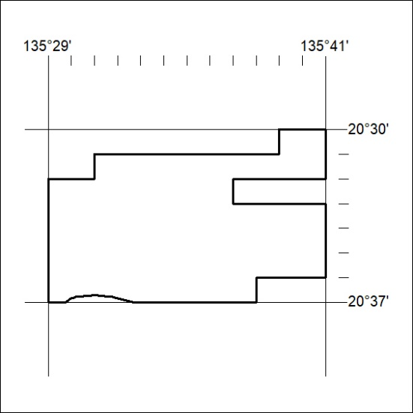
Area granted is indicated above. The titleholder is not permitted to exercise occupational rights on any land that is subject to a development title, or an application for a development title. Any land the subject of a Reserved Land gazettal under the Mineral Titles Act and all land vested in the Commonwealth of Australia is also excluded by description but not excised from the grant area.

353/21

