Mineral Titles Act 2010
NOTICE OF LAND CEASING TO BE A MINERAL TITLE APPLICATION AREA
Title Type and Number: | Exploration Licence 26088
Area Ceased on: | 16 August 2021
Area: | 6 Blocks, 6.72 km²
Locality: | HOWSHIP
Name of Applicant(s)/Holder(s): | 98% VIVA RESOURCES PTY LTD [ACN. 120 165 139], 2% WEST ARNHEM CORPORATION PTY LTD [ACN. 070 561 965]
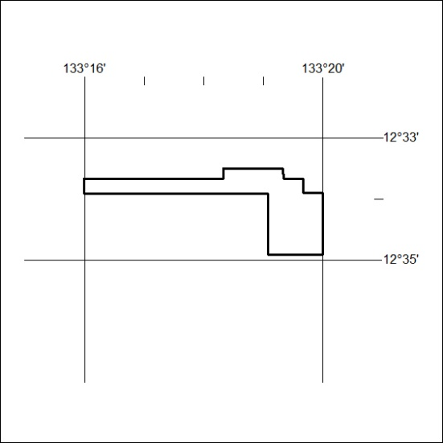

311/21

Mineral Titles Act 2010
NOTICE OF LAND CEASING TO BE A MINERAL TITLE APPLICATION AREA
Title Type and Number: | Exploration Licence 26090
Area Ceased on: | 16 August 2021
Area: | 3 Blocks, 8.10 km²
Locality: | OENPELLI
Name of Applicant(s)/Holder(s): | 98% VIVA RESOURCES PTY LTD [ACN. 120 165 139], 2% WEST ARNHEM CORPORATION PTY LTD [ACN. 070 561 965]
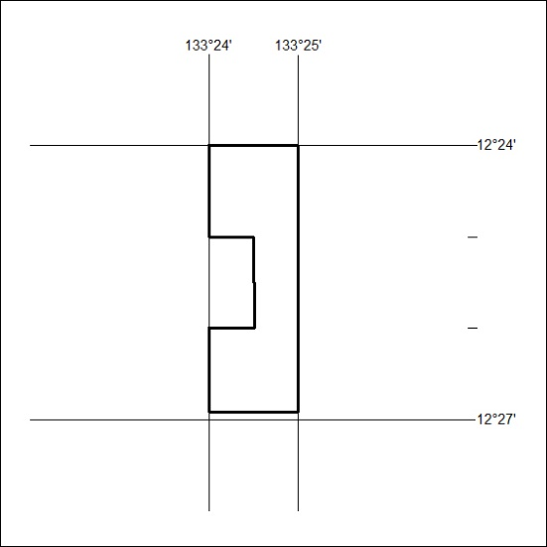

312/21
Mineral Titles Act 2010
NOTICE OF LAND CEASING TO BE A MINERAL TITLE APPLICATION AREA
Title Type and Number: | Exploration Licence 31438
Area Ceased on: | 16 August 2021
Area: | 1 Block, 3.35 km²
Locality: | HOWSHIP
Name of Applicant(s)/Holder(s): | 98% VIVA RESOURCES PTY LTD [ACN. 120 165 139], 2% WEST ARNHEM CORPORATION PTY LTD [ACN. 070 561 965]
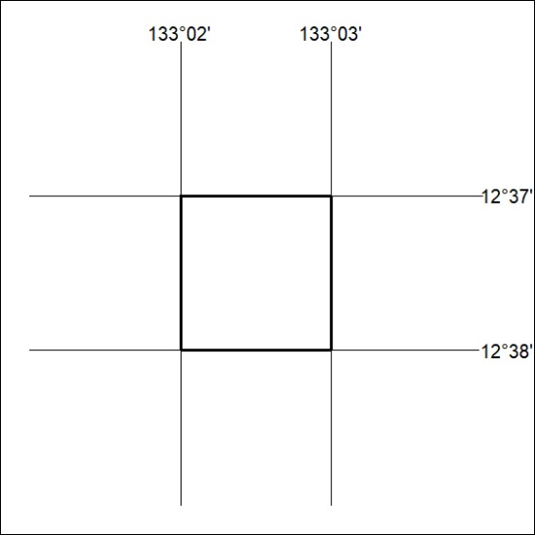

313/21

Mineral Titles Act 2010
NOTICE OF LAND CEASING TO BE A MINERAL TITLE APPLICATION AREA
Title Type and Number: | Exploration Licence 31439
Area Ceased on: | 16 August 2021
Area: | 8 Blocks, 21.12 km²
Locality: | HOWSHIP
Name of Applicant(s)/Holder(s): | 98% VIVA RESOURCES PTY LTD [ACN. 120 165 139], 2% WEST ARNHEM CORPORATION PTY LTD [ACN. 070 561 965]
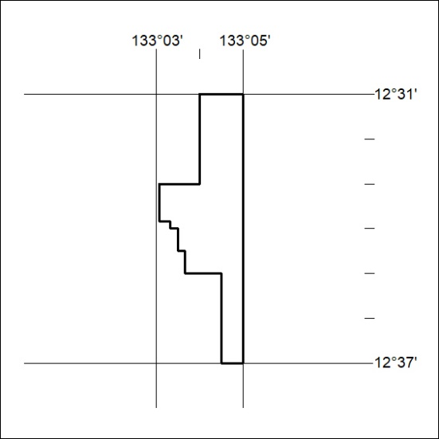

314/21

Mineral Titles Act
NOTICE OF GRANT OF A MINERAL TITLE
Title Type and Number: | Exploration Licence 32620
Granted: | 16 August 2021, for a period of 6 Years
Area: | 47 Blocks, 135.07 km²
Locality: | MITCHIEBO
Name of Holder/s: | 100% CIENTIFICA PTY LTD [ACN. 645 504 178]
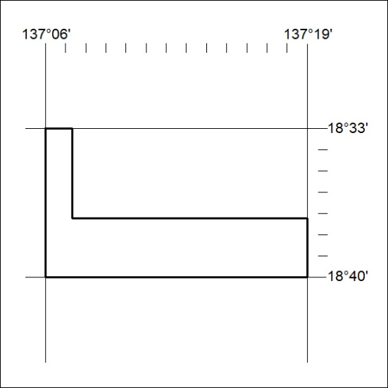
Area granted is indicated above. The titleholder is not permitted to exercise occupational rights on any land that is subject to a development title, or an application for a development title. Any land the subject of a Reserved Land gazettal under the Mineral Titles Act and all land vested in the Commonwealth of Australia is also excluded by description but not excised from the grant area.
315/21

Mineral Titles Act
NOTICE OF GRANT OF A MINERAL TITLE
Title Type and Number: | Exploration Licence 32622
Granted: | 16 August 2021, for a period of 6 Years
Area: | 63 Blocks, 196.80 km²
Locality: | CARRARA
Name of Holder/s: | 100% CIENTIFICA PTY LTD [ACN. 645 504 178]
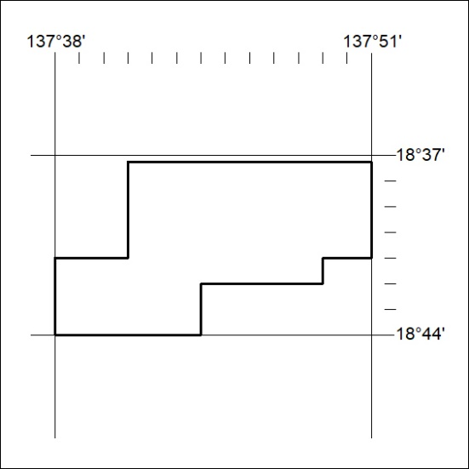
Area granted is indicated above. The titleholder is not permitted to exercise occupational rights on any land that is subject to a development title, or an application for a development title. Any land the subject of a Reserved Land gazettal under the Mineral Titles Act and all land vested in the Commonwealth of Australia is also excluded by description but not excised from the grant area.
316/21

Mineral Titles Act
NOTICE OF GRANT OF A MINERAL TITLE
Title Type and Number: | Exploration Licence 32632
Granted: | 18 August 2021, for a period of 6 Years
Area: | 221 Blocks, 667.73 km²
Locality: | MT BARRINGTON
Name of Holder/s: | 100% PLUTONIC LIMITED [ACN. 632 991 167]
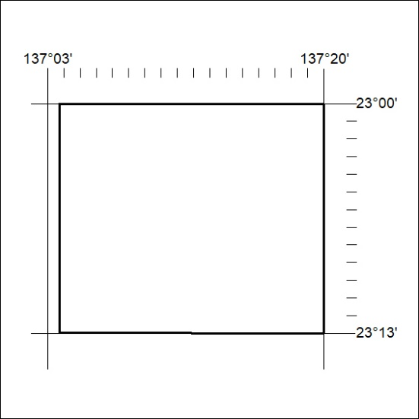
Area granted is indicated above. The titleholder is not permitted to exercise occupational rights on any land that is subject to a development title, or an application for a development title. Any land the subject of a Reserved Land gazettal under the Mineral Titles Act and all land vested in the Commonwealth of Australia is also excluded by description but not excised from the grant area.
317/21

Mineral Titles Act
NOTICE OF GRANT OF A MINERAL TITLE
Title Type and Number: | Exploration Licence 32633
Granted: | 18 August 2021, for a period of 6 Years
Area: | 221 Blocks, 697.77 km²
Locality: | MT BARRINGTON
Name of Holder/s: | 100% PLUTONIC LIMITED [ACN. 632 991 167]
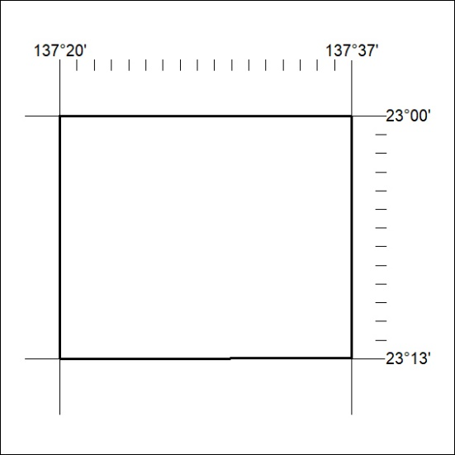
Area granted is indicated above. The titleholder is not permitted to exercise occupational rights on any land that is subject to a development title, or an application for a development title. Any land the subject of a Reserved Land gazettal under the Mineral Titles Act and all land vested in the Commonwealth of Australia is also excluded by description but not excised from the grant area.

318/21

Mineral Titles Act
NOTICE OF GRANT OF A MINERAL TITLE
Title Type and Number: | Exploration Licence 32637
Granted: | 18 August 2021, for a period of 6 Years
Area: | 92 Blocks, 289.47 km²
Locality: | ADAM
Name of Holder/s: | 100% PLUTONIC LIMITED [ACN. 632 991 167]
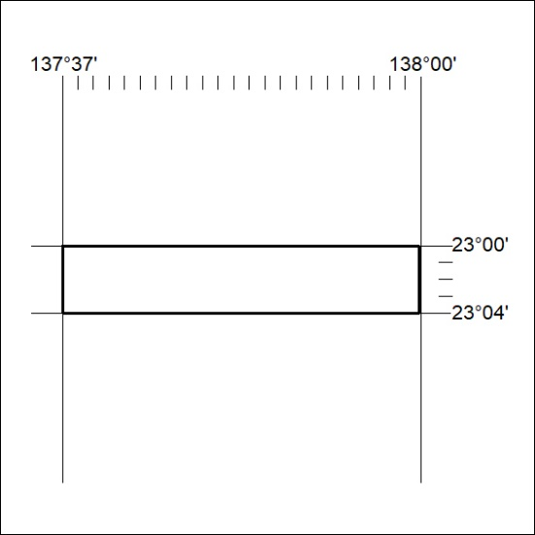
Area granted is indicated above. The titleholder is not permitted to exercise occupational rights on any land that is subject to a development title, or an application for a development title. Any land the subject of a Reserved Land gazettal under the Mineral Titles Act and all land vested in the Commonwealth of Australia is also excluded by description but not excised from the grant area.
319/21

