Mineral Titles Act 2010
NOTICE OF LAND CEASING TO BE A MINERAL TITLE APPLICATION AREA
Title Type and Number: | Mineral Lease 30013
Area ceased on: | 16 April 2021
Area: | 10.00 Hectare
Locality: | McKINLAY RIVER
Name of Applicants(s)Holder(s): | 100% EGGLESTON Arthur Ernest
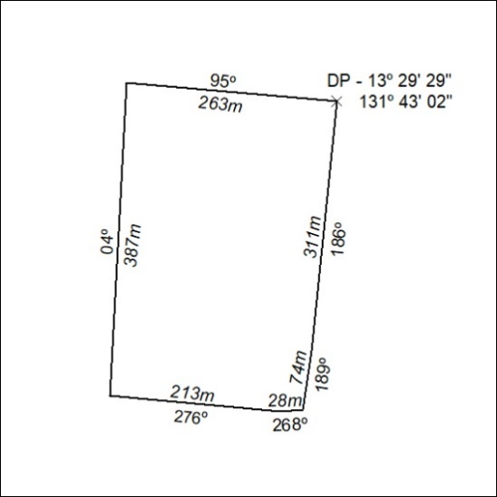
92/21

Mineral Titles Act
NOTICE OF GRANT OF A MINERAL TITLE
Title Type and Number: | Exploration Licence 32439
Granted: | 16 April 2021, for a period of 6 Years
Area: | 20 Blocks, 66.82 km²
Locality: | McKINLAY RIVER
Name of Holder/s: | 100% GMG MINING (NT) PTY LTD [ACN. 634 618 410]
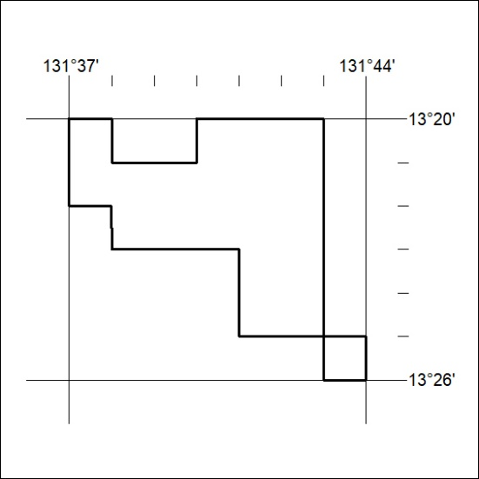
Area granted is indicated above. The titleholder is not permitted to exercise occupational rights on any land that is subject to a development title, or an application for a development title. Any land the subject of a Reserved Land gazettal under the Mineral Titles Act and all land vested in the Commonwealth of Australia is also excluded by description but not excised from the grant area.
93/21

Mineral Titles Act
NOTICE OF GRANT OF A MINERAL TITLE
Title Type and Number: | Exploration Licence 32440
Granted: | 16 April 2021, for a period of 6 Years
Area: | 34 Blocks, 94.63 km²
Locality: | McKINLAY RIVER
Name of Holder/s: | 100% GMG MINING (NT) PTY LTD [ACN. 634 618 410]
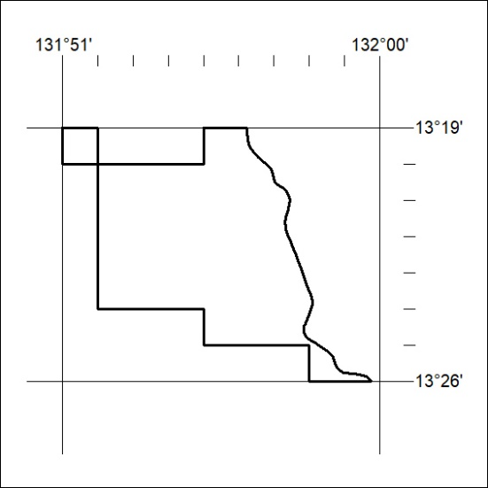
Area granted is indicated above. The titleholder is not permitted to exercise occupational rights on any land that is subject to a development title, or an application for a development title. Any land the subject of a Reserved Land gazettal under the Mineral Titles Act and all land vested in the Commonwealth of Australia is also excluded by description but not excised from the grant area.
94/21

Mineral Titles Act
NOTICE OF GRANT OF A MINERAL TITLE
Title Type and Number: | Exploration Licence 32441
Granted: | 16 April 2021, for a period of 6 Years
Area: | 31 Blocks, 103.71 km²
Locality: | McKINLAY RIVER
Name of Holder/s: | 100% GMG MINING (NT) PTY LTD [ACN. 634 618 410]
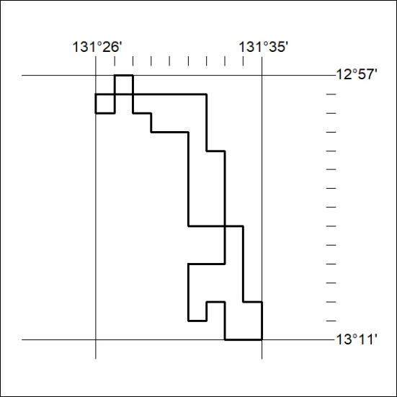
Area granted is indicated above. The titleholder is not permitted to exercise occupational rights on any land that is subject to a development title, or an application for a development title. Any land the subject of a Reserved Land gazettal under the Mineral Titles Act and all land vested in the Commonwealth of Australia is also excluded by description but not excised from the grant area.
95/21

Mineral Titles Act
NOTICE OF GRANT OF A MINERAL TITLE
Title Type and Number: | Exploration Licence 32485
Granted: | 16 April 2021, for a period of 6 Years
Area: | 215 Blocks, 678.49 km²
Locality: | JERVOIS RANGE
Name of Holder/s: | 90% INCA MINERALS LIMITED [ACN. 128 512 907], 10% MRG RESOURCES PTY LTD [ACN. 614 946 164]
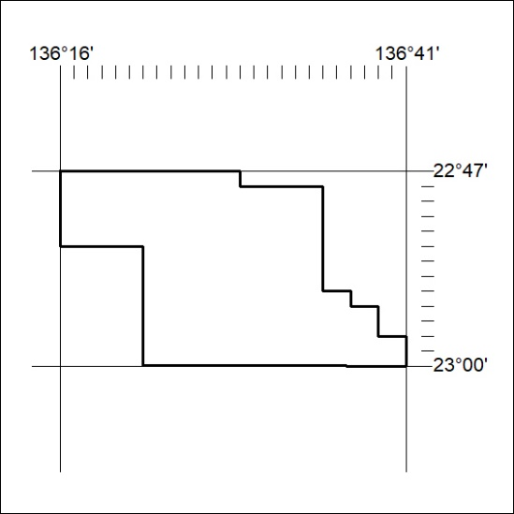
Area granted is indicated above. The titleholder is not permitted to exercise occupational rights on any land that is subject to a development title, or an application for a development title. Any land the subject of a Reserved Land gazettal under the Mineral Titles Act and all land vested in the Commonwealth of Australia is also excluded by description but not excised from the grant area.
96/21

Mineral Titles Act
NOTICE OF GRANT OF A MINERAL TITLE
Title Type and Number: | Exploration Licence 32486
Granted: | 16 April 2021, for a period of 6 Years
Area: | 250 Blocks, 790.60 km²
Locality: | TARLTON
Name of Holder/s: | 90% INCA MINERALS LIMITED [ACN. 128 512 907], 10% MRG RESOURCES PTY LTD [ACN. 614 946 164]
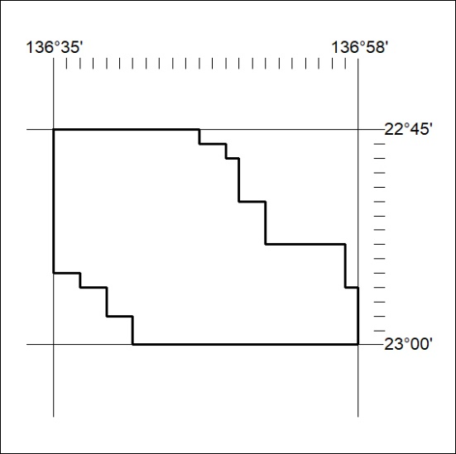
Area granted is indicated above. The titleholder is not permitted to exercise occupational rights on any land that is subject to a development title, or an application for a development title. Any land the subject of a Reserved Land gazettal under the Mineral Titles Act and all land vested in the Commonwealth of Australia is also excluded by description but not excised from the grant area.
97/21

