Mineral Titles Act 2010
NOTICE OF LAND CEASING TO BE A MINERAL TITLE AREA
Title Type and Number: | Exploration Licence 23862
Area Ceased on: | 06 April 2021
Area: | 39 Blocks, 131.33 km²
Locality: | SNAKE BAY
Name of Applicant(s)/Holder(s): | 100% TIWI RESOURCES PTY LTD [ACN. 054 667 051]
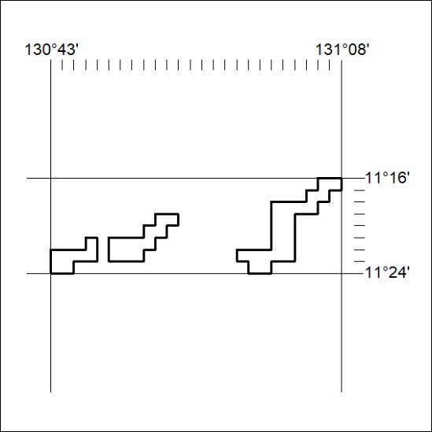
72/21

Mineral Titles Act 2010
NOTICE OF LAND CEASING TO BE A MINERAL TITLE AREA
Title Type and Number: | Mineral Lease 24510
Area ceased on: | 06 April 2021
Area: | 822.00 Hectares
Locality: | SNAKE BAY
Name of Applicants(s)Holder(s): | 100% TIWI RESOURCES PTY LTD [ACN. 054 667 051]
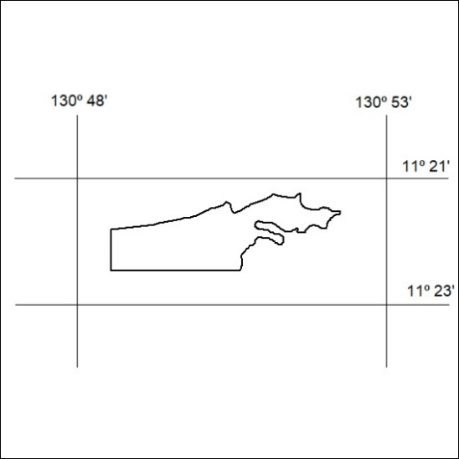
73/21

Mineral Titles Act 2010
NOTICE OF LAND CEASING TO BE A MINERAL TITLE AREA
Title Type and Number: | Mineral Lease 24511
Area ceased on: | 06 April 2021
Area: | 909.00 Hectares
Locality: | JAHLEEL
Name of Applicants(s)Holder(s): | 100% TIWI RESOURCES PTY LTD [ACN. 054 667 051]
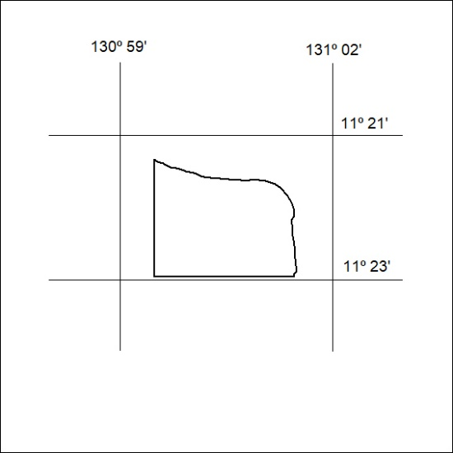
74/21

Mineral Titles Act
NOTICE OF GRANT OF A MINERAL TITLE
Title Type and Number: | Exploration Licence 32361
Granted: | 01 April 2021, for a period of 6 Years
Area: | 40 Blocks, 126.32 km²
Locality: | LAUGHLEN
Name of Holder/s: | 100% TERRITORY EXPLORATION PTY LTD [ACN. 123 338 376]
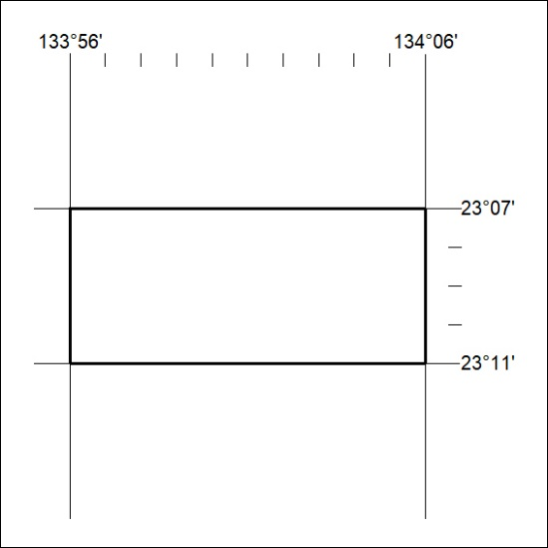
Area granted is indicated above. The titleholder is not permitted to exercise occupational rights on any land that is subject to a development title, or an application for a development title. Any land the subject of a Reserved Land gazettal under the Mineral Titles Act and all land vested in the Commonwealth of Australia is also excluded by description but not excised from the grant area.
75/21

Mineral Titles Act
NOTICE OF GRANT OF A MINERAL TITLE
Title Type and Number: | Exploration Licence 32433
Granted: | 01 April 2021, for a period of 6 Years
Area: | 246 Blocks, 810.36 km²
Locality: | MIDDLE CREEK
Name of Holder/s: | 100% ENIGMA MINING LIMITED [ACN. 009 225 558]
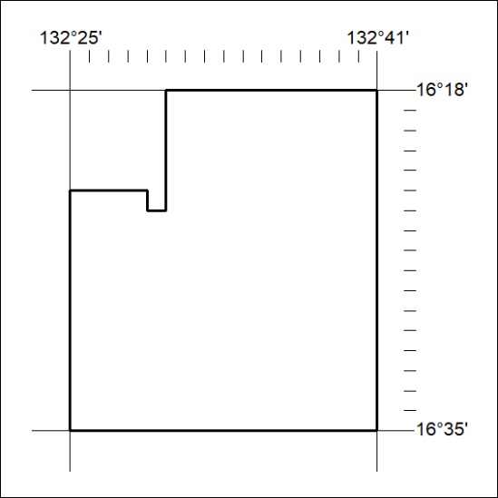
Area granted is indicated above. The titleholder is not permitted to exercise occupational rights on any land that is subject to a development title, or an application for a development title. Any land the subject of a Reserved Land gazettal under the Mineral Titles Act and all land vested in the Commonwealth of Australia is also excluded by description but not excised from the grant area.
76/21

Mineral Titles Act
NOTICE OF GRANT OF A MINERAL TITLE
Title Type and Number: | Exploration Licence 32434
Granted: | 01 April 2021, for a period of 6 Years
Area: | 238 Blocks, 783.99 km²
Locality: | MIDDLE CREEK
Name of Holder/s: | 100% ENIGMA MINING LIMITED [ACN. 009 225 558]
Area granted is indicated above. The titleholder is not permitted to exercise occupational rights on any land that is subject to a development title, or an application for a development title. Any land the subject of a Reserved Land gazettal under the Mineral Titles Act and all land vested in the Commonwealth of Australia is also excluded by description but not excised from the grant area.
77/21

