Mineral Titles Act
NOTICE OF GRANT OF A MINERAL TITLE
Title Type and Number: | Exploration Licence 32392
Granted: | 18 March 2021, for a period of 6 Years
Area: | 125 Blocks, 390.94 km²
Locality: | TAYLOR
Name of Holder/s: | 100% LITHIUM DEVELOPMENTS PTY LTD [ACN. 612 245 020]
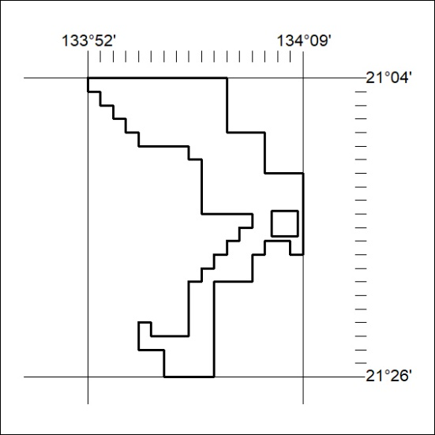
Area granted is indicated above. The titleholder is not permitted to exercise occupational rights on any land that is subject to a development title, or an application for a development title. Any land the subject of a Reserved Land gazettal under the Mineral Titles Act and all land vested in the Commonwealth of Australia is also excluded by description but not excised from the grant area.
51/21

Mineral Titles Act
NOTICE OF GRANT OF A MINERAL TITLE
Title Type and Number: | Exploration Licence 32396
Granted: | 18 March 2021, for a period of 6 Years
Area: | 240 Blocks, 767.05 km²
Locality: | CONICAL HILL
Name of Holder/s: | 100% LITHIUM DEVELOPMENTS PTY LTD [ACN. 612 245 020]
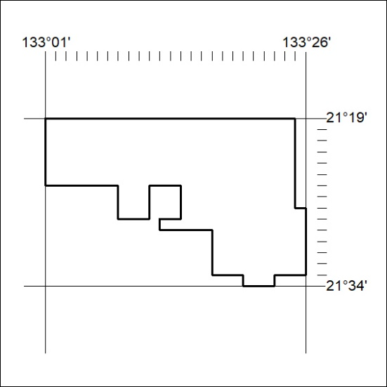
Area granted is indicated above. The titleholder is not permitted to exercise occupational rights on any land that is subject to a development title, or an application for a development title. Any land the subject of a Reserved Land gazettal under the Mineral Titles Act and all land vested in the Commonwealth of Australia is also excluded by description but not excised from the grant area.
52/21

Mineral Titles Act
NOTICE OF GRANT OF A MINERAL TITLE
Title Type and Number: | Mineral Lease 32278
Granted: | 18 March 2021, for a period of 25 Years
Area: | 27.80 Hectares
Locality: | BYNOE
Name of Holder/s: | 100% LITHIUM DEVELOPMENTS (GRANTS NT) PTY LTD [ACN. 622 047 232]
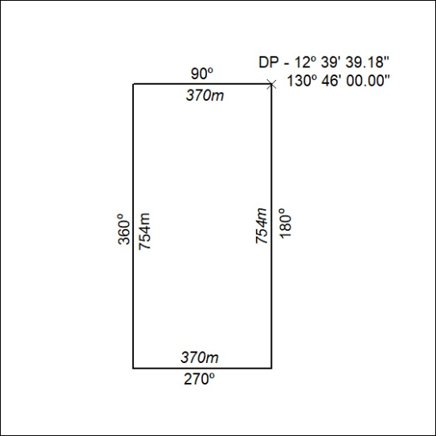

53/21

