Mineral Titles Act 2010
NOTICE OF LAND CEASING TO BE A MINERAL TITLE AREA
Title Type and Number: | Exploration Licence 28083
Area Ceased on: | 31 January 2021
Area: | 3 Blocks, 9.53 km²
Locality: | REYNOLDS RANGE
Name of Applicant(s)/Holder(s): | 100% PRODIGY GOLD NL* [ACN. 009 127 020]
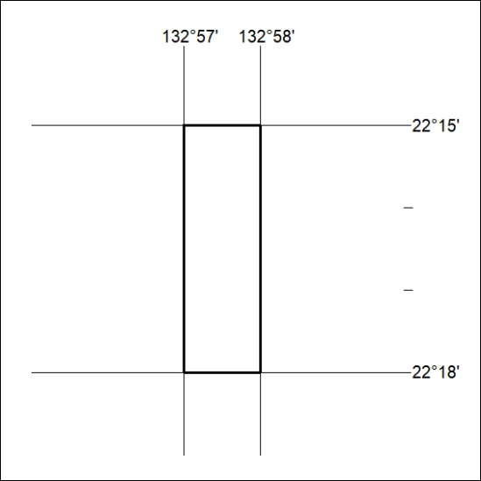

21/21

Mineral Titles Act
NOTICE OF GRANT OF A MINERAL TITLE
Title Type and Number: | Mineral Lease 32411
Granted: | 29 January 2021, for a period of 24 Years
Area: | 35.00 Hectares
Locality: | AILERON
Name of Holder/s: | 100% ARAFURA RARE EARTHS PTY LTD [ACN. 118 158 900]
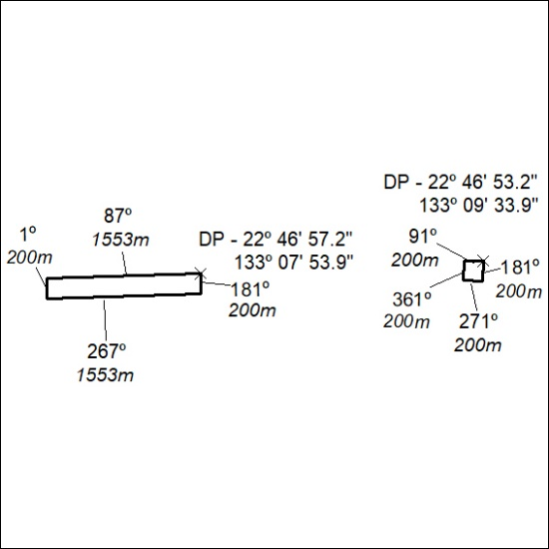

22/21

Mineral Titles Act
NOTICE OF GRANT OF A MINERAL TITLE
Title Type and Number: | Mineral Lease 32412
Granted: | 29 January 2021, for a period of 24 Years
Area: | 26.00 Hectares
Locality: | AILERON
Name of Holder/s: | 100% ARAFURA RARE EARTHS PTY LTD [ACN. 118 158 900]
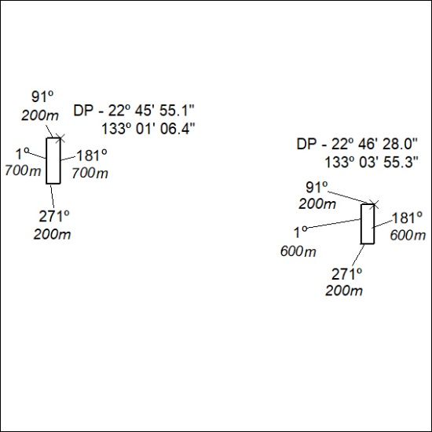

23/21

Mineral Titles Act
NOTICE OF GRANT OF A MINERAL TITLE
Title Type and Number: | Mineral Lease 32413
Granted: | 29 January 2021, for a period of 24 Years
Area: | 30.00 Hectares
Locality: | NAPPERBY
Name of Holder/s: | 100% ARAFURA RARE EARTHS PTY LTD [ACN. 118 158 900]
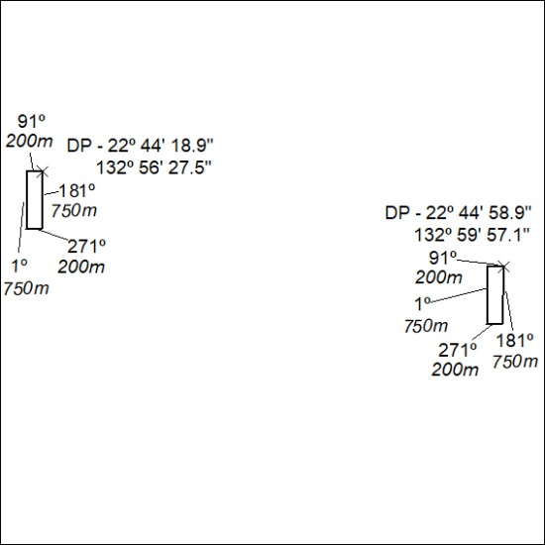

24/21

Mineral Titles Act
NOTICE OF GRANT OF A MINERAL TITLE
Title Type and Number: | Mineral Lease 32414
Granted: | 29 January 2021, for a period of 24 Years
Area: | 32.00 Hectares
Locality: | NAPPERBY
Name of Holder/s: | 100% ARAFURA RARE EARTHS PTY LTD [ACN. 118 158 900]
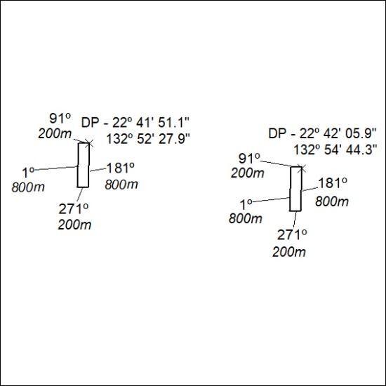

25/21

Mineral Titles Act
NOTICE OF GRANT OF A MINERAL TITLE
Title Type and Number: | Mineral Lease 32415
Granted: | 29 January 2021, for a period of 24 Years
Area: | 16.00 Hectares
Locality: | NAPPERBY
Name of Holder/s: | 100% ARAFURA RARE EARTHS PTY LTD [ACN. 118 158 900]
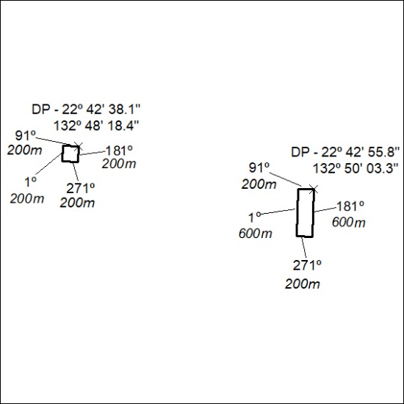

26/21

Mineral Titles Act
NOTICE OF GRANT OF A MINERAL TITLE
Title Type and Number: | Mineral Lease 32416
Granted: | 29 January 2021, for a period of 24 Years
Area: | 33.01 Hectares
Locality: | AILERON
Name of Holder/s: | 100% ARAFURA RARE EARTHS PTY LTD [ACN. 118 158 900]
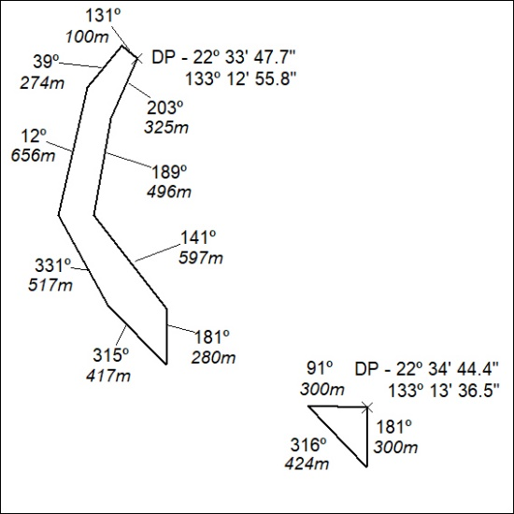

27/21

