Mineral Titles Act 2010
NOTICE OF LAND CEASING TO BE A MINERAL TITLE APPLICATION AREA
Title Type and Number: | Exploration Licence 32458
Area Ceased on: | 18 December 2020
Area: | 153 Blocks, 498.01 km²
Locality: | LEGUNE
Name of Applicant(s)/Holder(s): | 100% FMG RESOURCES PTY LTD [ACN. 095 546 428]
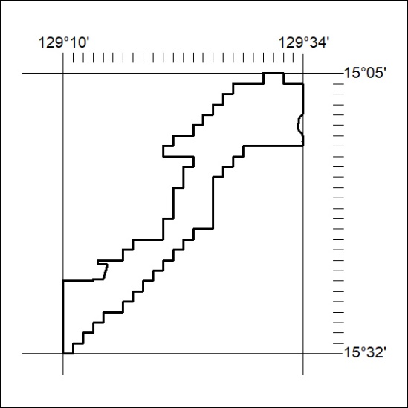

420/20

Mineral Titles Act 2010
NOTICE OF LAND CEASING TO BE A MINERAL TITLE APPLICATION AREA
Title Type and Number: | Exploration Licence 32459
Area Ceased on: | 18 December 2020
Area: | 98 Blocks, 306.04 km²
Locality: | KEEP
Name of Applicant(s)/Holder(s): | 100% FMG RESOURCES PTY LTD [ACN. 095 546 428]
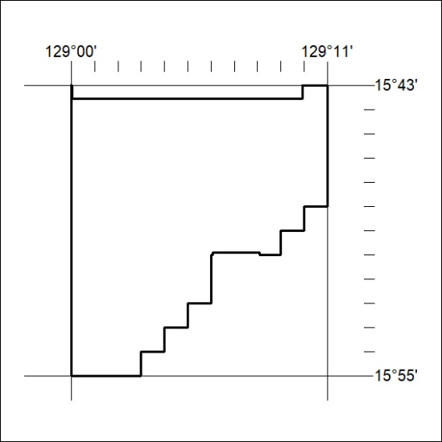

421/20

Mineral Titles Act 2010
NOTICE OF LAND CEASING TO BE A MINERAL TITLE APPLICATION AREA
Title Type and Number: | Extractive Mineral Permit 30361
Area ceased on: | 18 December 2020
Area: | 100.00 Hectare
Locality: | KOOLPINYAH
Name of Applicants(s)Holder(s): | 50% N.T. GOLD PTY LTD * [ACN. 009 625 870], 50% WILLIAMS PROJECTS NT PTY LTD [ACN. 165 412 779]
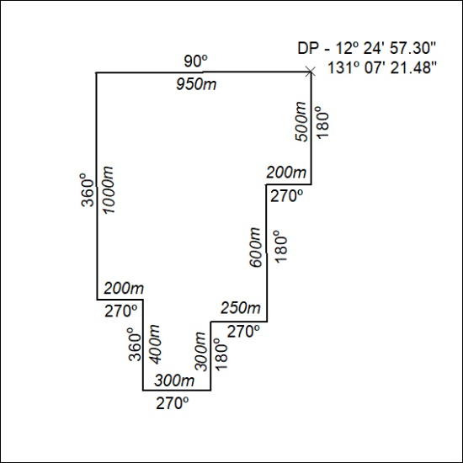
422/20

Mineral Titles Act 2010
NOTICE OF LAND CEASING TO BE A MINERAL TITLE APPLICATION AREA
Title Type and Number: | Extractive Mineral Permit 30363
Area ceased on: | 18 December 2020
Area: | 100.00 Hectare
Locality: | KOOLPINYAH
Name of Applicants(s)Holder(s): | 50% N.T. GOLD PTY LTD * [ACN. 009 625 870], 50% WILLIAMS PROJECTS NT PTY LTD [ACN. 165 412 779]
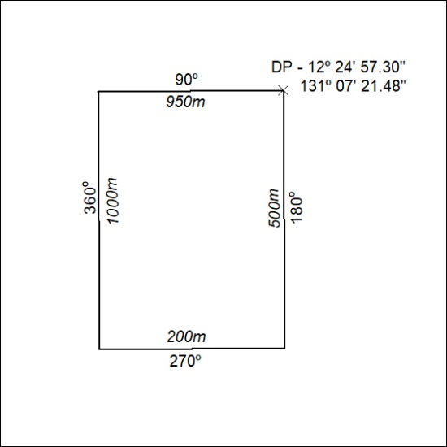
423/20

Mineral Titles Act
NOTICE OF GRANT OF A MINERAL TITLE
Title Type and Number: | Exploration Licence 32297
Granted: | 18 December 2020, for a period of 6 Years
Area: | 35 Blocks, 110.92 km²
Locality: | DALMORE
Name of Holder/s: | 100% BARKLY OPERATIONS PTY LTD [ACN. 641 856 706]
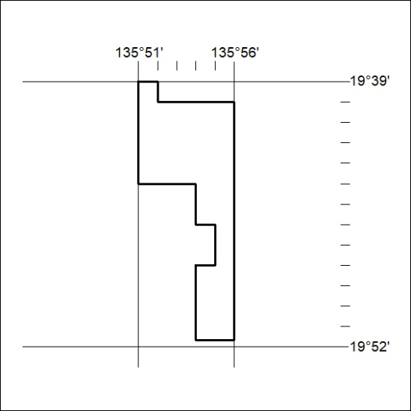
Area granted is indicated above. The titleholder is not permitted to exercise occupational rights on any land that is subject to a development title, or an application for a development title. Any land the subject of a Reserved Land gazettal under the Mineral Titles Act and all land vested in the Commonwealth of Australia is also excluded by description but not excised from the grant area.
424/20

Mineral Titles Act
NOTICE OF GRANT OF A MINERAL TITLE
Title Type and Number: | Exploration Licence 32298
Granted: | 18 December 2020, for a period of 6 Years
Area: | 137 Blocks, 443.37 km²
Locality: | DALMORE
Name of Holder/s: | 100% BARKLY OPERATIONS PTY LTD [ACN. 641 856 706]
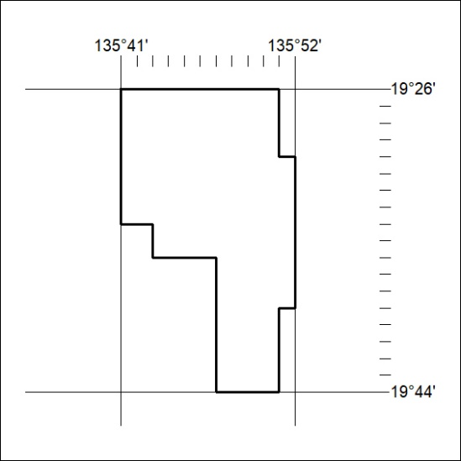
Area granted is indicated above. The titleholder is not permitted to exercise occupational rights on any land that is subject to a development title, or an application for a development title. Any land the subject of a Reserved Land gazettal under the Mineral Titles Act and all land vested in the Commonwealth of Australia is also excluded by description but not excised from the grant area.
425/20

Mineral Titles Act
NOTICE OF GRANT OF A MINERAL TITLE
Title Type and Number: | Exploration Licence 32301
Granted: | 18 December 2020, for a period of 6 Years
Area: | 230 Blocks, 740.70 km²
Locality: | PLAYFORD
Name of Holder/s: | 100% BARKLY OPERATIONS PTY LTD [ACN. 641 856 706]
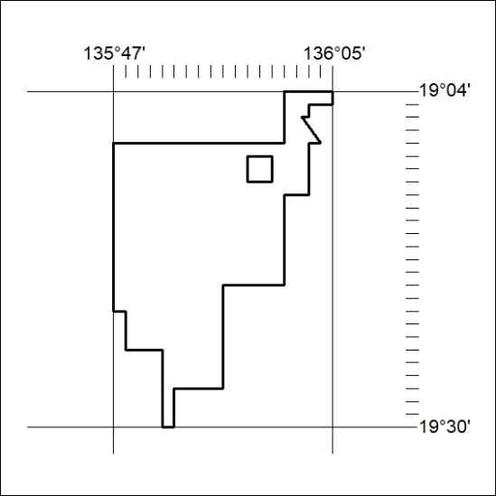
Area granted is indicated above. The titleholder is not permitted to exercise occupational rights on any land that is subject to a development title, or an application for a development title. Any land the subject of a Reserved Land gazettal under the Mineral Titles Act and all land vested in the Commonwealth of Australia is also excluded by description but not excised from the grant area.
426/20

Mineral Titles Act
NOTICE OF GRANT OF A MINERAL TITLE
Title Type and Number: | Exploration Licence 32308
Granted: | 18 December 2020, for a period of 6 Years
Area: | 212 Blocks, 685.55 km²
Locality: | ALROY
Name of Holder/s: | 100% BARKLY OPERATIONS PTY LTD [ACN. 641 856 706]
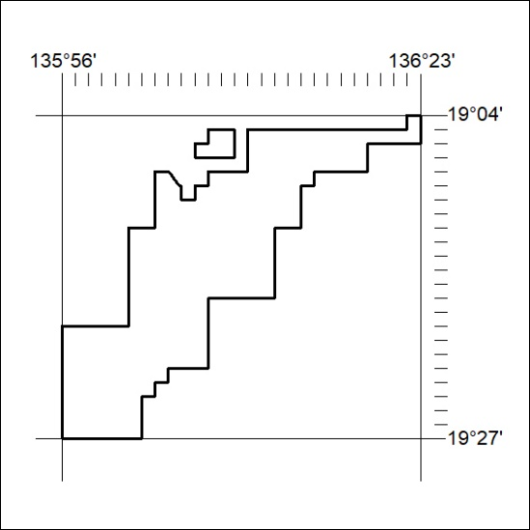
Area granted is indicated above. The titleholder is not permitted to exercise occupational rights on any land that is subject to a development title, or an application for a development title. Any land the subject of a Reserved Land gazettal under the Mineral Titles Act and all land vested in the Commonwealth of Australia is also excluded by description but not excised from the grant area.
427/20

Mineral Titles Act
NOTICE OF GRANT OF A MINERAL TITLE
Title Type and Number: | Exploration Licence 32309
Granted: | 18 December 2020, for a period of 6 Years
Area: | 106 Blocks, 343.47 km²
Locality: | ALROY
Name of Holder/s: | 100% BARKLY OPERATIONS PTY LTD [ACN. 641 856 706]
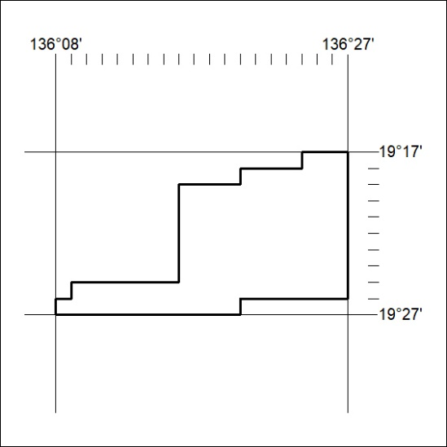
Area granted is indicated above. The titleholder is not permitted to exercise occupational rights on any land that is subject to a development title, or an application for a development title. Any land the subject of a Reserved Land gazettal under the Mineral Titles Act and all land vested in the Commonwealth of Australia is also excluded by description but not excised from the grant area.
428/20

