Mineral Titles Act 2010
NOTICE OF LAND CEASING TO BE A MINERAL TITLE AREA
Title Type and Number: | Exploration Licence 28041
Area Ceased on: | 09 December 2020
Area: | 10 Blocks, 32.60 km²
Locality: | HELEN
Name of Applicant(s)/Holder(s): | 100% OM (MANGANESE) LTD [ACN. 097 091 506]
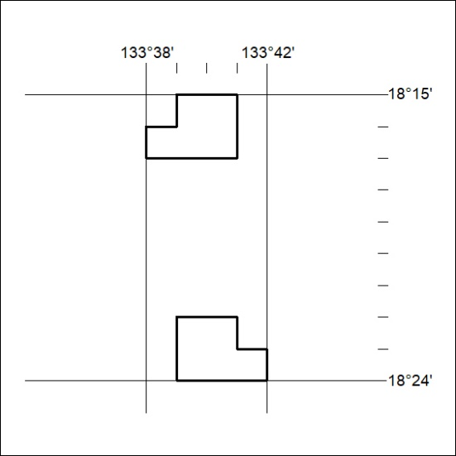

403/20

Mineral Titles Act 2010
NOTICE OF LAND CEASING TO BE A MINERAL TITLE APPLICATION AREA
Title Type and Number: | Exploration Licence 31353
Area Ceased on: | 09 December 2020
Area: | 2 Blocks, .32 km²
Locality: | MARUMBA
Name of Applicant(s)/Holder(s): | 100% KINGSREEF PTY LTD [ACN. 083 553 968]
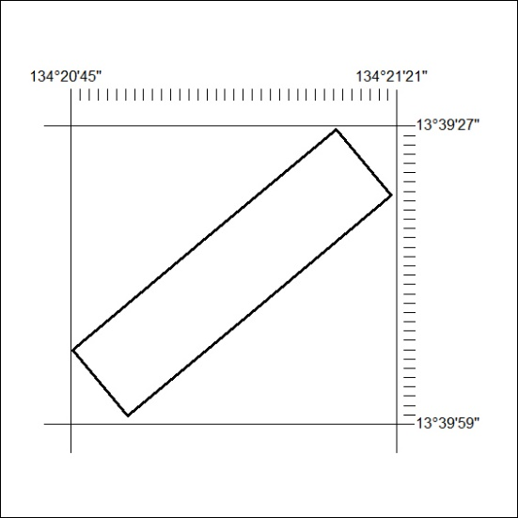

404/20

Mineral Titles Act 2010
NOTICE OF LAND CEASING TO BE A MINERAL TITLE AREA
Title Type and Number: | Mineral Lease 31075
Area ceased on: | 08 December 2020
Area: | 21.00 Hectare
Locality: | FLYNN
Name of Applicants(s)Holder(s): | 100% GECKO MINING COMPANY PTY LTD* [ACN. 169 920 745]
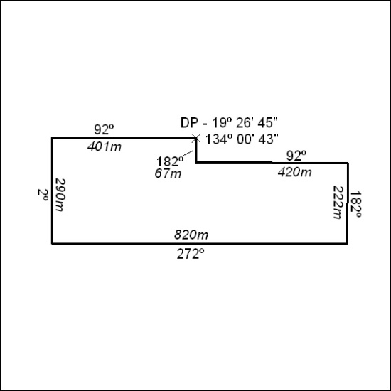

405/20

