Mineral Titles Act 2010
NOTICE OF LAND CEASING TO BE A MINERAL TITLE AREA
Title Type and Number: | Exploration Licence 30157
Area Ceased on: | 17 June 2020
Area: | 26 Blocks, 86.08 km²
Locality: | MT YOUNG
Name of Applicant(s)/Holder(s): | 100% SANDFIRE RESOURCES LIMITED* [ACN. 105 154 185]
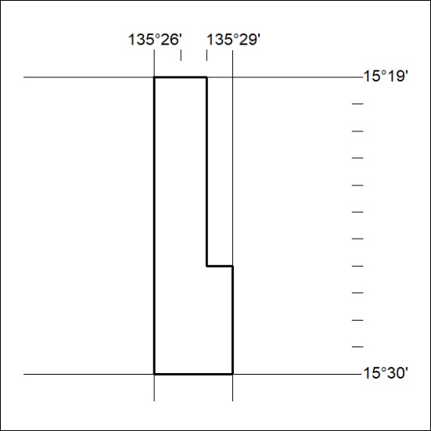

203/20

Mineral Titles Act 2010
NOTICE OF LAND CEASING TO BE A MINERAL TITLE AREA
Title Type and Number: | Exploration Licence 31899
Area Ceased on: | 17 June 2020
Area: | 13 Blocks, 43.42 km²
Locality: | McKINLAY RIVER
Name of Applicant(s)/Holder(s): | 100% BACCHUS RESOURCES PTY LTD [ACN. 606 340 872]
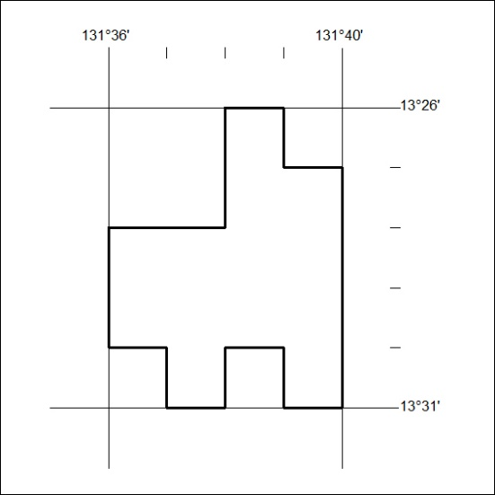

204/20

