Mineral Titles Act 2010
NOTICE OF LAND CEASING TO BE A MINERAL TITLE AREA
Title Type and Number: | Exploration Licence in Retention 45
Area ceased on: | 29 May 2020
Area: | 203.00 Hectares
Locality: | YUENDUMU
Name of Applicants(s)Holder(s): | 100% ENERGY METALS LTD [ACN. 111 306 533]
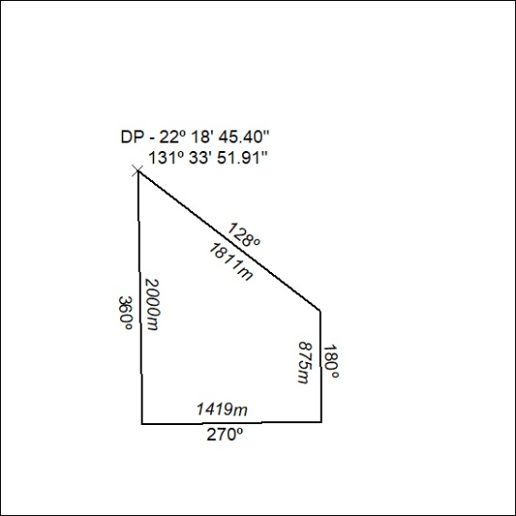

196/20

