Mineral Titles Act 2010
NOTICE OF LAND CEASING TO BE A MINERAL TITLE AREA
Title Type and Number: | Extractive Mineral Exploration Licence 31604
Area Ceased on: | 04 March 2020
Area: | 3 Blocks, 7.69 km²
Locality: | KOOLPINYAH
Name of Applicant(s)/Holder(s): | 100% SAGE CONSTRUCTIONS PTY. LTD. [ACN. 009 654 648]
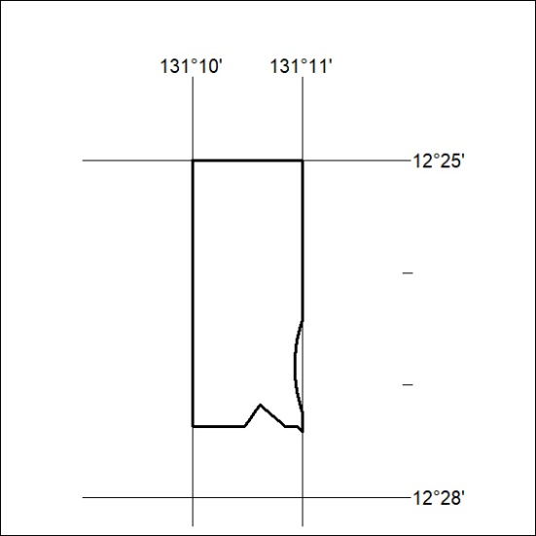

125/20

Mineral Titles Act 2010
NOTICE OF LAND CEASING TO BE A MINERAL TITLE AREA
Title Type and Number: | Extractive Mineral Exploration Licence 31605
Area Ceased on: | 04 March 2020
Area: | 2 Blocks, 1.66 km²
Locality: | KOOLPINYAH
Name of Applicant(s)/Holder(s): | 100% SAGE CONSTRUCTIONS PTY. LTD. [ACN. 009 654 648]
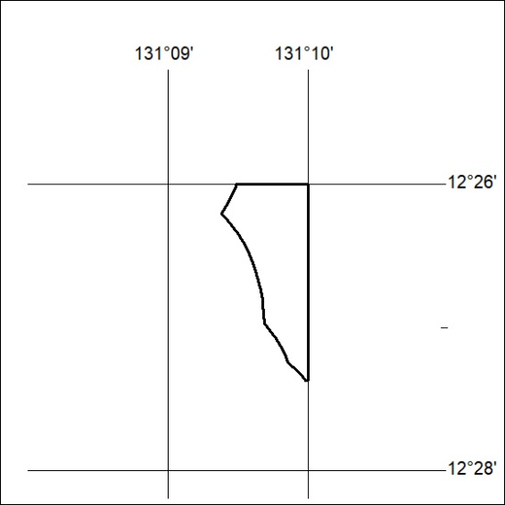

126/20
Mineral Titles Act 2010
NOTICE OF LAND CEASING TO BE A MINERAL TITLE AREA
Title Type and Number: | Extractive Mineral Exploration Licence 31656
Area Ceased on: | 04 March 2020
Area: | 3 Blocks, 7.82 km²
Locality: | KOOLPINYAH
Name of Applicant(s)/Holder(s): | 100% SAGE CONSTRUCTIONS PTY. LTD. [ACN. 009 654 648]
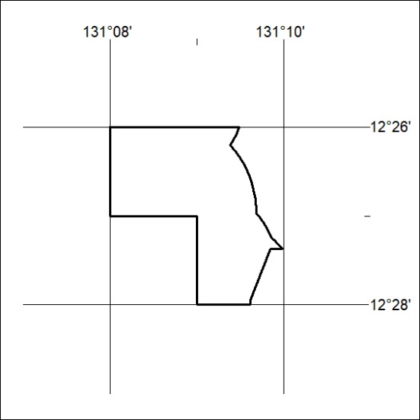

127/20

