Mineral Titles Act 2010
NOTICE OF LAND CEASING TO BE A MINERAL TITLE APPLICATION AREA
Title Type and Number: | Exploration Licence 24830
Area Ceased on: | 10 February 2020
Area: | 42 Blocks, 119.32 km²
Locality: | GOVE
Name of Applicant(s)/Holder(s): | 100% GROOTE EYLANDT MINING COMPANY PROPRIETARY LIMITED [ACN. 004 618 491]
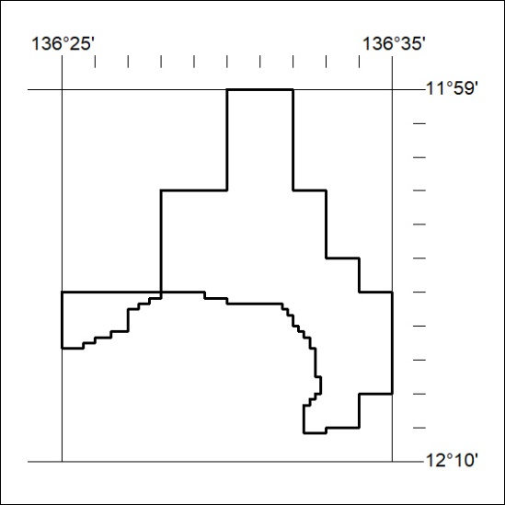

73/20

Mineral Titles Act 2010
NOTICE OF LAND CEASING TO BE A MINERAL TITLE APPLICATION AREA
Title Type and Number: | Exploration Licence 27212
Area Ceased on: | 10 February 2020
Area: | 4 Blocks, 4.20 km²
Locality: | GOVE
Name of Applicant(s)/Holder(s): | 100% GROOTE EYLANDT MINING COMPANY PROPRIETARY LIMITED [ACN. 004 618 491]
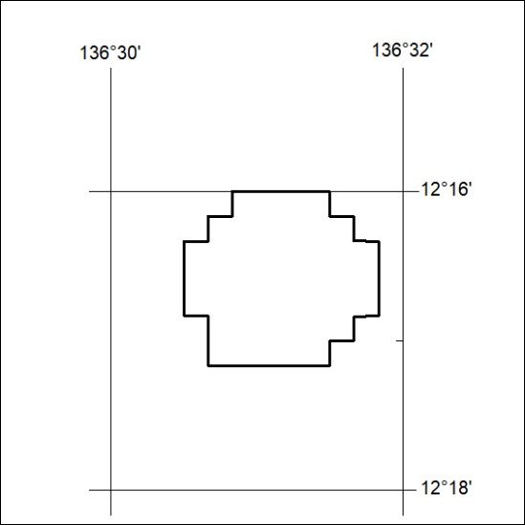

74/20
Mineral Titles Act 2010
NOTICE OF LAND CEASING TO BE A MINERAL TITLE APPLICATION AREA
Title Type and Number: | Exploration Licence 27213
Area Ceased on: | 10 February 2020
Area: | 4 Blocks, 4.01 km²
Locality: | GOVE
Name of Applicant(s)/Holder(s): | 100% GROOTE EYLANDT MINING COMPANY PROPRIETARY LIMITED [ACN. 004 618 491]
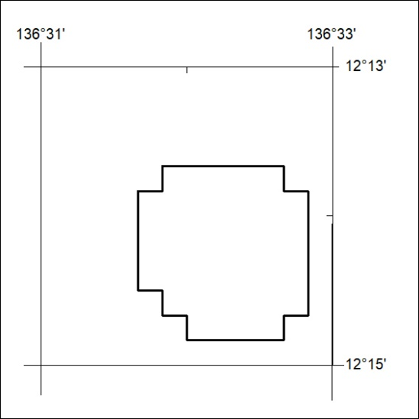

75/20

Mineral Titles Act 2010
NOTICE OF LAND CEASING TO BE A MINERAL TITLE APPLICATION AREA
Title Type and Number: | Exploration Licence 27214
Area Ceased on: | 10 February 2020
Area: | 7 Blocks, 14.26 km²
Locality: | GOVE
Name of Applicant(s)/Holder(s): | 100% GROOTE EYLANDT MINING COMPANY PROPRIETARY LIMITED [ACN. 004 618 491]
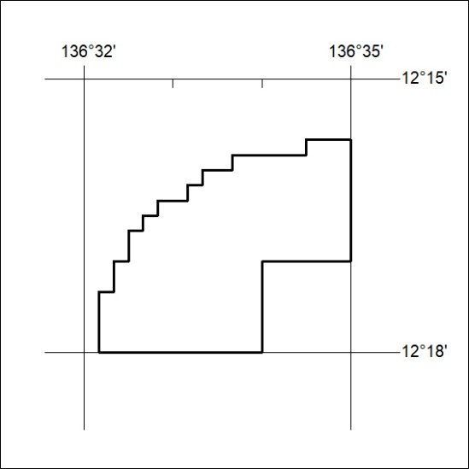

76/20
Mineral Titles Act 2010
NOTICE OF LAND CEASING TO BE A MINERAL TITLE APPLICATION AREA
Title Type and Number: | Exploration Licence 27215
Area Ceased on: | 10 February 2020
Area: | 9 Blocks, 20.70 km²
Locality: | GOVE
Name of Applicant(s)/Holder(s): | 100% GROOTE EYLANDT MINING COMPANY PROPRIETARY LIMITED [ACN. 004 618 491]
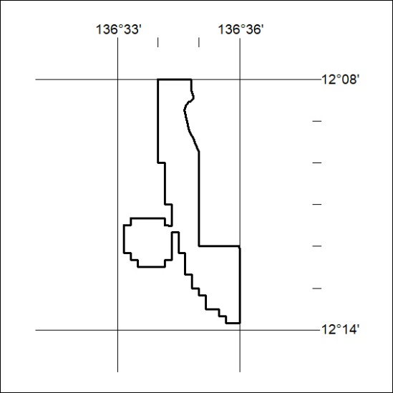

77/20

Mineral Titles Act 2010
NOTICE OF LAND CEASING TO BE A MINERAL TITLE APPLICATION AREA
Title Type and Number: | Exploration Licence 27245
Area Ceased on: | 10 February 2020
Area: | 5 Blocks, 7.41 km²
Locality: | DURABUDBOI
Name of Applicant(s)/Holder(s): | 100% GROOTE EYLANDT MINING COMPANY PROPRIETARY LIMITED [ACN. 004 618 491]
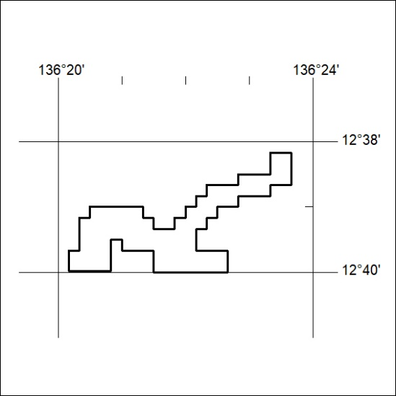

78/20
Mineral Titles Act 2010
NOTICE OF LAND CEASING TO BE A MINERAL TITLE APPLICATION AREA
Title Type and Number: | Exploration Licence 27246
Area Ceased on: | 10 February 2020
Area: | 6 Blocks, 6.48 km²
Locality: | DURABUDBOI
Name of Applicant(s)/Holder(s): | 100% GROOTE EYLANDT MINING COMPANY PROPRIETARY LIMITED [ACN. 004 618 491]
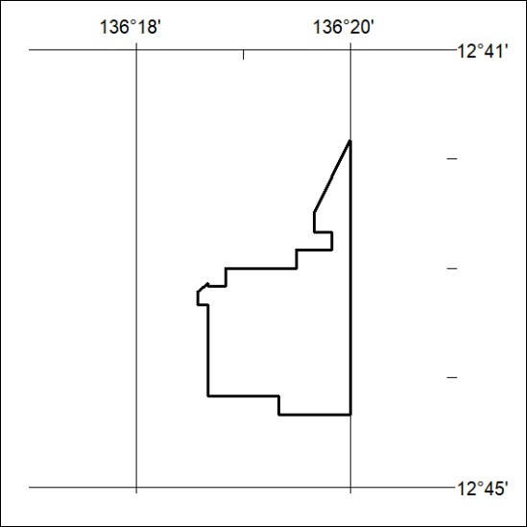

79/20

Mineral Titles Act 2010
NOTICE OF LAND CEASING TO BE A MINERAL TITLE APPLICATION AREA
Title Type and Number: | Exploration Licence 27247
Area Ceased on: | 10 February 2020
Area: | 4 Blocks, 3.42 km²
Locality: | DURABUDBOI
Name of Applicant(s)/Holder(s): | 100% GROOTE EYLANDT MINING COMPANY PROPRIETARY LIMITED [ACN. 004 618 491]
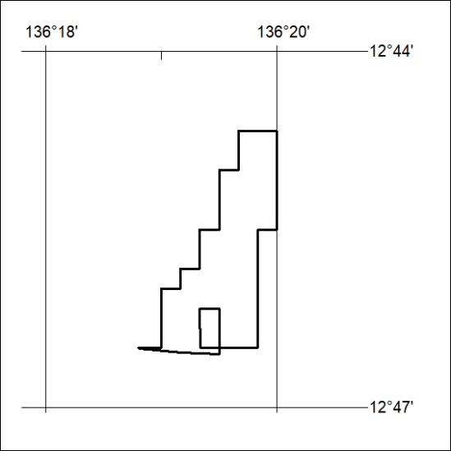

80/20
Mineral Titles Act 2010
NOTICE OF LAND CEASING TO BE A MINERAL TITLE APPLICATION AREA
Title Type and Number: | Exploration Licence 31320
Area Ceased on: | 10 February 2020
Area: | 2 Blocks, 1.49 km²
Locality: | GOVE
Name of Applicant(s)/Holder(s): | 100% GROOTE EYLANDT MINING COMPANY PROPRIETARY LIMITED [ACN. 004 618 491]
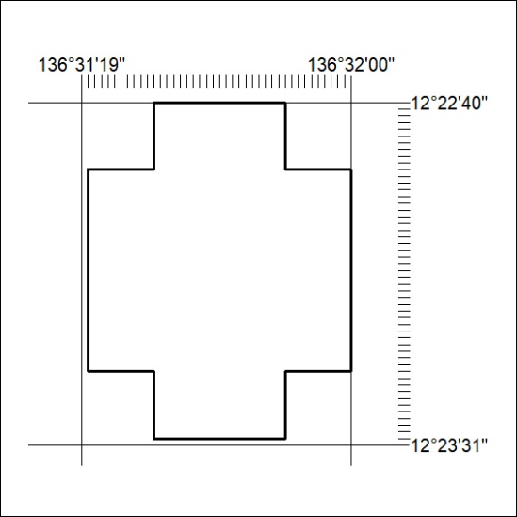

81/20

Mineral Titles Act 2010
NOTICE OF LAND CEASING TO BE A MINERAL TITLE APPLICATION AREA
Title Type and Number: | Exploration Licence 31321
Area Ceased on: | 10 February 2020
Area: | 2 Blocks, 1.40 km²
Locality: | GOVE
Name of Applicant(s)/Holder(s): | 100% GROOTE EYLANDT MINING COMPANY PROPRIETARY LIMITED [ACN. 004 618 491]
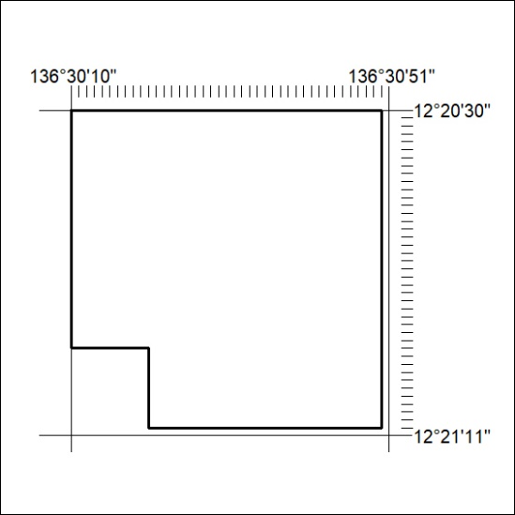

82/20
Mineral Titles Act 2010
NOTICE OF LAND CEASING TO BE A MINERAL TITLE APPLICATION AREA
Title Type and Number: | Exploration Licence 31322
Area Ceased on: | 10 February 2020
Area: | 4 Blocks, 3.17 km²
Locality: | GOVE
Name of Applicant(s)/Holder(s): | 100% GROOTE EYLANDT MINING COMPANY PROPRIETARY LIMITED [ACN. 004 618 491]
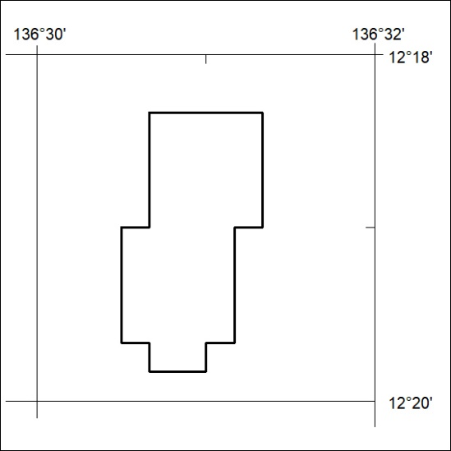

83/20

Mineral Titles Act 2010
NOTICE OF LAND CEASING TO BE A MINERAL TITLE APPLICATION AREA
Title Type and Number: | Exploration Licence 31323
Area Ceased on: | 10 February 2020
Area: | 6 Blocks, 6.52 km²
Locality: | GOVE
Name of Applicant(s)/Holder(s): | 100% GROOTE EYLANDT MINING COMPANY PROPRIETARY LIMITED [ACN. 004 618 491]
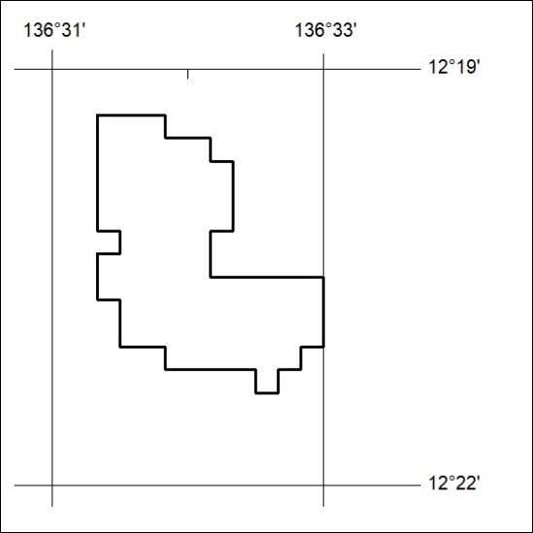

84/20
Mineral Titles Act 2010
NOTICE OF LAND CEASING TO BE A MINERAL TITLE APPLICATION AREA
Title Type and Number: | Exploration Licence 31324
Area Ceased on: | 10 February 2020
Area: | 2 Blocks, 1.40 km²
Locality: | GOVE
Name of Applicant(s)/Holder(s): | 100% GROOTE EYLANDT MINING COMPANY PROPRIETARY LIMITED [ACN. 004 618 491]
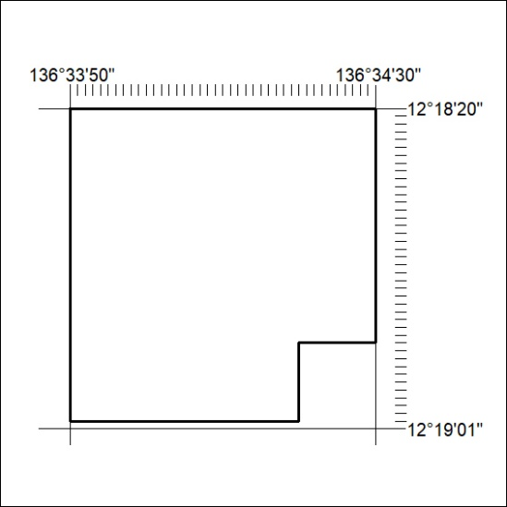

85/20

Mineral Titles Act 2010
NOTICE OF LAND CEASING TO BE A MINERAL TITLE APPLICATION AREA
Title Type and Number: | Exploration Licence 31325
Area Ceased on: | 10 February 2020
Area: | 2 Blocks, 1.49 km²
Locality: | GOVE
Name of Applicant(s)/Holder(s): | 100% GROOTE EYLANDT MINING COMPANY PROPRIETARY LIMITED [ACN. 004 618 491]
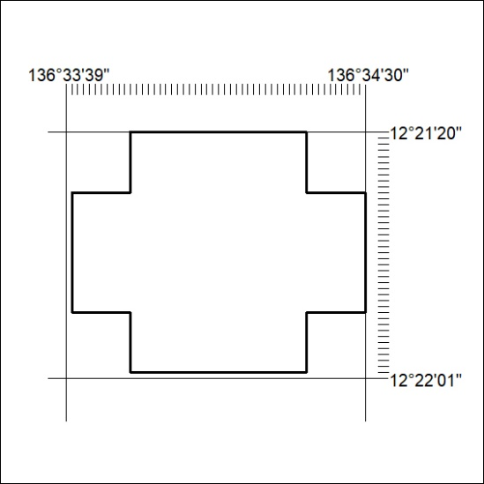

86/20
Mineral Titles Act 2010
NOTICE OF LAND CEASING TO BE A MINERAL TITLE APPLICATION AREA
Title Type and Number: | Exploration Licence 31326
Area Ceased on: | 10 February 2020
Area: | 4 Blocks, 2.05 km²
Locality: | GOVE
Name of Applicant(s)/Holder(s): | 100% GROOTE EYLANDT MINING COMPANY PROPRIETARY LIMITED [ACN. 004 618 491]
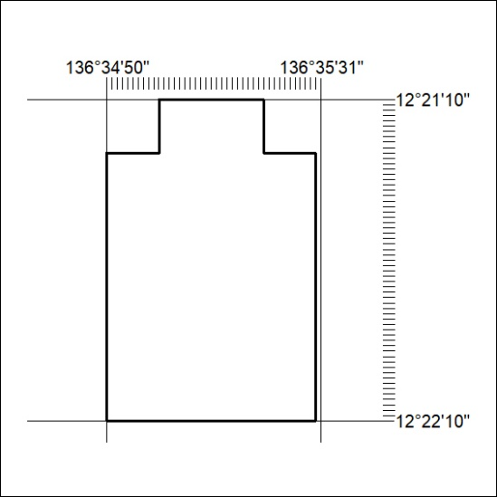

87/20

Mineral Titles Act 2010
NOTICE OF LAND CEASING TO BE A MINERAL TITLE APPLICATION AREA
Title Type and Number: | Exploration Licence 31327
Area Ceased on: | 10 February 2020
Area: | 2 Blocks, 2.14 km²
Locality: | GOVE
Name of Applicant(s)/Holder(s): | 100% GROOTE EYLANDT MINING COMPANY PROPRIETARY LIMITED [ACN. 004 618 491]
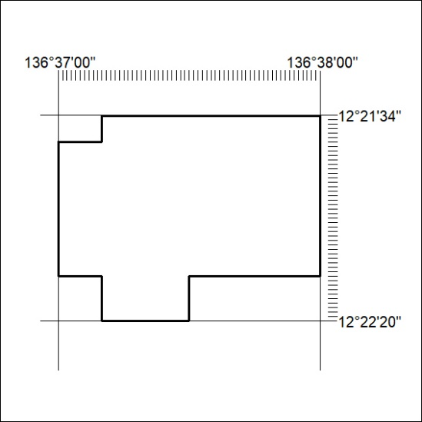

88/20
Mineral Titles Act 2010
NOTICE OF LAND CEASING TO BE A MINERAL TITLE APPLICATION AREA
Title Type and Number: | Exploration Licence 31328
Area Ceased on: | 10 February 2020
Area: | 116 Blocks, 325.39 km²
Locality: | GOVE
Name of Applicant(s)/Holder(s): | 100% GROOTE EYLANDT MINING COMPANY PROPRIETARY LIMITED [ACN. 004 618 491]
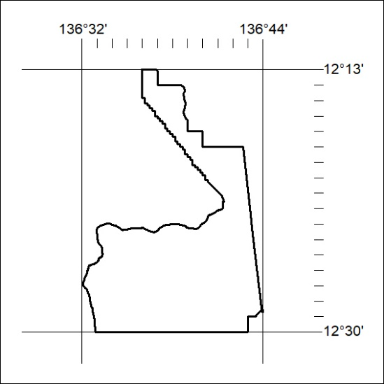

89/20

Mineral Titles Act 2010
NOTICE OF LAND CEASING TO BE A MINERAL TITLE AREA
Title Type and Number: | Exploration Licence 26406
Area Ceased on: | 07 February 2020
Area: | 25 Blocks, 80.79 km²
Locality: | BORROLOOLA
Name of Applicant(s)/Holder(s): | 100% TECK AUSTRALIA PTY LTD [ACN. 091 271 911]
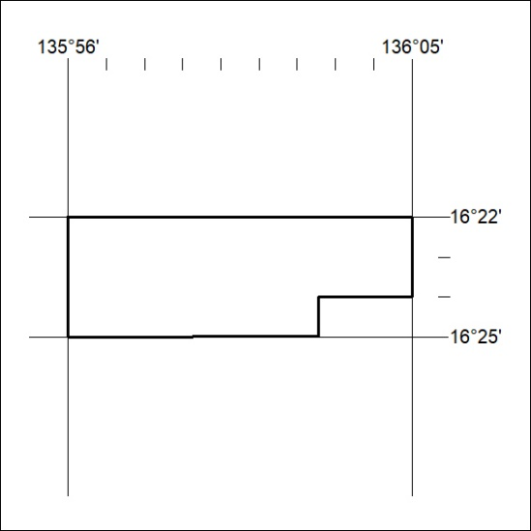
(Area now amalgamated into Exploration Licence 32333 under s102 – EL moratorium period does not apply)

90/20
Mineral Titles Act 2010
NOTICE OF LAND CEASING TO BE A MINERAL TITLE AREA
Title Type and Number: | Exploration Licence 31518
Area Ceased on: | 07 February 2020
Area: | 2 Blocks, .40 km²
Locality: | BORROLOOLA
Name of Applicant(s)/Holder(s): | 100% TECK AUSTRALIA PTY LTD [ACN. 091 271 911]
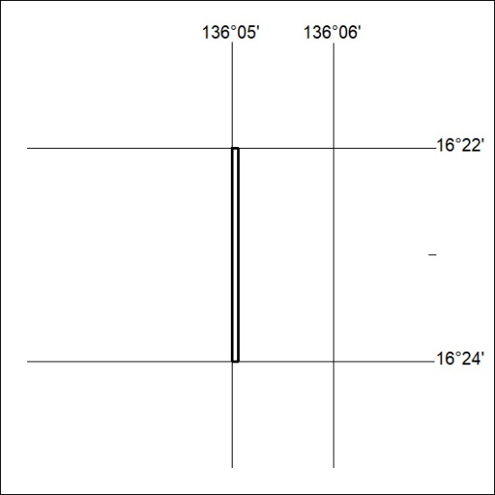
(Area now amalgamated into Exploration Licence 32333 under s102 – EL moratorium period does not apply)

91/20

