Mineral Titles Act 2010
NOTICE OF LAND CEASING TO BE A MINERAL TITLE AREA
Title Type and Number: | Exploration Licence 31700
Area Ceased on: | 04 February 2020
Area: | 1 Block, 3.34 km²
Locality: | BATCHELOR
Name of Applicant(s)/Holder(s): | 100% BACCHUS RESOURCES PTY LTD [ACN. 606 340 872]
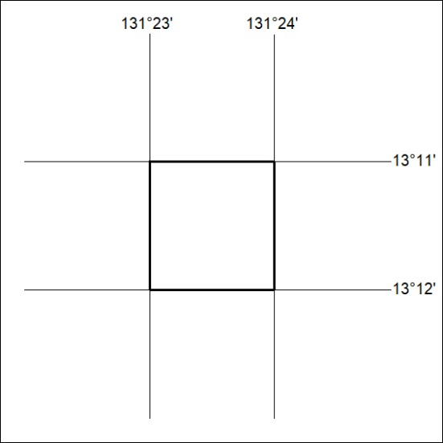
(Area now amalgamated into Exploration Licence 32356 under s102 – EL moratorium period does not apply)

57/20

Mineral Titles Act 2010
NOTICE OF LAND CEASING TO BE A MINERAL TITLE AREA
Title Type and Number: | Exploration Licence 31892
Area Ceased on: | 04 February 2020
Area: | 8 Blocks, 26.75 km²
Locality: | BATCHELOR
Name of Applicant(s)/Holder(s): | 100% BACCHUS RESOURCES PTY LTD [ACN. 606 340 872]
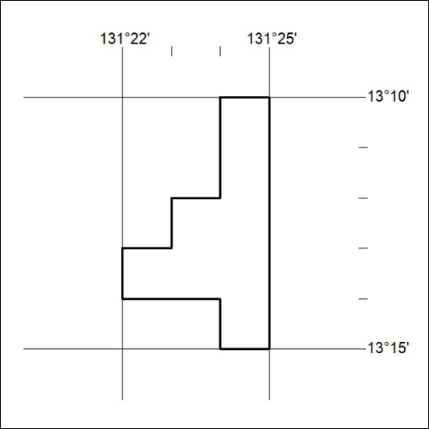
(Area now amalgamated into Exploration Licence 32356 under s102 – EL moratorium period does not apply)

58/20

Mineral Titles Act
NOTICE OF GRANT OF A MINERAL TITLE
Title Type and Number: | Exploration Licence 32156
Granted: | 04 February 2020, for a period of 6 Years
Area: | 248 Blocks, 807.26 km²
Locality: | ELLIOTT
Name of Holder/s: | 100% BAUDIN RESOURCES PTY LTD [ACN. 618 455 593]
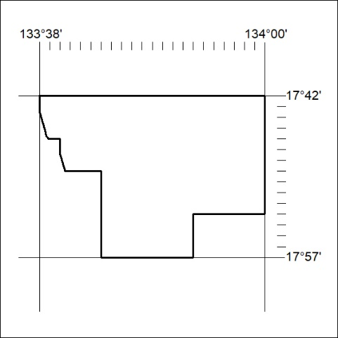
Area granted is indicated above. The titleholder is not permitted to exercise occupational rights on any land that is subject to a development title, or an application for a development title. Any land the subject of a Reserved Land gazettal under the Mineral Titles Act and all land vested in the Commonwealth of Australia is also excluded by description but not excised from the grant area.

59/20

Mineral Titles Act
NOTICE OF GRANT OF A MINERAL TITLE
Title Type and Number: | Exploration Licence 32157
Granted: | 04 February 2020, for a period of 6 Years
Area: | 220 Blocks, 696.31 km²
Locality: | ELLIOTT
Name of Holder/s: | 100% BAUDIN RESOURCES PTY LTD [ACN. 618 455 593]
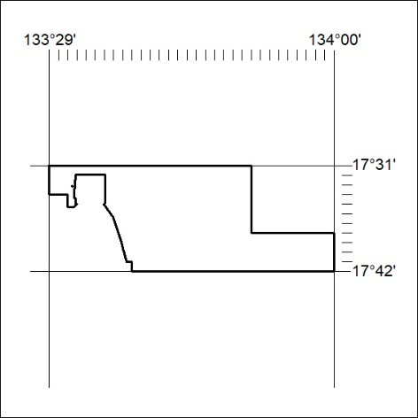
Area granted is indicated above. The titleholder is not permitted to exercise occupational rights on any land that is subject to a development title, or an application for a development title. Any land the subject of a Reserved Land gazettal under the Mineral Titles Act and all land vested in the Commonwealth of Australia is also excluded by description but not excised from the grant area.

60/20

Mineral Titles Act
NOTICE OF GRANT OF A MINERAL TITLE
Title Type and Number: | Exploration Licence 32158
Granted: | 04 February 2020, for a period of 6 Years
Area: | 246 Blocks, 793.71 km²
Locality: | HELEN
Name of Holder/s: | 100% BAUDIN RESOURCES PTY LTD [ACN. 618 455 593]
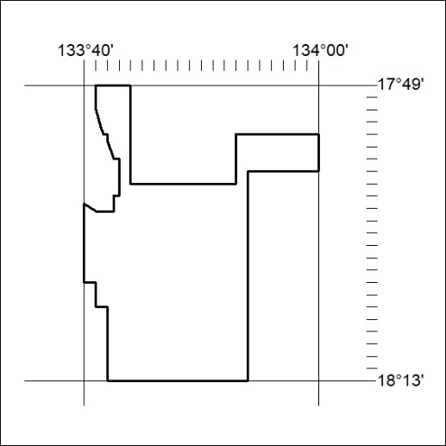
Area granted is indicated above. The titleholder is not permitted to exercise occupational rights on any land that is subject to a development title, or an application for a development title. Any land the subject of a Reserved Land gazettal under the Mineral Titles Act and all land vested in the Commonwealth of Australia is also excluded by description but not excised from the grant area.

61/20

Mineral Titles Act
NOTICE OF GRANT OF A MINERAL TITLE
Title Type and Number: | Exploration Licence 32159
Granted: | 04 February 2020, for a period of 6 Years
Area: | 221 Blocks, 723.89 km²
Locality: | BEETALOO
Name of Holder/s: | 100% BAUDIN RESOURCES PTY LTD [ACN. 618 455 593]
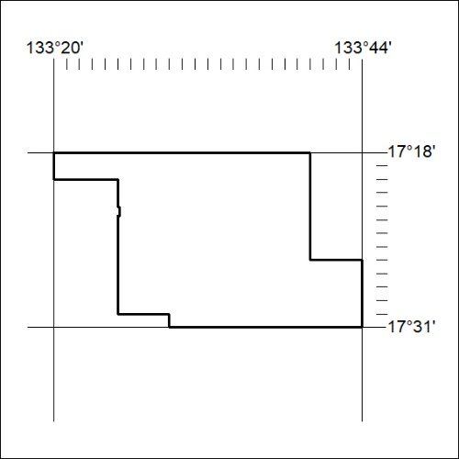
Area granted is indicated above. The titleholder is not permitted to exercise occupational rights on any land that is subject to a development title, or an application for a development title. Any land the subject of a Reserved Land gazettal under the Mineral Titles Act and all land vested in the Commonwealth of Australia is also excluded by description but not excised from the grant area.

62/20

