Mineral Titles Act 2010
NOTICE OF LAND CEASING TO BE A MINERAL TITLE AREA
Title Type and Number: | Exploration Licence 31524
Area Ceased on: | 17 January 2020
Area: | 18 Blocks, 53.96 km²
Locality: | RANFORD HILL
Name of Applicant(s)/Holder(s): | 100% ROCKWASH PTY LTD [ACN. 611 356 837]
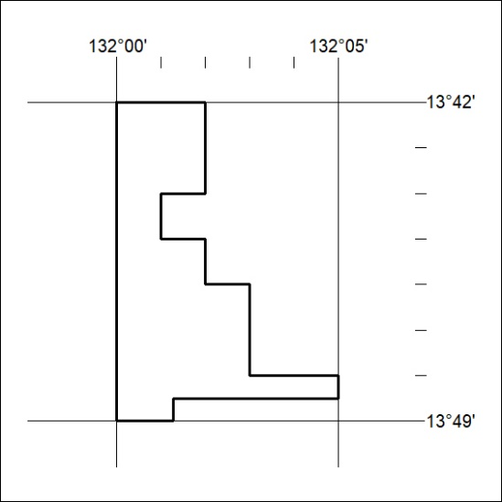

22/20

