Mineral Titles Act 2010
NOTICE OF LAND CEASING TO BE A MINERAL TITLE AREA
Title Type and Number: | Exploration Licence 25313
Area Ceased on: | 18 November 2019
Area: | 8 Blocks, 24.53 km²
Locality: | BORROLOOLA
Name of Applicant(s)/Holder(s): | 100% MARINDI METALS LIMITED* [ACN. 118 522 124]
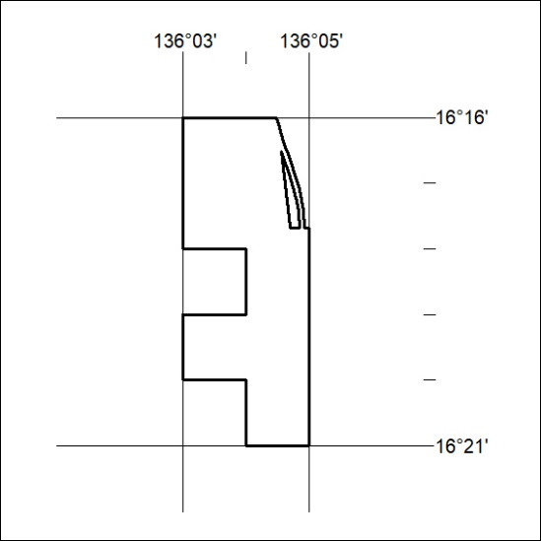

487/19

Mineral Titles Act 2010
NOTICE OF LAND CEASING TO BE A MINERAL TITLE AREA
Title Type and Number: | Exploration Licence 27358
Area Ceased on: | 17 November 2019
Area: | 78 Blocks, 233.08 km²
Locality: | ANBURLA
Name of Applicant(s)/Holder(s): | 100% CROSSLAND NICKEL PTY LTD* [ACN. 099 477 915]
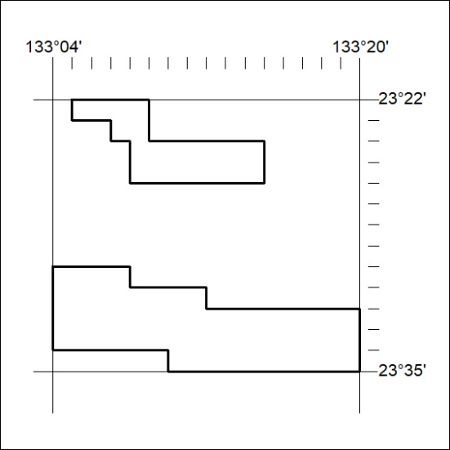

488/19

Mineral Titles Act 2010
NOTICE OF LAND CEASING TO BE A MINERAL TITLE AREA
Title Type and Number: | Exploration Licence 28006
Area Ceased on: | 18 November 2019
Area: | 19 Blocks, 59.06 km²
Locality: | BORROLOOLA
Name of Applicant(s)/Holder(s): | 100% MARINDI METALS LIMITED* [ACN. 118 522 124]
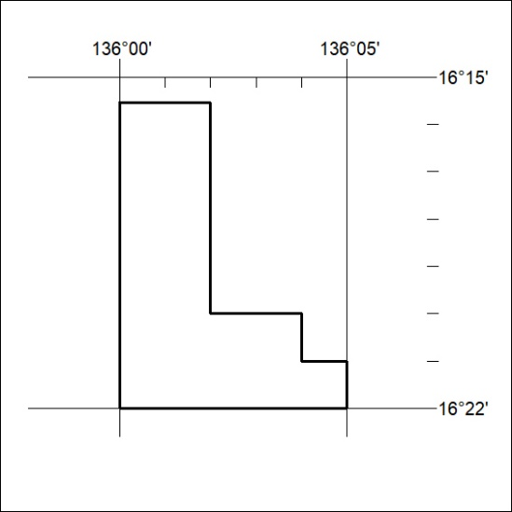

489/19

Mineral Titles Act 2010
NOTICE OF LAND CEASING TO BE A MINERAL TITLE AREA
Title Type and Number: | Exploration Licence 28007
Area Ceased on: | 18 November 2019
Area: | 13 Blocks, 40.41 km²
Locality: | BORROLOOLA
Name of Applicant(s)/Holder(s): | 100% MARINDI METALS LIMITED* [ACN. 118 522 124]
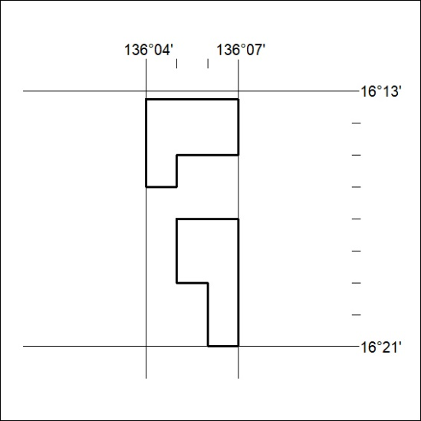

490/19

Mineral Titles Act 2010
NOTICE OF LAND CEASING TO BE A MINERAL TITLE AREA
Title Type and Number: | Exploration Licence 28951
Area Ceased on: | 18 November 2019
Area: | 3 Blocks, 9.89 km²
Locality: | BORROLOOLA
Name of Applicant(s)/Holder(s): | 100% MARINDI METALS LIMITED* [ACN. 118 522 124]
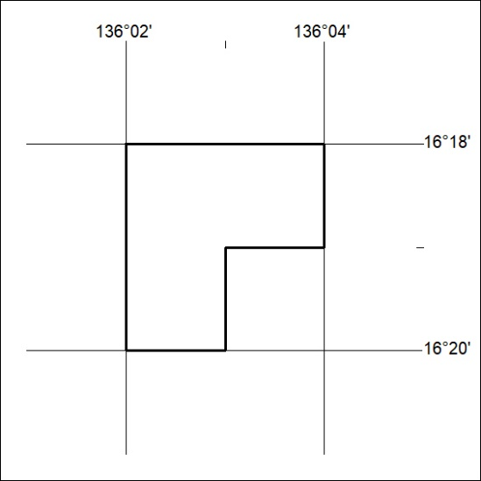

491/19

Mineral Titles Act 2010
NOTICE OF LAND CEASING TO BE A MINERAL TITLE AREA
Title Type and Number: | Exploration Licence 28952
Area Ceased on: | 18 November 2019
Area: | 3 Blocks, 9.89 km²
Locality: | BORROLOOLA
Name of Applicant(s)/Holder(s): | 100% MARINDI METALS LIMITED* [ACN. 118 522 124]
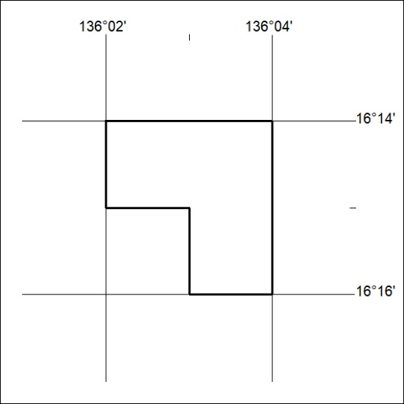

492/19

Mineral Titles Act 2010
NOTICE OF LAND CEASING TO BE A MINERAL TITLE AREA
Title Type and Number: | Exploration Licence 31424
Area Ceased on: | 18 November 2019
Area: | 14 Blocks, 26.50 km²
Locality: | BORROLOOLA
Name of Applicant(s)/Holder(s): | 100% MARINDI METALS LIMITED* [ACN. 118 522 124]
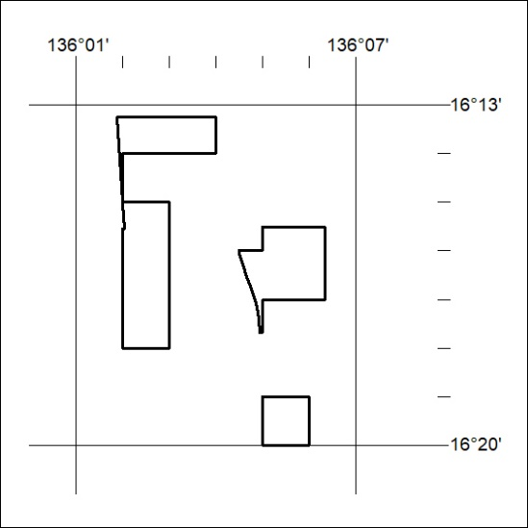

493/19

Mineral Titles Act
NOTICE OF GRANT OF A MINERAL TITLE
Title Type and Number: | Mineral Lease 30847
Granted: | 18 November 2019, for a period of 6 Years
Area: | 18.36 Hectares
Locality: | RIDDOCH
Name of Holder/s: | 100% ASTERISM GEMS AUSTRALIA PTY LTD [ACN. 604 439 956]
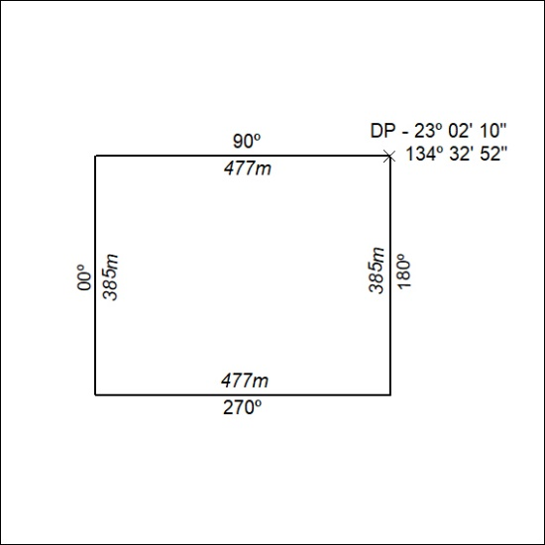

494/19

Mineral Titles Act
NOTICE OF GRANT OF A MINERAL TITLE
Title Type and Number: | Exploration Licence 32109
Granted: | 18 November 2019, for a period of 6 Years
Area: | 250 Blocks, 807.48 km²
Locality: | FAVENC
Name of Holder/s: | 100% STRATEGIC ENERGY RESOURCES LIMITED* [ACN. 051 212 429]
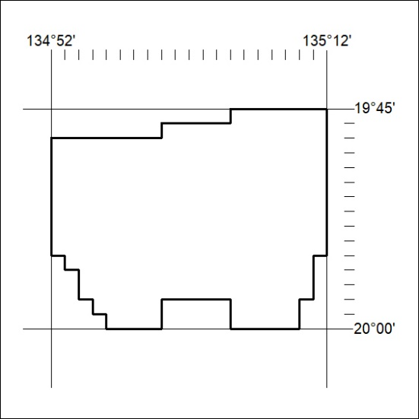
Area granted is indicated above. The titleholder is not permitted to exercise occupational rights on any land that is subject to a development title, or an application for a development title. Any land the subject of a Reserved Land gazettal under the Mineral Titles Act and all land vested in the Commonwealth of Australia is also excluded by description but not excised from the grant area.

495/19

