Mineral Titles Act 2010
NOTICE OF LAND CEASING TO BE A MINERAL TITLE AREA
Title Type and Number: | Exploration Licence 28764
Area Ceased on: | 25 October 2019
Area: | 6 Blocks, 19.22 km²
Locality: | ELKEDRA
Name of Applicant(s)/Holder(s): | 100% AUSTRALIA MINING & GEMSTONE CO. PTY LTD [ACN. 114 395 247]
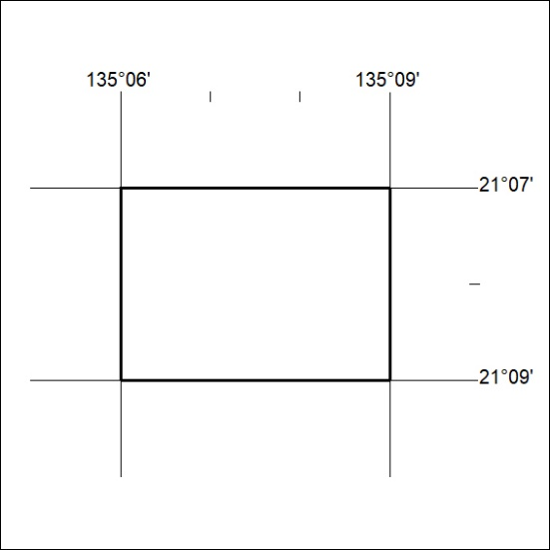

460/19

