Livestock movement conditions relating to cattle tick

Livestock movements within the NT

Cattle tick zones
The Northern Territory has four cattle tick zones (see the map on page 4).
The Parkhurst Infected Zone – Parkhurst strain cattle ticks are known to be present here.
The Infected Zone – cattle ticks are known to be present here.
The Control Zone – this is a buffer zone separating the infected zone from the free zone. Cattle ticks may occur on some properties in this zone.
The Free Zone – no cattle ticks are known to be present here.

Conditions for movement

Parkhurst Infected Zone

Movement from the Parkhurst Infected Zone to or through the Infected Zone, Control Zone or Free Zone (cattle, buffalo, bison, deer, banteng, goats, sheep, camel, llamas and alpacas):
- Clean inspection.
- Supervised treatment with Amitraz.

Movement from the Parkhurst Infected Zone to or through the Control Zone or Free Zone (horses):
- Clean inspection.
- Supervised treatment with Bayticol®.

Movement from the Parkhurst Infected Zone to the Infected Zone (horses):
- No restrictions

Movement from property to property within the Parkhurst Infected Zone:
- No restrictions.

Cattle Tick Infected Zone
Movement from the Infected Zone to or through the Control Zone or the Free Zone
(Cattle, buffalo, bison, deer, banteng, horses, goats, sheep, camel, llamas and alpacas):
- Clean inspection.
- Supervised treatment.
Note: If horses, sheep, goats, camels, deer or alpacas move from a property in the Infected Zone through the Control Zone (without stopping) and back into the Infected Zone no inspection or treatment is required.
If the travel route goes through any other zone, the conditions of movement to, or from, that other zone must be met.

Conditions for livestock moving out of the NT
Livestock moving out of the NT are subject to the conditions relating to the NT’s cattle tick zones and the conditions of the importing state or Territory.

Conditions for livestock moving into the NT
Livestock entering the NT are subject to the conditions stipulated in the species-specific NT health certificate and waybill.
Cattle, buffalo, bison, banteng, horses, sheep, goats, deers, camels, alpacas and llamas coming from a property of origin in a tick infested area are required to have a supervised treatment with an approved chemical prior to entry into the NT. The health certificate/waybill must be endorsed by an approved inspector from the states Department of Agriculture, or equivalent. If from a tick free area, the health certificate will still require endorsement from an approved inspector.
Please see AgNote: Health Certificates and waybills for cattle entering the NT

Definitions
Movement must be within 24 hours (or not exceeding 48 hours with approval of an inspector) of supervised plunge or spray dip treatment.
Movement outside these time frames requires permission from an inspector.
Clean inspection Where no ticks are found upon inspection of a group of animals.
Supervised treatment Plunge dip in an approved dip charged with a registered tickicide under the supervision of an inspector.
Spray for led and manageable stock.
Approved dip This is a dip with a recently-recorded correct or over-strength sample.
When an adjustment is necessary, a check sample is assessed after the adjustment has been made.
Repeat dip strength samples must be taken at least every two months (30 days for export yards).
When consecutive under-strength samples are obtained, or poor dip management is demonstrated, the “approved dip” status will be withdrawn by an inspector.
The Regional Livestock Biosecurity Officer will maintain a list of “approved dips” for the region. No supervised dipping will occur in under – strength dips.

Proof of treatment and inspection
Authority to travel cattle, buffaloes, sheep, goats, camels, horses, deer, alpacas and llamas may be in the form of an endorsed Waybill, Health Certificate and Waybill, or a Movement Permit for a Declared Area.
For an inspection and supervised treatment, or for more information, contact your Regional Livestock Biosecurity Officer (RLBO).
RLBO - Darwin Telephone: (08) 8999 2034
RLBO – Katherine Telephone: (08) 8973 9767
RLBO - Tennant Creek Telephone: (08) 8962 4458
RLBO - Alice Springs Telephone: (08) 8951 8125

Offence
A penalty of up to $78 500 or two years imprisonment applies to persons who conduct unauthorised stock movements to declared areas.
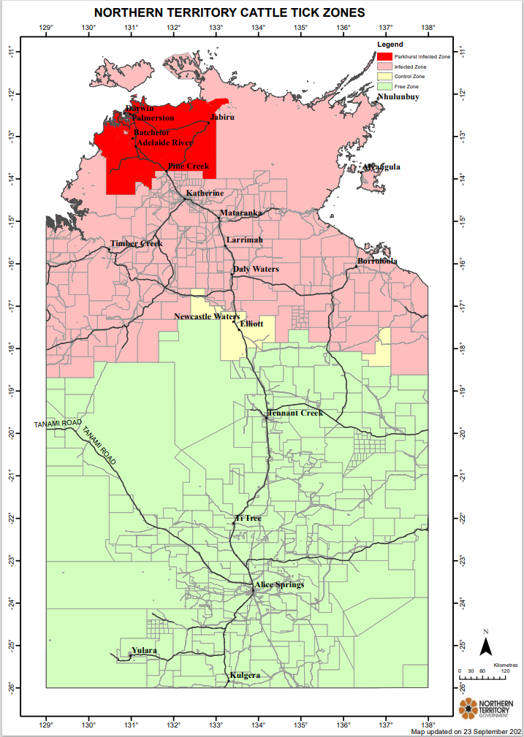

- https://industry.nt.gov.au/__data/assets/pdf_file/0017/233108/797.pdf

