Mineral Titles Act 2010
NOTICE OF LAND CEASING TO BE A MINERAL TITLE APPLICATION AREA
Title Type and Number: | Exploration Licence 32060
Area Ceased on: | 01 October 2019
Area: | 230 Blocks, 744.80 km²
Locality: | LIMBUNYA
Name of Applicant(s)/Holder(s): | 100% TIGER TASMAN MINERALS PTY LTD [ACN. 162 561 908]
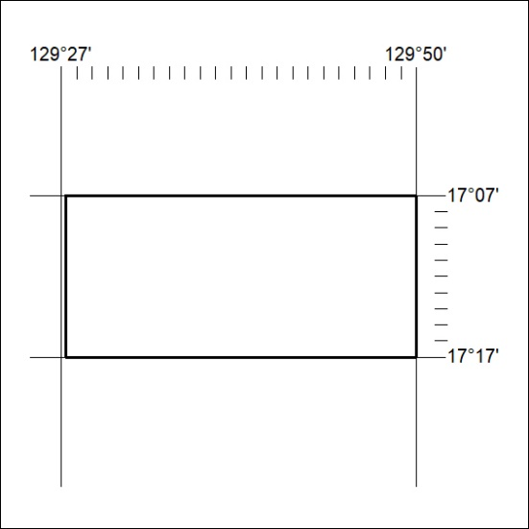

411/19

Mineral Titles Act 2010
NOTICE OF LAND CEASING TO BE A MINERAL TITLE APPLICATION AREA
Title Type and Number: | Exploration Licence 32061
Area Ceased on: | 01 October 2019
Area: | 222 Blocks, 715.47 km²
Locality: | LIMBUNYA
Name of Applicant(s)/Holder(s): | 100% TIGER TASMAN MINERALS PTY LTD [ACN. 162 561 908]
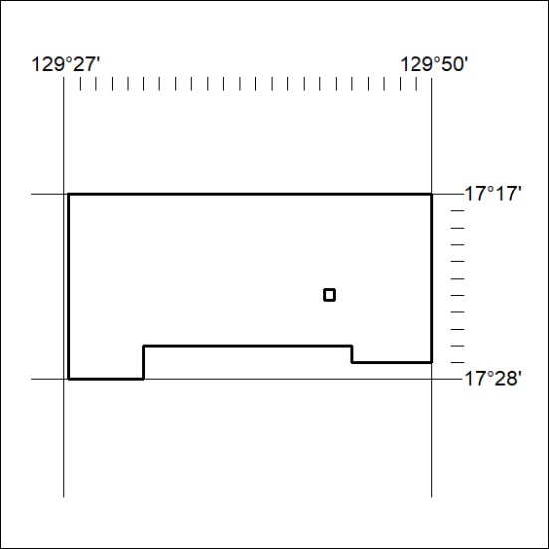

412/19
Mineral Titles Act 2010
NOTICE OF LAND CEASING TO BE A MINERAL TITLE APPLICATION AREA
Title Type and Number: | Exploration Licence 32062
Area Ceased on: | 01 October 2019
Area: | 244 Blocks, 797.42 km²
Locality: | INVERWAY
Name of Applicant(s)/Holder(s): | 100% TIGER TASMAN MINERALS PTY LTD [ACN. 162 561 908]
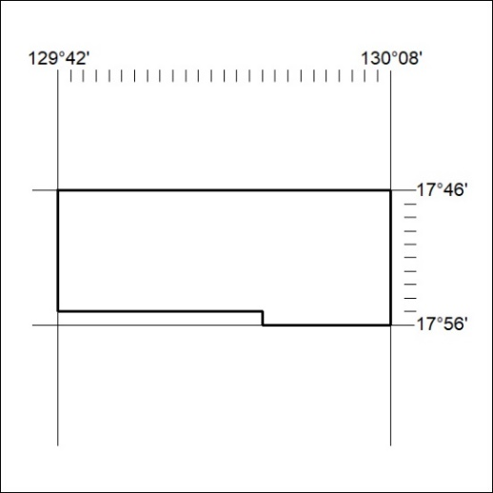

413/19

Mineral Titles Act 2010
NOTICE OF LAND CEASING TO BE A MINERAL TITLE APPLICATION AREA
Title Type and Number: | Exploration Licence 32063
Area Ceased on: | 01 October 2019
Area: | 250 Blocks, 800.80 km²
Locality: | NONGRA
Name of Applicant(s)/Holder(s): | 100% TIGER TASMAN MINERALS PTY LTD [ACN. 162 561 908]
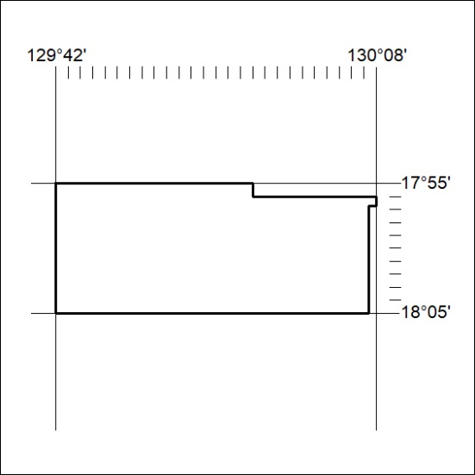

414/19

