Mineral Titles Act 2010
NOTICE OF LAND CEASING TO BE A MINERAL TITLE APPLICATION AREA
Title Type and Number: | Exploration Licence 31603
Area Ceased on: | 20 May 2019
Area: | 24 Blocks, 63.20 km²
Locality: | BATCHELOR
Name of Applicant(s)/Holder(s): | 100% BACCHUS RESOURCES PTY LTD [ACN. 606 340 872]
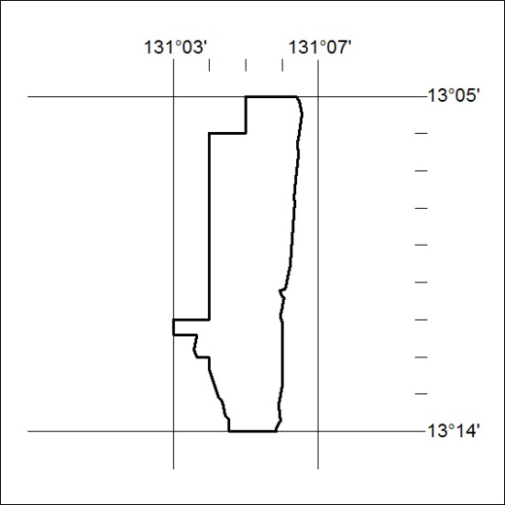

182/19

Mineral Titles Act
NOTICE OF GRANT OF A MINERAL TITLE
Title Type and Number: | Exploration Licence 31982
Granted: | 16 May 2019, for a period of 6 Years
Area: | 4 Blocks, 11.34 km²
Locality: | RODINGA
Name of Holder/s: | 100% CHANDLER PT PTY LTD [ACN. 627 920 370]
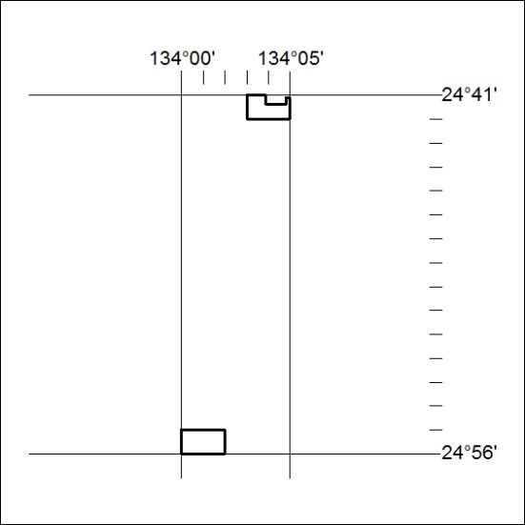
Area granted is indicated above. The titleholder is not permitted to exercise occupational rights on any land that is subject to a development title, or an application for a development title. Any land the subject of a Reserved Land gazettal under the Mineral Titles Act and all land vested in the Commonwealth of Australia is also excluded by description but not excised from the grant area.

183/19

Mineral Titles Act
NOTICE OF GRANT OF A MINERAL TITLE
Title Type and Number: | Exploration Licence 31989
Granted: | 16 May 2019, for a period of 6 Years
Area: | 5 Blocks, 16.70 km²
Locality: | BATCHELOR
Name of Holder/s: | 100% NT MINING OPERATIONS PTY LTD* [ACN. 136 525 990]
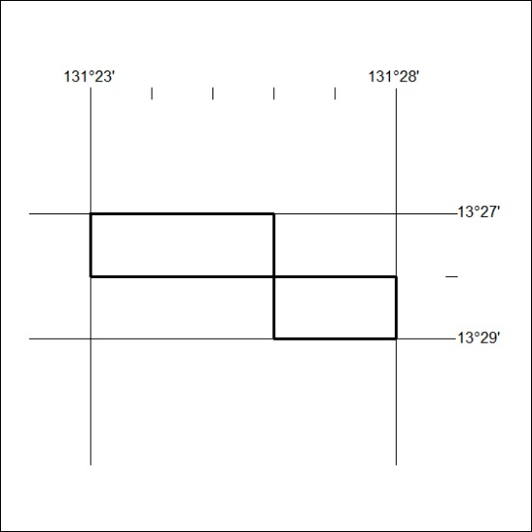
Area granted is indicated above. The titleholder is not permitted to exercise occupational rights on any land that is subject to a development title, or an application for a development title. Any land the subject of a Reserved Land gazettal under the Mineral Titles Act and all land vested in the Commonwealth of Australia is also excluded by description but not excised from the grant area.

184/19

