Mineral Titles Act 2010
NOTICE OF LAND CEASING TO BE A MINERAL TITLE AREA
Title Type and Number: | Extractive Mineral Permit 24086
Area ceased on: | 08 May 2019
Area: | 14.58 Hectare
Locality: | KOOLPINYAH
Name of Applicants(s)Holder(s): | 100% ALISANTE HOLDINGS PTY LTD [ACN. 067 361 559]
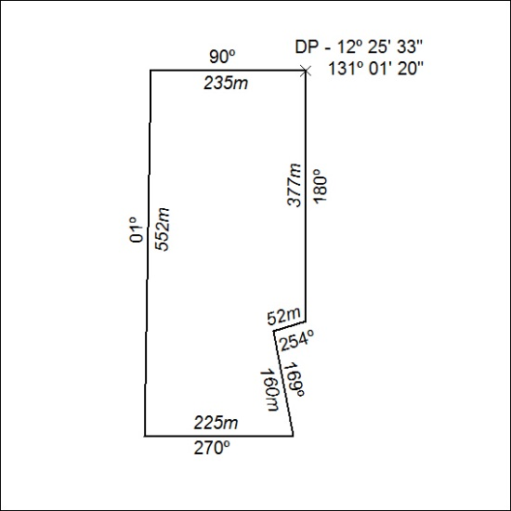

179/19

Mineral Titles Act 2010
NOTICE OF LAND CEASING TO BE A MINERAL TITLE AREA
Title Type and Number: | Extractive Mineral Permit 24489
Area ceased on: | 08 May 2019
Area: | 25.28 Hectare
Locality: | KOOLPINYAH
Name of Applicants(s)Holder(s): | 100% ALISANTE HOLDINGS PTY LTD [ACN. 067 361 559]
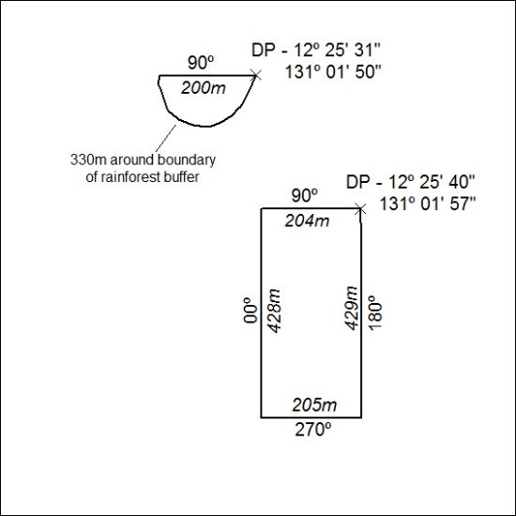

180/19

