Mineral Titles Act 2010
NOTICE OF LAND CEASING TO BE A MINERAL TITLE AREA
Title Type and Number: | Exploration Licence 31723
Area Ceased on: | 13 May 2019
Area: | 165 Blocks, 471.38 km²
Locality: | HAAST BLUFF
Name of Applicant(s)/Holder(s): | 100% INDEPENDENCE GROUP NL* [ACN. 092 786 304]
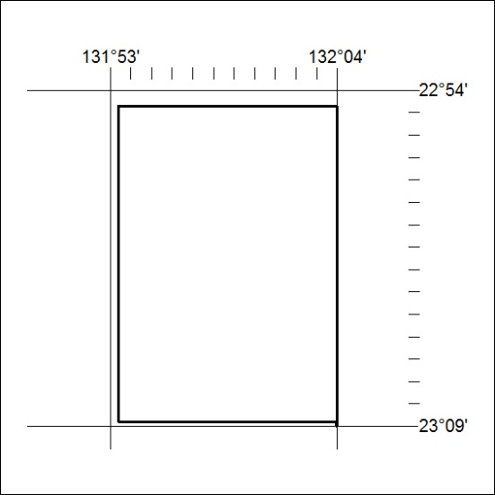

175/19

