Mineral Titles Act
NOTICE OF LAND CEASING TO BE A MINERAL TITLE AREA
Title Type and Number: | Exploration Licence 30830
Area Ceased on: | 08 February 2019
Area: | 4 Blocks, 12.78 km²
Locality: | AMMAROO
Name of Applicant(s)/Holder(s): | 100% TRACKER GEOSERVICES PTY LTD [ACN. 093 390 197]
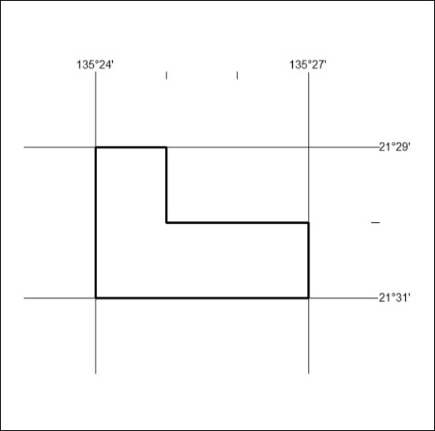

42/19

Mineral Titles Act
NOTICE OF GRANT OF A MINERAL TITLE
Title Type and Number: | Exploration Licence 31953
Granted: | 05 February 2019, for a period of 6 Years
Area: | 42 Blocks, 137.53 km²
Locality: | INVERWAY
Name of Holder/s: | 100% TERRITORY PROSPECTING PTY LTD [ACN. 627 334 034]
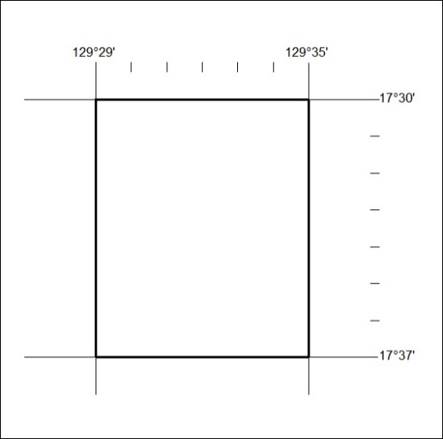
Area granted is indicated above. The titleholder is not permitted to exercise occupational rights on any land that is subject to a development title, or an application for a development title. Any land the subject of a Reserved Land gazettal under the Mineral Titles Act and all land vested in the Commonwealth of Australia is also excluded by description but not excised from the grant area.

43/19

Mineral Titles Act
NOTICE OF GRANT OF A MINERAL TITLE
Title Type and Number: | Exploration Licence 31955
Granted: | 05 February 2019, for a period of 6 Years
Area: | 25 Blocks, 81.83 km²
Locality: | NAPIER
Name of Holder/s: | 100% TERRITORY PROSPECTING PTY LTD [ACN. 627 334 034]
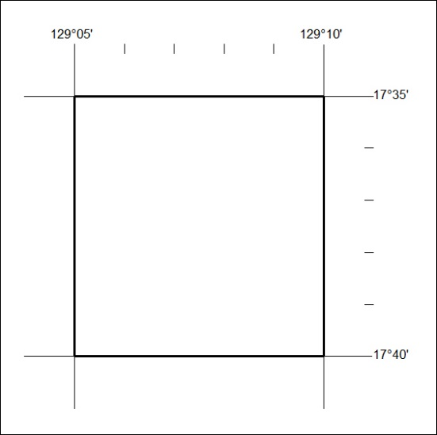
Area granted is indicated above. The titleholder is not permitted to exercise occupational rights on any land that is subject to a development title, or an application for a development title. Any land the subject of a Reserved Land gazettal under the Mineral Titles Act and all land vested in the Commonwealth of Australia is also excluded by description but not excised from the grant area.
44/19

Mineral Titles Act
NOTICE OF GRANT OF A MINERAL TITLE
Title Type and Number: | Exploration Licence 31958
Granted: | 05 February 2019, for a period of 6 Years
Area: | 24 Blocks, 76.16 km²
Locality: | FLORA
Name of Holder/s: | 100% TERRITORY PROSPECTING PTY LTD [ACN. 627 334 034]
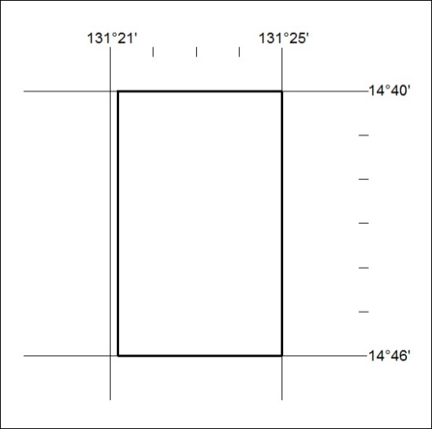
Area granted is indicated above. The titleholder is not permitted to exercise occupational rights on any land that is subject to a development title, or an application for a development title. Any land the subject of a Reserved Land gazettal under the Mineral Titles Act and all land vested in the Commonwealth of Australia is also excluded by description but not excised from the grant area.
45/19

Mineral Titles Act
NOTICE OF GRANT OF A MINERAL TITLE
Title Type and Number: | Exploration Licence 31962
Granted: | 05 February 2019, for a period of 6 Years
Area: | 50 Blocks, 160.17 km²
Locality: | FLORA
Name of Holder/s: | 100% TERRITORY PROSPECTING PTY LTD [ACN. 627 334 034]
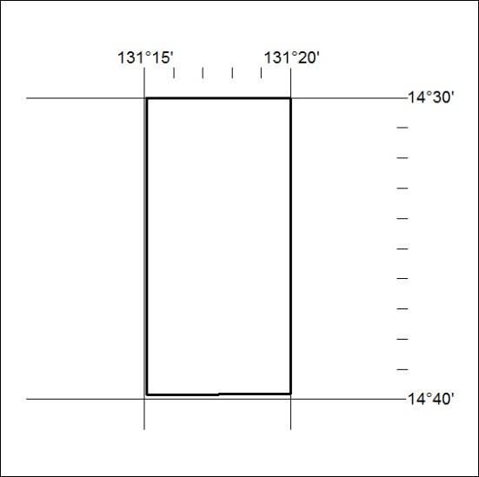
Area granted is indicated above. The titleholder is not permitted to exercise occupational rights on any land that is subject to a development title, or an application for a development title. Any land the subject of a Reserved Land gazettal under the Mineral Titles Act and all land vested in the Commonwealth of Australia is also excluded by description but not excised from the grant area.
46/19

Mineral Titles Act
NOTICE OF GRANT OF A MINERAL TITLE
Title Type and Number: | Exploration Licence 31963
Granted: | 06 February 2019, for a period of 6 Years
Area: | 231 Blocks, 729.27 km²
Locality: | DALMORE
Name of Holder/s: | 100% NEWCREST OPERATIONS LIMITED [ACN. 009 221 505]
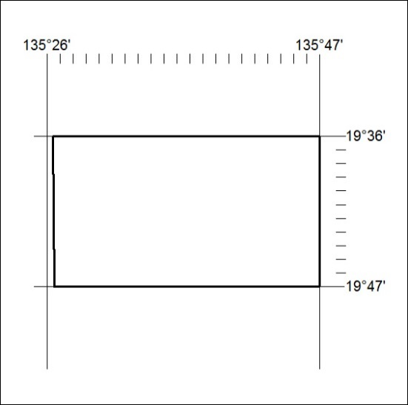
Area granted is indicated above. The titleholder is not permitted to exercise occupational rights on any land that is subject to a development title, or an application for a development title. Any land the subject of a Reserved Land gazettal under the Mineral Titles Act and all land vested in the Commonwealth of Australia is also excluded by description but not excised from the grant area.
47/19

Mineral Titles Act
NOTICE OF GRANT OF A MINERAL TITLE
Title Type and Number: | Exploration Licence 31964
Granted: | 06 February 2019, for a period of 6 Years
Area: | 212 Blocks, 667.87 km²
Locality: | FAVENC
Name of Holder/s: | 100% NEWCREST OPERATIONS LIMITED [ACN. 009 221 505]
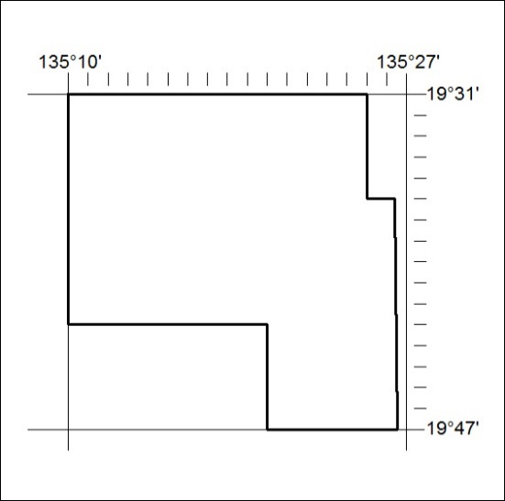
Area granted is indicated above. The titleholder is not permitted to exercise occupational rights on any land that is subject to a development title, or an application for a development title. Any land the subject of a Reserved Land gazettal under the Mineral Titles Act and all land vested in the Commonwealth of Australia is also excluded by description but not excised from the grant area.
48/19

