Mineral Titles Act
NOTICE OF LAND CEASING TO BE A MINERAL TITLE AREA
Title Type and Number: | Exploration Licence 24451
Area Ceased on: | 21 January 2019
Area: | 20 Blocks, 63.36 km²
Locality: | MT WEDGE
Name of Applicant(s)/Holder(s): | 100% ENERGY METALS LTD [ACN. 111 306 533]
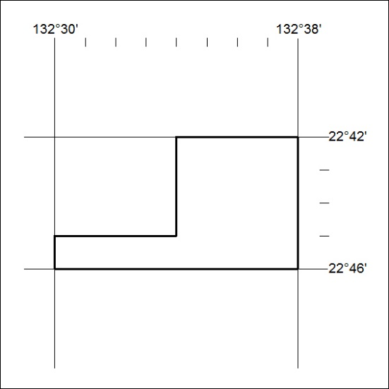

11/19

Mineral Titles Act
NOTICE OF LAND CEASING TO BE A MINERAL TITLE AREA
Title Type and Number: | Exploration Licence 24463
Area Ceased on: | 21 January 2019
Area: | 16 Blocks, 50.84 km²
Locality: | YUENDUMU
Name of Applicant(s)/Holder(s): | 100% ENERGY METALS LTD [ACN. 111 306 533]
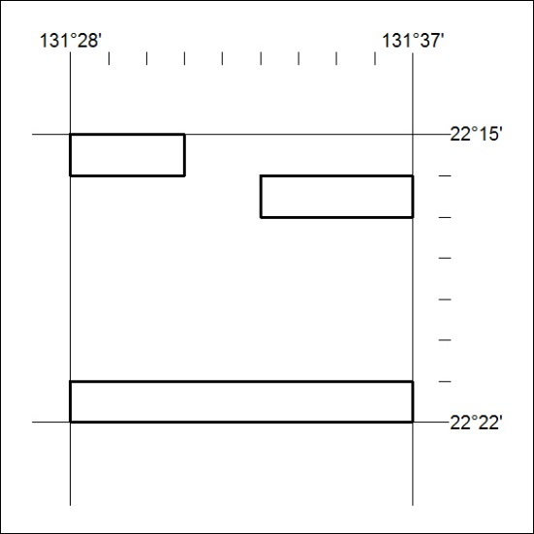

12/19

Mineral Titles Act
NOTICE OF LAND CEASING TO BE A MINERAL TITLE AREA
Title Type and Number: | Exploration Licence 29223
Area Ceased on: | 21 January 2019
Area: | 9 Blocks, 27.95 km²
Locality: | FITZMAURICE
Name of Applicant(s)/Holder(s): | 100% ENERGY EXPLORATION PTY LIMITED* [ACN. 073 959 789]
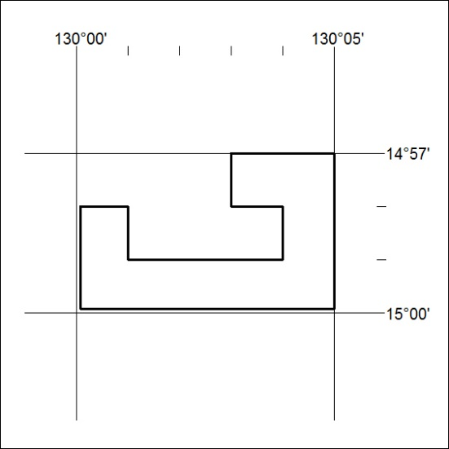

13/19

Mineral Titles Act
NOTICE OF LAND CEASING TO BE A MINERAL TITLE AREA
Title Type and Number: | Exploration Licence 29557
Area Ceased on: | 21 January 2019
Area: | 37 Blocks, 120.25 km²
Locality: | MITCHIEBO
Name of Applicant(s)/Holder(s): | 100% TECK AUSTRALIA PTY LTD [ACN. 091 271 911]
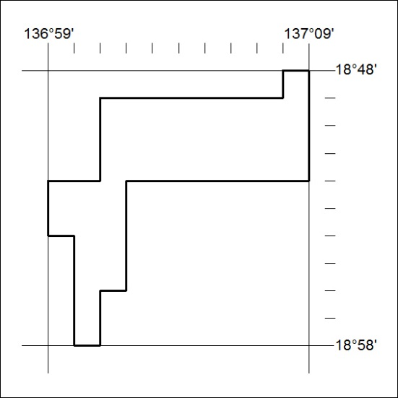

14/19

Mineral Titles Act
NOTICE OF LAND CEASING TO BE A MINERAL TITLE AREA
Title Type and Number: | Exploration Licence 31275
Area Ceased on: | 15 January 2019
Area: | 61 Blocks, 192.44 km²
Locality: | QUARTZ
Name of Applicant(s)/Holder(s): | 100% GBE EXPLORATION PTY LTD [ACN. 121 535 948]
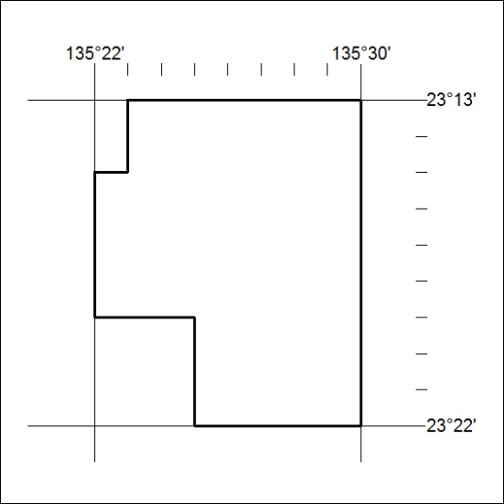

15/19

Mineral Titles Act
NOTICE OF GRANT OF A MINERAL TITLE
Title Type and Number: | Mineral Lease 31726
Granted: | 18 January 2019, for a period of 20 Years
Area: | 768.00 Hectares
Locality: | BYNOE
Name of Holder/s: | 100% LITHIUM DEVELOPMENTS (GRANTS NT) PTY LTD [ACN. 622 047 232]
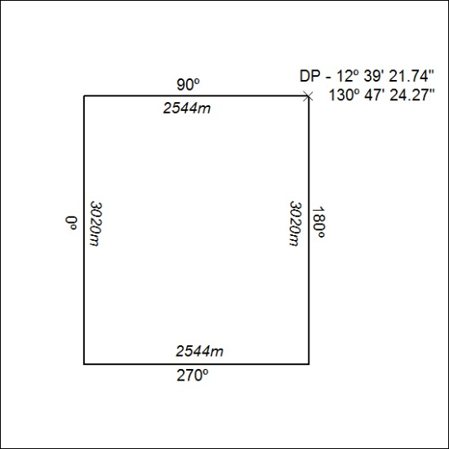

16/19

