Mineral Titles Act
NOTICE OF LAND CEASING TO BE A MINERAL TITLE
Title Type and Number: | Mineral Lease 30636
Area ceased on: | 02 October 2018
Area: | 39.00 Hectare
Locality: | TENNANT CREEK
Name of Applicants(s)Holder(s): | 100% GIANTS REEF EXPLORATION PTY LTD* [ACN. 009 200 346]
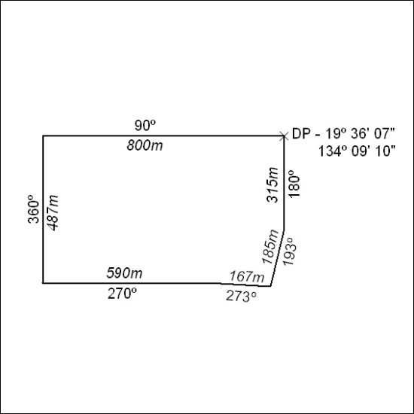

422/18

Mineral Titles Act
NOTICE OF LAND CEASING TO BE A MINERAL TITLE
Title Type and Number: | Mineral Lease 30715
Area ceased on: | 02 October 2018
Area: | 39.00 Hectare
Locality: | KELLY
Name of Applicants(s)Holder(s): | 100% SANTEXCO PTY LTD [ACN. 002 910 296]
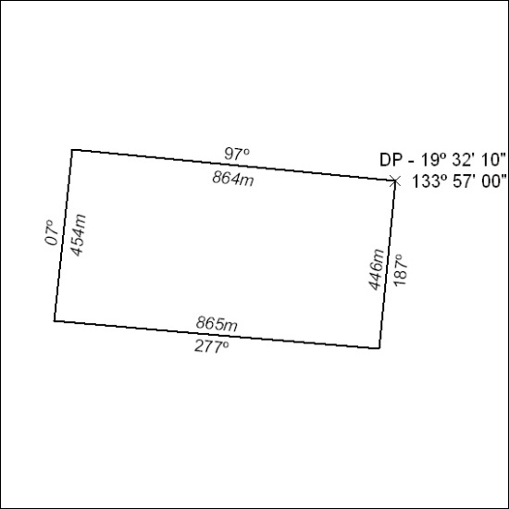

423/18

Mineral Titles Act
NOTICE OF LAND CEASING TO BE A MINERAL TITLE
Title Type and Number: | Mineral Lease 30744
Area ceased on: | 02 October 2018
Area: | 30.00 Hectare
Locality: | SHORT RANGE
Name of Applicants(s)Holder(s): | 100% SANTEXCO PTY LTD [ACN. 002 910 296]
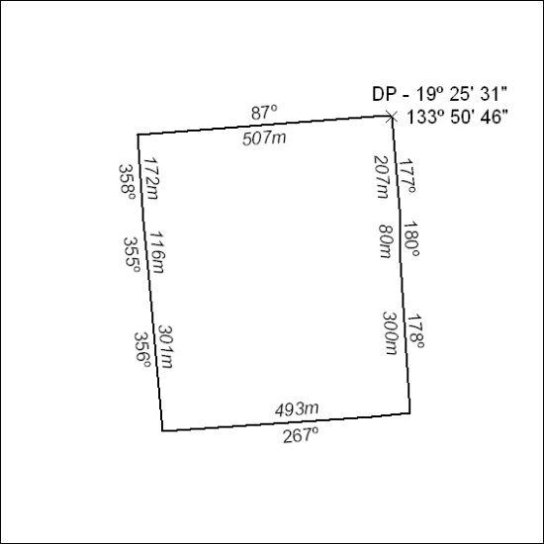

424/18

Mineral Titles Act
NOTICE OF LAND CEASING TO BE A MINERAL TITLE
Title Type and Number: | Mineral Lease 30781
Area ceased on: | 02 October 2018
Area: | 20.00 Hectare
Locality: | SHORT RANGE
Name of Applicants(s)Holder(s): | 100% SANTEXCO PTY LTD [ACN. 002 910 296]
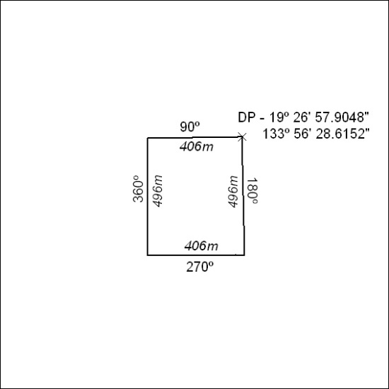

425/18

Mineral Titles Act
NOTICE OF LAND CEASING TO BE A MINERAL TITLE
Title Type and Number: | Mineral Lease 30782
Area ceased on: | 02 October 2018
Area: | 19.00 Hectare
Locality: | SHORT RANGE
Name of Applicants(s)Holder(s): | 100% SANTEXCO PTY LTD [ACN. 002 910 296]
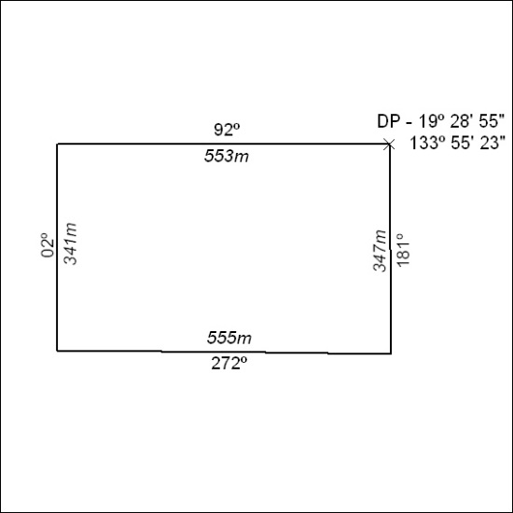

426/18

Mineral Titles Act
NOTICE OF LAND CEASING TO BE A MINERAL TITLE
Title Type and Number: | Mineral Lease 30784
Area ceased on: | 02 October 2018
Area: | 31.00 Hectare
Locality: | SHORT RANGE
Name of Applicants(s)Holder(s): | 100% SANTEXCO PTY LTD [ACN. 002 910 296]
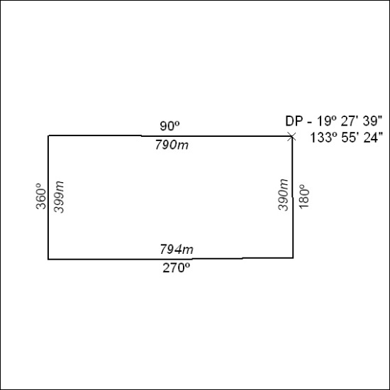

427/18

Mineral Titles Act
NOTICE OF LAND CEASING TO BE A MINERAL TITLE
Title Type and Number: | Mineral Lease 30874
Area ceased on: | 02 October 2018
Area: | 33.00 Hectare
Locality: | TENNANT CREEK
Name of Applicants(s)Holder(s): | 100% SANTEXCO PTY LTD [ACN. 002 910 296]
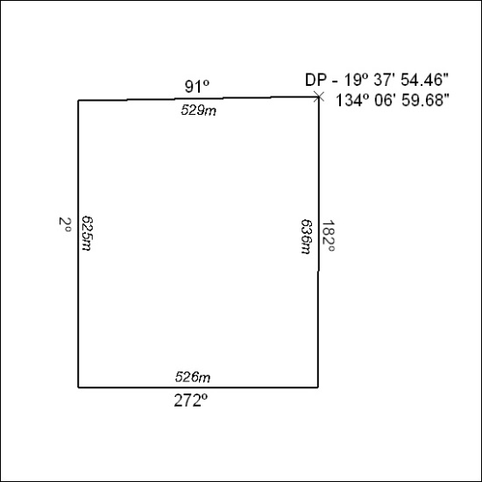

428/18

Mineral Titles Act
NOTICE OF LAND CEASING TO BE A MINERAL TITLE
Title Type and Number: | Mineral Lease 30946
Area ceased on: | 02 October 2018
Area: | 19.00 Hectare
Locality: | SHORT RANGE
Name of Applicants(s)Holder(s): | 100% SANTEXCO PTY LTD [ACN. 002 910 296]
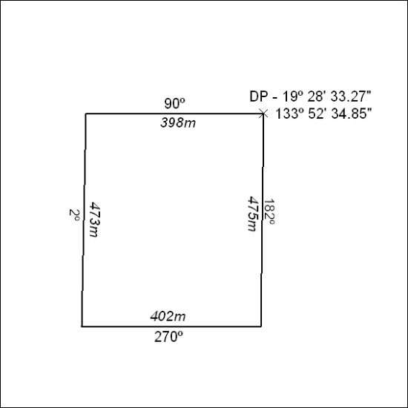

429/18

Mineral Titles Act
NOTICE OF LAND CEASING TO BE A MINERAL TITLE
Title Type and Number: | Mineral Lease 30947
Area ceased on: | 02 October 2018
Area: | 270.00 Hectares
Locality: | SHORT RANGE
Name of Applicants(s)Holder(s): | 100% GIANTS REEF EXPLORATION PTY LTD* [ACN. 009 200 346]
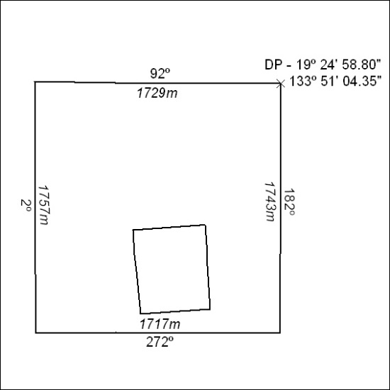

430/18

Mineral Titles Act
NOTICE OF LAND CEASING TO BE A MINERAL TITLE
Title Type and Number: | Mineral Lease 31055
Area ceased on: | 02 October 2018
Area: | 18.00 Hectare
Locality: | TENNANT CREEK
Name of Applicants(s)Holder(s): | 100% SANTEXCO PTY LTD [ACN. 002 910 296]
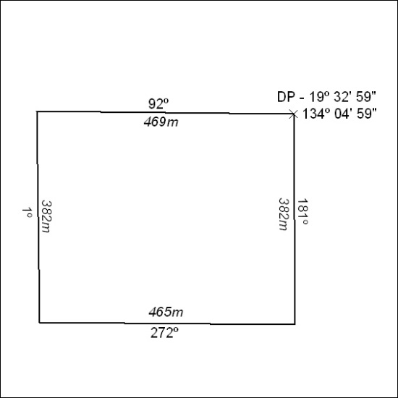

431/18

Mineral Titles Act
NOTICE OF LAND CEASING TO BE A MINERAL TITLE
Title Type and Number: | Mineral Lease 31057
Area ceased on: | 02 October 2018
Area: | 64.00 Hectare
Locality: | KELLY
Name of Applicants(s)Holder(s): | 100% SANTEXCO PTY LTD [ACN. 002 910 296]
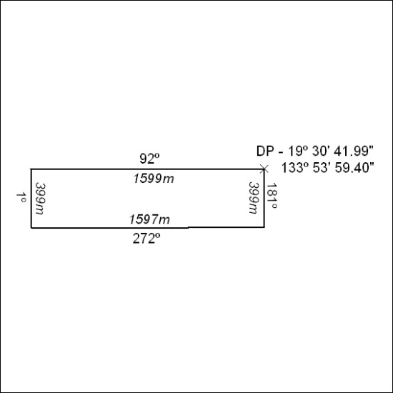

432/18

Mineral Titles Act
NOTICE OF LAND CEASING TO BE A MINERAL TITLE
Title Type and Number: | Mineral Lease 31076
Area ceased on: | 02 October 2018
Area: | 26.00 Hectare
Locality: | TENNANT CREEK
Name of Applicants(s)Holder(s): | 100% SANTEXCO PTY LTD [ACN. 002 910 296]
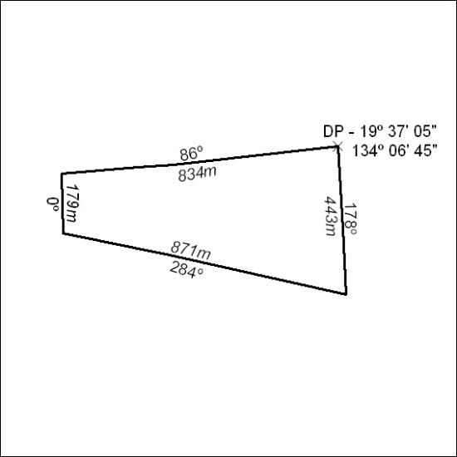

433/18

Mineral Titles Act
NOTICE OF LAND CEASING TO BE A MINERAL TITLE
Title Type and Number: | Mineral Lease (Central) 120
Area ceased on: | 02 October 2018
Area: | 15.00 Hectare
Locality: | SHORT RANGE
Name of Applicants(s)Holder(s): | 100% SANTEXCO PTY LTD [ACN. 002 910 296]
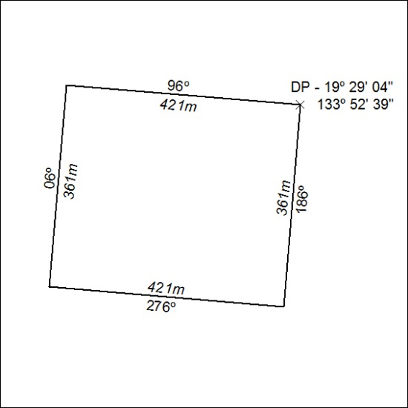

434/18

Mineral Titles Act
NOTICE OF LAND CEASING TO BE A MINERAL TITLE
Title Type and Number: | Mineral Lease (Central) 121
Area ceased on: | 02 October 2018
Area: | 15.00 Hectare
Locality: | SHORT RANGE
Name of Applicants(s)Holder(s): | 100% SANTEXCO PTY LTD [ACN. 002 910 296]
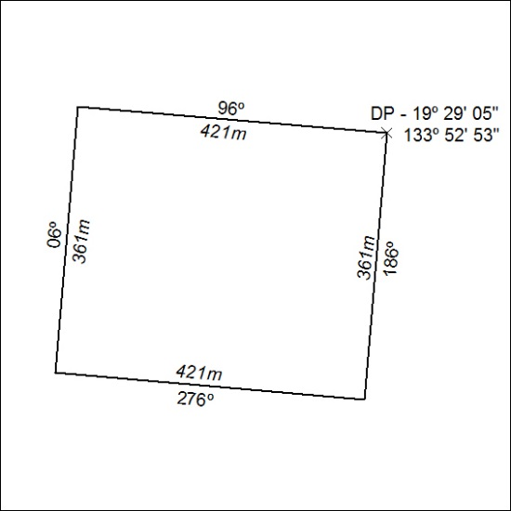

435/18

Mineral Titles Act
NOTICE OF LAND CEASING TO BE A MINERAL TITLE
Title Type and Number: | Mineral Lease (Central) 122
Area ceased on: | 02 October 2018
Locality: | SHORT RANGE
Name of Applicants(s)Holder(s): | 100% SANTEXCO PTY LTD [ACN. 002 910 296]
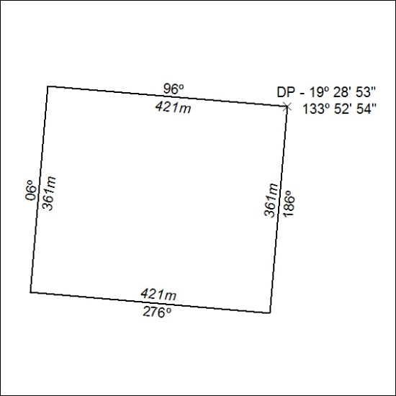

436/18

Mineral Titles Act
NOTICE OF LAND CEASING TO BE A MINERAL TITLE
Title Type and Number: | Mineral Lease (Central) 123
Area ceased on: | 02 October 2018
Area: | 15.00 Hectare
Locality: | SHORT RANGE
Name of Applicants(s)Holder(s): | 100% SANTEXCO PTY LTD [ACN. 002 910 296]
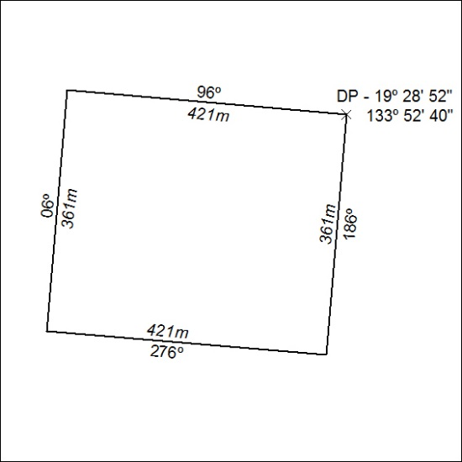

437/18

Mineral Titles Act
NOTICE OF LAND CEASING TO BE A MINERAL TITLE
Title Type and Number: | Mineral Lease (Central) 626
Area ceased on: | 02 October 2018
Area: | 8.00 Hectare
Locality: | TENNANT CREEK
Name of Applicants(s)Holder(s): | 100% GIANTS REEF EXPLORATION PTY LTD* [ACN. 009 200 346]
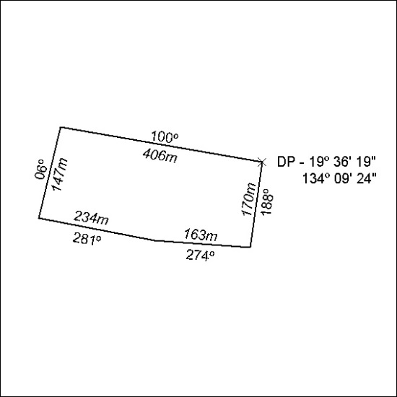

438/18

