Mineral Titles Act
NOTICE OF GRANT OF A MINERAL TITLE
Title Type and Number: | Exploration Licence 31623
Granted: | 20 August 2018, for a period of 6 Years
Area: | 84 Blocks, 262.14 km²
Locality: | OORADIDGEE
Name of Holder/s: | 100% TREASURE CREEK PTY LTD [ACN. 619 057 644]
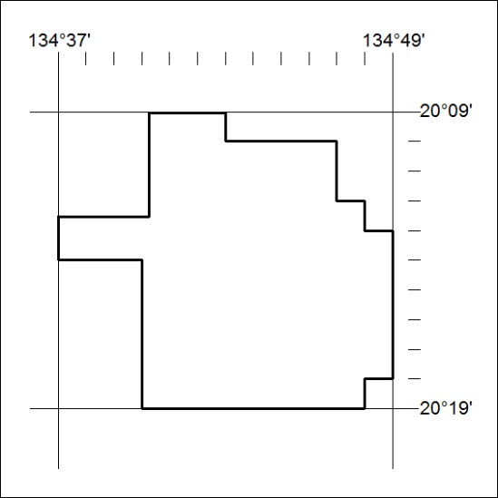
Area granted is indicated above. The titleholder is not permitted to exercise occupational rights on any land that is subject to a development title, or an application for a development title. Any land the subject of a Reserved Land gazettal under the Mineral Titles Act and all land vested in the Commonwealth of Australia is also excluded by description but not excised from the grant area.
351/18

Mineral Titles Act
NOTICE OF GRANT OF A MINERAL TITLE
Title Type and Number: | Exploration Licence 31625
Granted: | 20 August 2018, for a period of 6 Years
Area: | 250 Blocks, 805.25 km²
Locality: | EPENARRA
Name of Holder/s: | 100% TREASURE CREEK PTY LTD [ACN. 619 057 644]
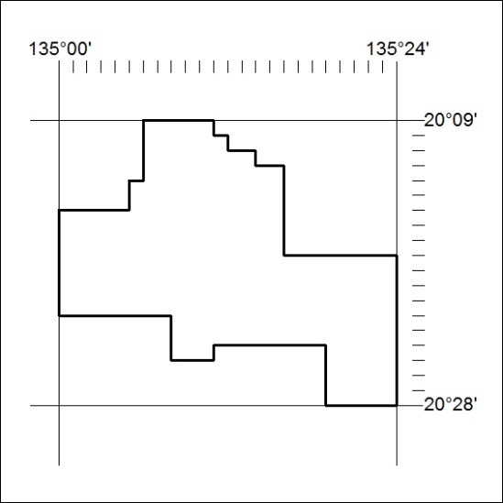
Area granted is indicated above. The titleholder is not permitted to exercise occupational rights on any land that is subject to a development title, or an application for a development title. Any land the subject of a Reserved Land gazettal under the Mineral Titles Act and all land vested in the Commonwealth of Australia is also excluded by description but not excised from the grant area.
352/18

Mineral Titles Act
NOTICE OF GRANT OF A MINERAL TITLE
Title Type and Number: | Exploration Licence 31627
Granted: | 20 August 2018, for a period of 6 Years
Area: | 105 Blocks, 337.41 km²
Locality: | EPENARRA
Name of Holder/s: | 100% TREASURE CREEK PTY LTD [ACN. 619 057 644]
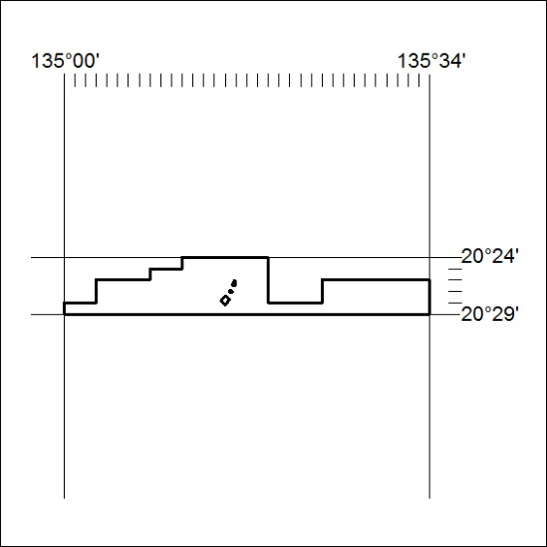
Area granted is indicated above. The titleholder is not permitted to exercise occupational rights on any land that is subject to a development title, or an application for a development title. Any land the subject of a Reserved Land gazettal under the Mineral Titles Act and all land vested in the Commonwealth of Australia is also excluded by description but not excised from the grant area.
353/18

Mineral Titles Act
NOTICE OF GRANT OF A MINERAL TITLE
Title Type and Number: | Exploration Licence 31628
Granted: | 20 August 2018, for a period of 6 Years
Area: | 250 Blocks, 777.93 km²
Locality: | HATCHES
Name of Holder/s: | 100% TREASURE CREEK PTY LTD [ACN. 619 057 644]
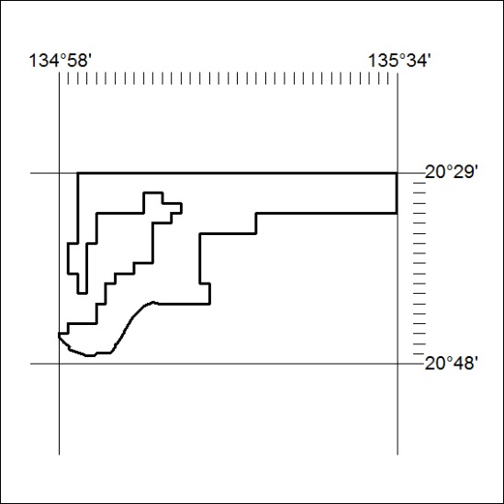
Area granted is indicated above. The titleholder is not permitted to exercise occupational rights on any land that is subject to a development title, or an application for a development title. Any land the subject of a Reserved Land gazettal under the Mineral Titles Act and all land vested in the Commonwealth of Australia is also excluded by description but not excised from the grant area.
354/18

